# 143-x-20

Optimization of Abrasive Machining of CFRP with ANOVA

Jaby Mohammed
Illinois State University
jmohamm@ilstu.edu

Jamal Sheik-Ahmad
Khalifa University
jahmad@ku.ac.ae

Abstract

The present study investigates effects of feed rate and spindle speed on diamond abrasive machining of carbon fiber reinforced polymers. Rough and finish routing of composite fiber reinforced plastics (CFRP) plate was performed under dry conditions. Cutting forces, machining power, surface roughness, and workpiece temperature were measured, and an ANOVA test was performed. It was found that feed rate has the most significant influence on machining power. In contrast, the spindle speed significantly influences surface roughness, cutting forces, and workpiece temperature. The study also provided recommendations for optimum machining conditions with abrasive diamond cutters.

Keywords: Abrasive machining, diamond abrasive cutters, ANOVA, design of experiments, roughness, temperature

Introduction

Two of the most common material removal processes by the action of small hard particles attached to a rigid body are abrasive machining and grinding. The hard particles typically used for both processes are aluminum oxide, silicon carbide, cubic boron nitride, or even diamond particles. The scientific community has received much attention with the grinding process in the manufacturing industry. Abrasive machining, on the other hand, is a relatively modern approach with lesser attention because most people confuse it with grinding. However, as Malkin et al. (1989) note, the similarities between these two-machining process in many scenarios are sufficient to bridge the gap in knowledge between the two. Ahmad et al. (2009) and Meagawa (2016) have discussed the aspects of abrasive machining to be different from grinding. The main difference between the two falls into the three process parameters: workpiece feed rate (the relative velocity at which the cutter is advanced to the workpiece), cutter diameter (with the resulting velocity), and depth of the cut (the depth of the material layer removed from the workpiece material). Ahmad et al. (2009) have discussed the differences between surface grinding and abrasive resistance regarding the depth of cut and cutting speed. Depth of cut ranges from 10 to 50 mm; typical wheel velocities are 1800 m/min, with some velocities reaching up to 7000m/min with surface grinding. The workpiece velocities are comparatively at a lower wheel velocity. Grinding wheels have larger diameters than the abrasive cutters and are primarily used for the lower material removal process.

The machining equivalent chip thickness is considerably larger in abrasive machining than grinding. The cutting speed and workpiece feed rate are considerably lower with a higher depth of cut, as Soo et al. (2012) mentioned. With fiber-reinforced polymers, instead of using edge cutters, Colligan and Ramalu (1999), Niu et al. (2016), and Boudelier and Ritou (2011) have used abrasive machining in edge trimming and bulk machining (milling). A metallic bond attaches diamond grit of various sizes to the tool shank used with this process. The main reason to use abrasive machining was to have a superior surface finish by eliminating the material's delamination. The abrasive particles are diamond grit of various sizes depending on the finish required by the user. The 30 grit is a general-purpose cutter used for the roughing application because of its wide grain spacing and larger diamond grains. An 80-grit size cutter is used for finishing operation, and it has a denser concentration of the diamond particles with smaller sizes.

Electroplating and brazing are two techniques used for bonding diamond grit to the tool shank. The electroplating and brazing process uses a single layer of diamond particles attached to the tool shank by a metallic bond. As Lee (2000) has described, “Electroplating involves immersing a steel tool shank in a nickel-plating solution with suspended diamond particles. The nickel ions build up on the steel shank between the diamond particles, tacking a single layer of particles to the tool's surface. The tool is then over plated with nickel until approximately 50-70% of the diamond particle is covered by the bond matrix.” The heat build-up and rapid tool wear are due to the reduced clearance (electroplating results in high-density diamond particles with low grain exposure) required for chip disposal. The braze alloy (diamond grit and nickel-chrome) bonds to the diamond particles and steel substrate in the brazing technique. This technique individually sets the diamond particle and bonding to the shank allowing greater control of diamond particle density and distribution. Though the processes are different, the mechanics of cutting using abrasive particles and edge trimming using multiple edge cutting tools are similar.

The following expression calculates the material removal rate,

Q = F. d .t (Equation 1)
Where
F is the feed rate
d is the radial depth of cut, and
t is the width of cut, which is the same as the thickness of the laminate

Equivalent chip thickness (h_{eq}) is a kinematic parameter that is used to characterize the uncut material size and is given by the expression

h_{eq} = d ( F/V_{s}) (Equation 2)
Where
F is the feed rate
d is the depth of cut, and
V_{s} is the wheel speed

Rowe (2009) noted that the equivalent chip thickness is much thinner than the actual thickness of chips removed by randomly spaced grains. However, since the actual uncut chip thickness in grinding is not easily defined or measured, the equivalent chip thickness is widely used instead in the empirical correlation of process response such as forces, temperature, and surface roughness.

Table 1. Chip thickness.

Type of process | Process Parameter | Chip thickness
Abrasive cutter | - 25 mm diameter  - rotating at 5000 rpm  - trimming 2 mm off a workpiece  - feed rate of 2 m/min | 0.01 mm
Edge trimming | Similar process parameter | More than 0.217 mm

Table 1 shows that the material removal rates implemented in this study are much higher than typical material removal rates implemented in grinding (Rowe, 2009; Girot, 2017). When edge trimming with a single edge cutter at the same cutting parameters, the maximum chip thickness obtained is significantly higher, and Rowe states, “the specific cutting energy is power-law proportional to the reciprocal of the chip thickness, the specific cutting forces in abrasive machining are significantly greater than those in edge trimming with an end mill. However, the cutting forces are distributed over many small abrasive particles that are engaged in the cut at the same time and the influence of each individual grit on the workpiece is minimized. This allows abrasive machining for less mechanical damage to the workpiece and better surface finish.”

In this study, the authors examine abrasive machining as a bulk material removal process and not as a finishing process. Most of the previous researchers studied material removal rates and chip thickness. The effect of process parameters on the machinability of CFRP is investigated to establish optimum machining conditions. The varied process parameters were spindle speed, feed rate, and depth of cut. Machinability was assessed in terms of cutting forces, specific cutting energy, machined surface temperature, and surface roughness. The choice of cutting parameters allowed high levels of material removal rates to be obtained. This is in the perspective of abrasive machining being utilized as a bulk material removal process instead of milling.

Materials and Methods

Researchers used a 3-axis CNC vertical milling machine equipped with a 7.5 KW spindle with a maximum spindle speed of 10000 rpm to conduct the CFRP’s edge trimming experiment.

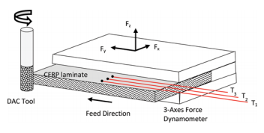
Figure 1. Down milling configuration with abrasive diamond cutter (DAC).

The cutting configuration was down milling as illustrated in Figure 1. T1, T2, and T3 stand for thermocouples. The cutting parameters were spindle speed (or cutting speed), feed rate, and radial depth of cut. The study used a full 2-level factorial design with two replicas. There were two repeats done for each factors Table 2 lists the range of parameters used in the experiments.

Table 2. Experimental matrix.

Type | F (m/min) | N (rpm) | Vs (m/s) | d(mm)
Corner | 0.25 | 3000 | 2.00 | 3.18
Corner | 0.25 | 5000 | 3.33 | 3.18
Corner | 0.76 | 3000 | 2.00 | 3.18
Corner | 0.76 | 5000 | 3.33 | 3.18
Corner | 0.25 | 3000 | 2.00 | 12.70
Corner | 0.25 | 5000 | 3.33 | 12.70
Corner | 0.76 | 3000 | 2.00 | 12.70
Corner | 0.76 | 5000 | 3.33 | 12.70
Center | 0.51 | 4000 | 2.66 | 7.93

The feed per revolution represents the advancement of the center of the cutter in one revolution. The feed per tooth is obtained by dividing feed per revolution by the number of teeth and would be the indicative of the uncut chip thickness. As discussed earlier, abrasive cutters do not have well defined cutting edges; hence feed per revolution is used to represent the size of chip.
Material removal rates used in this study are much higher than the rates used in grinding; hence the feed per revolution values are also significantly higher. The higher material removal rates are achieved because of the high diamond grit exposure of the single-layer abrasives bonded to the tool shank, which leaves adequate space for chip disposal. Therefore, it is recommended to utilize abrasive diamond cutters at higher material removal rates to ensure adequate productivity levels.

The response parameters were net cutting power, cutting forces, machined surface temperature and surface roughness. A universal power cell (Load Control) continuously monitored the spindle power consumption during the edge trimming operation. The net cutting power was determined by subtracting the idle spindle power from the total spindle power during cutting. A 3-axes force dynamometer (Kistler 9257B) measured the cutting forces along the feed, normal to the feed and in the axial directions, and trimming the edge of the laminate was done in one pass with a diamond abrasive brazed cutter DAC 30P.B.S. This is a typical roughing cutter for composite materials. The cutter diameter was 12.7 mm, and the grit size was 30. All trimming experiments were conducted without coolant. After trimming, inspection of the machined surface was performed inside a scanning electron microscope (SEM) and surface roughness was measured using a stylus profilometer. An ANOVA test with a significance level of 95% was performed to determine the individual effect of input parameters and their interactions.

The workpiece material is a 9 mm thick multidirectional CFRP/epoxy laminate consisting of 32 plies of plain weave carbon fibers with the stacking sequence [(XW/PW)16]s, where XW represents a single aligned at ±45o with the panel axes. PW is a single ply with the fiber directions aligned coincident with the panel axes. The fiber volume fraction was 0.60. The laminate was cut with a diamond saw into coupons measuring 150 mm x100 mm. The fiber orientation on the surface plies was XW. The coupons were clamped on top a 3-axes force dynamometer using a special fixture and trimming was performed along the 150 mm long edge as illustrated in Figure 1.

The temperature of the CFRP laminate near the cutting region was measured by surface mounted thermocouples as shown in Figure 1. Research by Yashiro et al. (2013) and Kerrigan et al. (2012) were used for temperature process monitoring. Three unsheathed fine gage type J thermocouples, 0.25 mm wire diameter, were bonded to the surface of the laminate near the edge using OMEGA BOND 400 high temperature cement. The thermocouple beads were placed approximately 2.5 mm apart, with the first bead being placed away from the edge by a distance that is slightly larger than the depth of cut. As the cutting tool removed material, the first thermocouple bead became was less than 1 mm to the cutting region and recorded the highest temperature. The reading from the three thermocouples was sampled using data acquisition hardware. The machined surface temperature is estimated by linear extrapolation on a log-log scale of the maximum temperatures recorded by the three thermocouples. The maximum temperature is estimated at the intercept of the fitted line with the temperature axis at a distance of 0.1 mm.

Roughness of the machined surface was measured with a surface roughness tester Surftest SJ-400 manufactured by Mitutoyo. Rz was used for quantifying surface finish, since it is the better roughness indicator for composites. Surface roughness was measured both in a longitudinal direction that is along the cutting direction and a transverse direction that is perpendicular to the cutting direction. The cut-off length was 0.8 mm, and the traverse length was 4.0 mm, according to the industry standard. Roughness measurement for both longitudinal and transverse directions was taken at five different locations of the workpiece and the average was calculated: surface roughness of the machined edge, measured in the longitudinal and transverse directions, as a function of the equivalent chip thickness; low- and high-magnification SEM images of the machined surface at low and high equivalent chip thickness values. Surface roughness in the longitudinal direction is considerably small and decreases slightly with an increase in equivalent chip thickness. The values of surface roughness obtained are comparable to those of grinding. (Ra values typically less than 5 mm are obtained.) Surface roughness in the transverse direction is considerably higher due to the presence of longitudinal grooves and other machining defects, and it increases slightly with an increase inequivalent chip thickness.

The effect of depth of cut in both cases is not profound and surface roughness appears to be independent of equivalent chip thickness. This is mainly because the grit size was fixed in the experiments, which is in general agreement with the findings. Inspection of the machined surfaces inside SEM revealed that machined surfaces at low and high equivalent chip thickness values have similar characteristics. Both surfaces are characterized by parallel longitudinal grooves that are caused by the individual diamond grains blowing the machined surface. The parallel grooves are almost of the same size. For lower equivalent chip thickness (finishing conditions), no visible damage can be seen inside the machined edge or at the surface. On the other hand, machining damage is visible for the cutting condition with high equivalent chip thickness (roughing conditions). Machining damage includes delamination at the surface ply due to lack of support, fiber pullout leading to deep pits, and fuzziness due to uncut fibers.

Results and Discussion

Design of experiments was used for conducting the experiments. The analysis was done using Minitab. The factors identified and its lower and upper limits are shown in Table 3. Assessing the factors and its effects on the various responses (power, normal force, feed force, axial force, temperature, longitudinal surface roughness and, and transverse surface roughness) has been carried out through (i) response table and response graph; (ii) normal probability plot; (iii) analysis of variance technique (ANOVA). The levels were selected based on the machine capability. The influence of the different factor parameters on the various responses collected is shown on Table 3. A full factorial design with a center point and two replicates was used in the model, so Table 3 shows a total of 18 run full factorial experimental design.

Table 3. Control parameters and their levels.
Si. No | Parameter | Notation | Unit | Level
 |  |  |  | Low | High
1 | Speed | Vs | m/min | 1.995 | 3.325
2 | Feed | F | m/min | 0.254 | 0.762
3 | Depth of cut | d | µmm | 3.175 | 12.70

The influence of feed, speed, and depth of cut for the various responses has to be studied. The significant factors that affect the response power at the chosen level of α (0.05) are the ones that extend the red line on the Pareto chart shown in Figure 4, and ANOVA is done removing the non-significant factors. For each response only the significant factors are considered and rest of them are eliminated, the red line in the Pareto chart shows the cut of point. The results have also been confirmed with the residual plots which includes the normal probability graph and the variance. The test was conducted for the various ANOVA test. The residual plots for the power response are shown in Figure 2. Residual plots were also conducted for the various responses to see if the normality and equal variances were achieved.

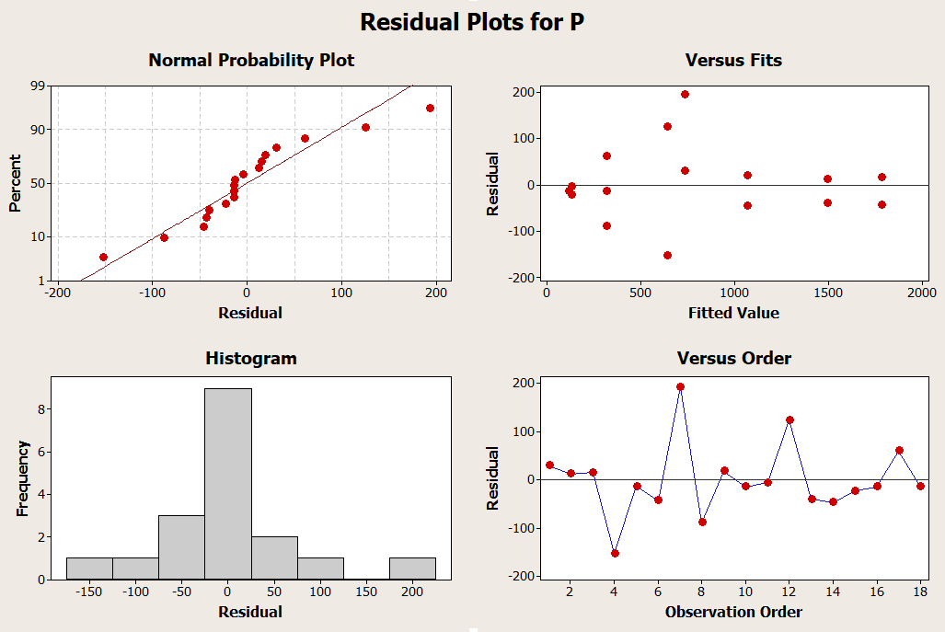
Figure 2. Residual plots.

Figure 3. Normalized plots of the standardized effects.

Significant factors for P | Significant factors for T
Significant factors for Fx | Significant factors for Fy
Significant factors for Rzl | Significant factors for Rzt
Figure 4. Significant effect for the various responses (power, temperature, and various forces).

The effects diagram reveals that some of the factor effects are larger than the other but not whether the results are real or chance. Normal probability is a graphical technique, based on the central theorem, where the points that are closer to the fitted lines would demonstrate no significant effect on the response variable and the points that are far away from the fitted line would represent the real effects. Figure 3 shows the normalized plots for the various standardized effects.

To identify these real effects normal probability plot is used and is shown in Figure 3. So the normal probability plot indicates that A, B, C and their interactions AC and BC are quite away from the fitted line, which is likely to represent the real factors on the response power.

Analysis of Variance

The ANOVA results in Table 4 show how much an estimate must differ from zero in order to be judged statistically significant. This analysis has been carried out of significance of 5% (a confidence interval of 95%). The main effects plot and interaction plots would also indicate significant factors and interaction effects. Table 4 shows the data means for the responses that were used.

Factorial analysis of the results was conducted using Minitab software. This analysis results in Table 4 in terms of the standardized effects of the process parameters and their interactions. The results clearly show that depth of cut generally is the most influential parameter in abrasive machining. It should also be noted that depth of cut was the main and only parameter that affected the machining temperature.

Table 4. Data means responses.
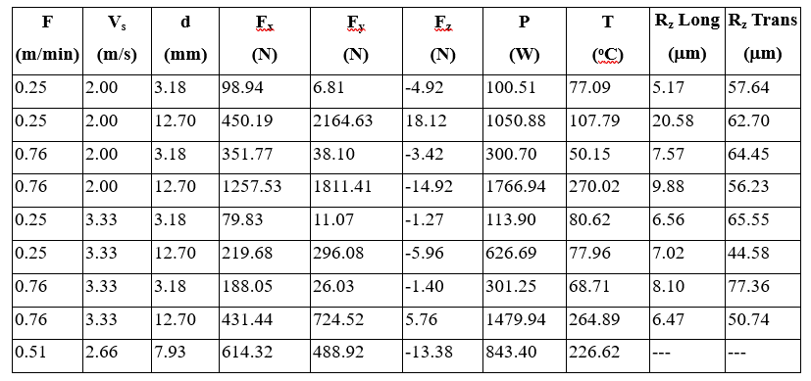

The surface roughness and feed force were also significant with the depth of cut. The other parameter (normal force, specific cutting energy, and longitudinal surface roughness) was secondary. The interaction between speed and depth of cut seems to be significant with most of the responses.

Table 5. Estimated standardized effects for the responses, α = 0.05.

 | Standardized Effect
Term | Fx | Fy | P | T | RzL | RzT
F | 345.0 | 30.4 | 489.21 | 28.86 | -1.827 | 4.579
Vs | 309.9 | -740.8 | -174.32 | -10.67 | -3.760 | -0.700
d | 410.1 | 1228.7 | 1027.02 | 159.74 | 4.138 | -12.686
F*Vs | 185.0 | 191.3 |  | 17.39 | 2.320 | 4.408
F*d | 164.5 | 7.2 | 295 | 48.29 | -3.797 | -4.731
Vs*d | -218.4 | -736.9 | -181.28 | -21.72 | -4.720 | -11.107
F*Vs*d | -112.7 | 199.5 |  | 9.87 | 2.755 | 1.910
R2 (adj) | 0.983 | 0.969 | 0.758 | 0.814 | 0.979 | 0.563

For the power response, P, the main effects plot for P shows,

- Strong positive effect on feed and depth of cut to the power with some negative effect for the speed
- The interactions between feed and speed do not affect the power and have strong interactions between depth of cut and feed
- Small interactions between depth of cut and speed
From the ANOVA results, it is concluded that the factors F, Vs, d, and their interactions F*d, and Vs*d have significant effect on power.

For the temperature response, the main effects plot for T shows,

- Strong positive effect on feed and depth of cut to the power and some negative effect for the speed
- The interactions between feed and speed do not affect the T and have strong interactions between depth of cut and feed, and also, the interactions between depth of cut and speed

From the ANOVA results it is concluded that the factors speed, feed, and depth of cut have significant effect on workpiece temperature.

A first-order regression model is predicted based on the behavior of the response parameter. The model includes the effects of process parameters and their interactions.

R = Const. + A*F + B*Vs + C*d + AB*F*Vs + AC*F*d + BC*Vs*d + ABC*F*Vs*d

Coefficients for this regression model are given in Table 5 for all responses.

Table 6. Regression model coefficients.
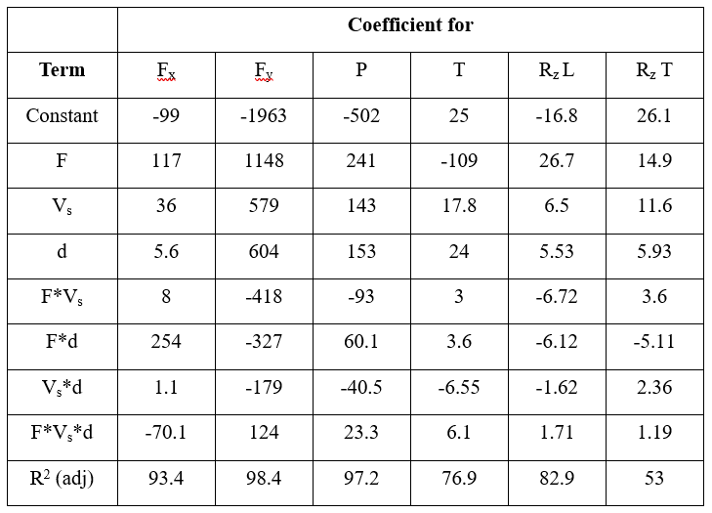

Conclusion and Recommendations

The effects of feed rate and spindle speed on diamond abrasive machining of carbon fiber reinforced polymers were studied. All the rough and finishing routing of carbon fiber reinforced polymer were performed under dry conditions. ANOVA was used to predict the results. The workpiece’s machinability was assessed based on the cutting force, temperature, energy, and surface roughness. The results of this study are as follows:

- The most significant factor influencing the machinability of composite fiber reinforced plastic laminate is the depth of cut, as there are multiple significant responses associated with it.
- Within the low cutting speed, the effect of feed rate was not significant.
- The high cutting speed and small depth of cut resulted in a low-level of cutting forces, cutting energy, and surface roughness.

References
Boudelier, A., Ritou, M., Garnier, S. & Furet, B. (2011). Optimization of process parameters in CFRP machining with diamond abrasive cutters. Advanced Materials Research, 223, 774-783.

Colligan, K., & Ramulu, M. (1999). Edge trimming of graphite=epoxy with diamond abrasive cutters. Journal of Manufacturing Science & Engineering, 12, 647-655.

Girot, F., Dau, F., & Gutiérrez-Orrantia, M. E. (2017). New analytical model for delamination of CFRP during drilling. Journal of Materials Processing Technology, 240, 332-343.

Kerrigan, K., Thil, J., Hewison, R., & O’Donnell, G. E. (2012). An integrated telemetric thermocouple sensor for process monitoring of CFRP milling operations. Procedia CIRP, 1, 449-454.

Lee, D. G., & Kim, P. J. (2000). Temperature rise and surface roughness of carbon fiber epoxy composites during cut-off grinding. Journal of Composite Materials, 34, 2061-2080.

Malkin, S. (1989). Grinding technology: Theory and applications of machining with abrasives. Society of Manufacturing Engineers.

Niu, B., Su, Y. L., Wang, F. J., Yang, R., & Sun, S. Y. (2016). Characterization of dynamic forces in orthogonal cutting of CFRPs. Paper presented at the 17th European Conference on Composite Materials, Munich Germany, June 26-30.

Rowe, W. B. (2009). Principles of modern grinding technology. Elsevier.

Soo, S. L., Shyhaa, I. S., Barnett, T., Aspinwall, D. K., & Sim, W.-M. (2012). Grinding performance and workpiece integrity when super abrasive edge routing carbon fiber reinforced plastic (CFRP) composites. CIRP Annals - Manufacturing Technology, 61, 295-298.

Yashiro, T., Ogawa, T., & Sasahara, H. (2013). Temperature measurement of cutting tool and machined surface layer in milling of CFRP. International Journal of Machine Tools & Manufacture, 70, 63-69.

Biographies

Dr. Jaby Mohammed is a faculty member at Illinois State University. He received his PhD in Industrial Engineering from University of Louisville (2006), master’s in Industrial Engineering from University of Louisville (2003) and also a master’s in business administration from Indira Gandhi National Open University (2001). His research interests include advanced manufacturing, design methodologies, six sigma, lean manufacturing, and engineering education. He previously taught at Khalifa University (UAE), Indiana Purdue Fort Wayne, IN, and at Morehead State University, KY. He is a member of IIE, SME, ASQ, ASEE, and Informs. His email address is jmohamm@ilstu.edu

Dr. Jamal Ahmad is an associate professor of mechanical engineering at the Petroleum Institute of Abu Dhabi. Prior to this, he was an associate professor of manufacturing engineering at Wichita State University. Dr. Ahmad teaches freshman design courses in addition to typical mechanical engineering curriculum. His research interests include manufacturing of composites, applications of composite materials in the aerospace and oil-gas industries, and teaching engineering design. His email address is jahmad@ku.ac.ae

