**# 157-M-20**

**Influence of Annealing Treatment on the Properties of Low-Temperature Silicon Nitride Films Produced by Inductively Coupled Plasma Chemical Vapor Deposition**

Qingzhou Xu

Morehead State University

[q.xu@moreheadstate.edu](mailto:q.xu@moreheadstate.edu)

**Abstract**

The silicon nitride (SiNx) thin films are synthesized at 170°C by inductively coupled plasma enhanced chemical vapor deposition. The as-deposited SiNx films are found to suffer high-density fixed charges and interface charge traps. This research is an effort to improve the properties of the as-deposited SiNx films by annealing treatment. The chemical, physical and electrical properties of the annealed SiNx films are characterized and compared with those of the as-deposited ones. The concentrations of both N-H and Si-H bonds decrease and, meanwhile, a small concentration of Si-O bonds are formed after annealing. No considerable changes are observed in the current density-voltage (J-V) behavior while the drastic changes happen in the capacitance-voltage (C-V) behavior. The flatband shift of the annealed films decreases significantly, revealing a drastic decrease in the fixed charge density. The interface state density of the annealed films also reduces significantly. For 800 W and 1000 W SiNx films, both the fixed charge and interface state densities decreases to the acceptable levels. Based on composition and chemical bond analyses, the possible explanation for these improvements is that hydrogen atoms migrate to the interface and chemically react with the interface traps during annealing, making them electrically inactive. Overall, the annealed 800 W’s silicon nitride film possesses the best combination of the chemical, physical and electrical properties adequate for practical device applications.

**Introduction**

Silicon nitride (SiNx) dielectric films have remarkable chemical, physical, mechanical and electrical properties and are the materials of choice for barrier, insulation, passivation and encapsulation layers for semiconductor devices and integrated circuits wherever high-quality native oxides are not available [1-18]. The SiNx films are made by plasma enhanced chemical vapor deposition (PECVD) and low-pressure chemical vapor deposition (LPCVD). The conventional PECVD method of a parallel-plate reactor is able to lower deposition temperatures to 250~350°C, as compared to at least 500°C needed by the LPCVD approach. However, the heat budget present in the conventional PECVD method is still too high for many emerging applications. Furthermore, because the substrate is placed on one of the two electrodes in the conventional PECVD reactor, the highly energetic bombardment of charged particles causes undesirable surface damages and high film stresses. As a result, there have recently been great interests in developing and utilizing low-temperature SiNx films for a variety of applications whereby low processing temperatures, surface damages, and film stresses are required.

Low-temperature SiNx films have found wide applications, and two main areas of these applications are nontraditional substrates [3-8, 11-13] and compound semiconductors [14-18]. One of the main interests in using nontraditional substrates is developing thin-film transistors (TFTs) and organic light-emitting diodes (OLEDs) on flexible plastics for light-weight, foldable displays [3-8]. The maximum working temperatures of most of the plastics are between 100 and 150°C, and even below 80°C in some cases. The poor electronic properties of the native oxides of III-V and II-VI compound semiconductors are well known. For example, As2O3 is unstable thermodynamically in the presence of GaAs and reacts to form As. Elemental As in turn produces near-mid-gap states that can pin down the Fermi level and enhances non-radiative recombination. Silicon dioxide films are prone to react with underneath semiconductor compounds and cause severe interface problems. In addition, III-V and II-VI semiconductor compounds are highly sensitive to ion bombardment and the non-congruent evaporation of volatile elements. The use of conventional PECVD SiNx films is usually undesirable due to the presence of high deposition temperatures and intense ion bombardment. The limitations associated with the existing techniques and those emerging demands give rise to the need of developing novel dielectric deposition techniques.

A number of deposition techniques have been developed to obtain high-quality SiNx films at low temperatures, along with decreased surface damages and controlled film stresses. High-density plasma is the most effective approach used to drive down deposition temperature. The evolving techniques based on using high-density plasma include electron cyclotron resonance plasma chemical vapor deposition (ECR-CVD) and inductively-coupled plasma-enhanced chemical vapor deposition (IC-PECVD). In the ECR-CVD and IC-PECVD reactors, the deposition zones are purposely separated from the plasma generation zones. This provides the possibility to minimize the surface damages due to energetic ion bombardment. There have been extensive researches on ECR-CVD [19-25]. It is reported that silicon nitride, silicon oxide and oxynitride films with good electrical properties can be deposited by the ECR-CVD technique at low temperatures of down to room temperature. Nonetheless, there are very limited reports on IC-PECVD and its films’ properties [2, 26].

This research work is to characterize the chemical, physical and electrical properties of annealed low-temperature SiNx films that are produced by IC-PECVD. It is part of the ongoing effort of developing high-quality dielectric thin films to passivate high electron mobility transistor (HEMT) integrated circuits at decreased temperatures and low ion bombardment. Lowering deposition temperatures makes it possible to avoid or minimize the alloying of the Schottky gate, the inter-diffusion and dopant redistribution of the multilayer structure, and the incongruous evaporation of volatile elements in HEMTs. From the perspective of minimizing the plasma-induced surface damages, a low microwave power deposition is preferred, but it may lead to poor-quality films because of less thorough chemical reaction. Thus, three RF powers are used in this research to study the effect of the deposition microwave power on the films’ properties. As revealed in the initial research results [27], all the as-deposited low-temperature SiNx films synthesized under three RF power condition are characterized with high-density fixed charges and interface charge traps, making the films unsuitable for practical device applications. In addition, lowering the deposition temperature favors the incorporation of hydrogen atoms. The migration of movable hydrogen atoms in the films results in long-term instability. As a result, post-deposition annealing treatment is needed to decrease the defects produced in low-temperature deposition, improve the electrical properties and mitigate the reliability concern. The focus of this paper is on the influence of the final device stability annealing treatment on the properties of the low-temperature silicon nitride films.

# Experimental Methods

The silicon nitride films in this research were made on silicon wafers at 170°C by using inductively coupled plasma enhanced chemical vapor deposition (IC-PECVD). A schematic diagram of the system is shown in Figure 1. A 13.56 RF power source is inductively coupled into the tubular reactor by an antenna wound around. Solenoidal magnets are uniformly distributed along the bottom of the reaction chamber, which help to sustain a high dissociation rate. Prior to deposition, Si wafers were stripped of native oxides by using dilute HF solution. N2 was used instead of NH3 in the deposition of silicon nitride films, thus providing the likelihood of reducing hydrogen concentration in silicon nitride films. Hydrogen atoms were considered one of the reasons causing a change of long-term dielectric properties. The reaction chamber utilized two separated sets of gas inlets. N2 was injected into the chamber from the top gas inlets; SiH4 was introduced by the side gas inlets that were radially distributed above the substrate chuck. Biasing the substrate chuck was independent of the generation of plasma, and a null bias was used to decrease the surface damages resulted from ion bombardment.

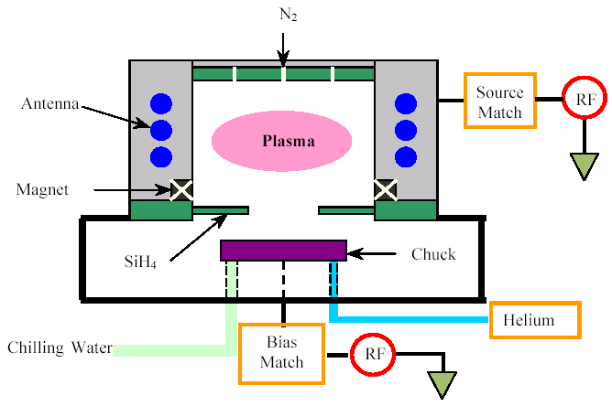

Figure 1: Schematic diagram of the ICPECVD reactor.

The SiNx films were annealed at 240°C for 48 hours in protective gases, a standard procedure used to improve the long-term stability of high electron mobility transistors (HEMTs) and their IC circuits, especially for high-power and space applications. The chemical bonds of the low-temperature silicon nitride films were analyzed by Fourier transform infrared (FTIR) spectroscopy. The wet etching property of the films was tested in a commercialized buffered oxide etch (BOE) solution at room temperature. The density of pin holes was evaluated by KOH etching at 70°C for 3 hours. The surface roughness of the silicon nitride films were measured by using atomic force microscopy (AFM). The refractive index of the silicon nitride films was measured by using laser ellipsometry.

The electrical properties of the low-temperature silicon nitride films were measured by using a metal-insulator-semiconductor (MIS) structure [28-30]. A mercury probe was used to make contact directly on the silicon nitride films to form a MIS structure for capacitance-voltage (C-V) measurements. Because meaningful quasi-static C-V curves were not obtained successfully, the high-frequency method was used to characterize the low-temperature silicon nitride films [28]. The dielectric constant of the films was determined by measuring metal-nitride-metal capacitance for calculating the ideal C-V curve of the MIS structure. High-frequency (1 MHz) C-V measurements used a sweep rate of 0.1 V/s, starting from accumulation to strong inversion and then reversely sweeping back. For current density-voltage (J-V) measurements, Ti/Cu films were e-beam evaporated and patterned to a series of square pads ranging from 50×50 μm2 to 10×10 mm2 by wet etching. These electrode pads of J-V measurements were randomly distributed on 4” silicon wafers so that the measured values could best represent the properties of the low-temperature silicon nitride films. The polarity was chosen in order to operate MIS capacitors in accumulation so that a depletion zone in the semiconductor was avoided. Ti/Cu films were also deposited onto the backsides of the silicon wafers. Both C-V and J-V measurements were performed by using Agilent semiconductor parameter analyzer B1500A.

**Results**

The following are the experimental results about the influence of post-deposition annealing treatment on the properties of the low-temperature silicon nitride films. Some relevant results in the as-deposited condition are included for the sake of comparison.

**1) Influence on Chemical Bonds**

The chemical bonding structures of the low-temperature silicon nitride films are studied by Fourier transform infrared spectroscopy (FTIR), as shown in Figure 2. Except the predominant absorption peak for the stretching vibration mode of the Si-N bond near 840 cm-1, other three major peaks are identified for the N-H stretching vibration mode around 3340 cm-1, the Si-H stretching vibration mode near 2200 cm-1, and the N-H bending vibration mode at 1180 cm-1. As aforementioned in the section of experiments, the low-temperature silicon nitride films are made by using N2 and SiH4. Although the N-H bond structure does not exist in the source gases, the N-H bonds are formed during the chemical reaction in the deposition process. There is slight variation in the area of an absorption peak among the three power conditions. The peak area for the same bond and vibration mode decreases with increasing microwave power, and this trend is more apparent at the stretching vibration mode at 3340 cm-1 and the bending vibration mode at 1180 cm-1 of the N-H bond.

By comparing the spectra of the as-deposited and annealed silicon nitride films, the peak area at the same vibration mode for the chemical bond of N-H or Si-H slightly decreases after the annealing treatment. This is evident for the N-H stretching vibration mode at around 3340 cm-1 and the N-H bending vibration mode at 1180 cm-1, and these two peaks become almost indiscernible (in Figure 1b). After annealing, a trace of absorption occurs at 1070~1090 cm-1, and the location of this absorption peak coincides with that of the absorption peak of the Si-O stretching vibration mode. Because the trace of this kind of absorption is not observed in the measured spectra of the as-deposition films, a possible explanation is that oxidation has occurred during the annealing treatment.

For comparison, Figure 2 also includes the measured result of a silicon nitride film made at 250°C by using a conventional parallel-plate reactor, PlasmaTherm 790 PECVD system, with the gas sources of NH3 and SiH4. The absorption peaks of the N-H bonds are more pronounced for the PlasmaTherm film than for the low-temperature films. On the other hand, the absorption peaks of the Si-H bond are larger for the low-temperature films than for the PlasmaTherm film. This observation is in agreement with the fact that the low-temperature films are made of N2 and SiH4, and it is less likely for H atoms to exist in a form of N-H bond.



(b) Annealed

(a) As-Deposited

Figure 2: FTIR spectra of (a) the as-deposited and (b) the annealed silicon nitride films.

Since the area of an absorption peak is proportional to the concentration of the corresponding atomic bonds, several conclusions can be drawn from the FTIR analyses. The low-temperature silicon nitride films incorporate a lower concentration of N-H bonds but a higher concentration of Si-H bonds than the conventional PECVD film. The low-temperature silicon nitride films have more Si-H bonds under a lower microwave power than under a higher microwave power. This happens maybe because, under a lower microwave power, the smaller disassociation rate of SiH4 favors more hydrogen retention in a form of Si-H. After annealing, the concentrations of both N-H and Si-H bonds decrease and, meanwhile, a small concentration of Si-O bonds are formed. It is known that Si-H bonds in silicon nitride play a dominant role in determining the trapped electron density in the silicon nitride.

**2) Influence on Pin-Hole density, Wet Etching Property and Surface Roughness**

Pinholes are tiny structure defects happening in thin dielectric films made by all kinds of chemical or physical vapor deposition techniques. In this research, the pinholes are exposed through large etched pits on silicon wafer surfaces that are obtained by KOH etching at 70°C for 3 hours and then removing the silicon nitride films by BOE. Figure 3 shows the typical diamond-shaped etched pits, which are taken from the edge area of a silicon wafer where there is higher pinhole density.

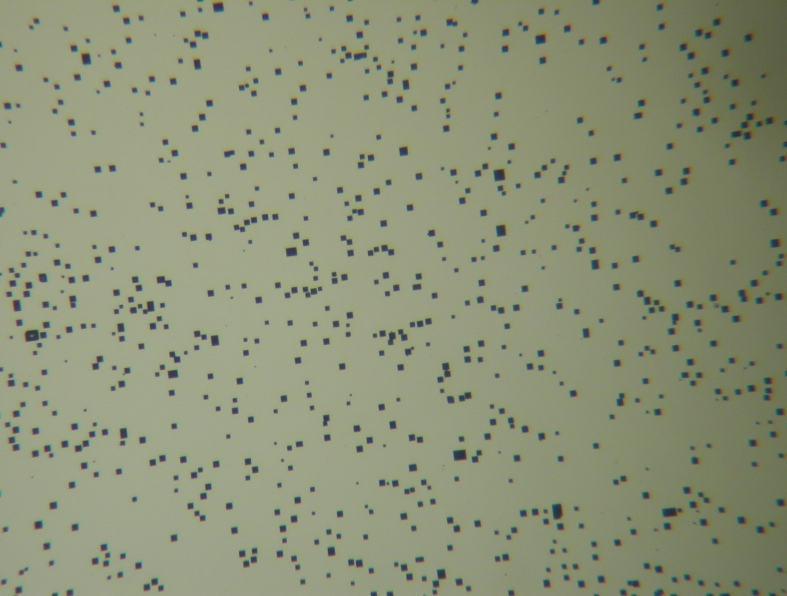

Figure 3: Etched pits on the Si wafer surface after the SiNx film is stripped.

The density of pin holes depends on processing parameters and is also strongly related to the thickness of a dielectric film. For the low-temperature silicon nitrides, when film thickness is larger than 2000 Å, there are few pinholes to show up. Thus, a 750 Å film thickness is chosen to evaluate the differences in the density of pin holes between the three microwave power conditions. The results show that, for each of the power conditions, the distribution of pin holes is not uniform on the wafer. The density of pin holes is much higher in the narrow edge region of about 0.5 cm wide. It is small and relatively uniform in the remaining central area but still has certain fluctuation. Figure 4 is the comparison of the pinhole density in the films under three RF powers in the as-deposited and annealed conditions. The result indicates that the annealing treatment has very limited impact on the pinhole density. The small differences are most likely due to counting errors.

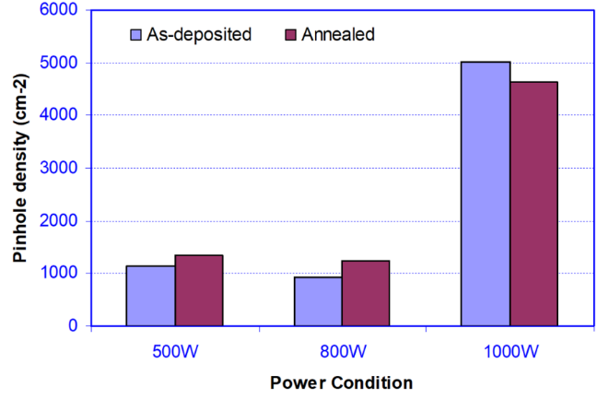

Figure 4: Pinhole densities in the as-deposited and annealed conditions.

Wet etching property is closely related to the composition, chemical bonding stability and mass density of a dielectric film and it is also important for device microfabrication. The wet etching property of the low-temperature silicon nitride films in the as-deposited and annealed conditions is tested and compared in a commercialized BOE solution at room temperature. There are not observable differences in the wet etching rate in these films between the as-deposited and annealed conditions. The surface roughness of the films in the as-deposited and annealed conditions is also measured and compared by AFM; and the annealing treatment is found to have minimal impact.

**3) Influence on Breakdown Strength, Leakage current and Resistivity**

Figure 5(a) shows a group of typical J-V curves of the low-temperature silicon nitrides. The figure uses a logarithm/square-root coordinate system for the convenience to ascertain the electrical conduction mechanism. The curves are obtained from four 200μm×200μm measurement electrode pads randomly distributing on an 800 W SiNx film. A distinctive characteristic of the J-V curves is that the film experiences abrupt breakdown, a feature of avalanche breakdown. The breakdown does not happen at a precise value but in a range of electrical field strengths, from 5.4 to 7.9 MV/cm for this specific sample. The average breakdown electrical field strength based on these four measurements is 6.02 MV/cm.

 

(a)

(b)

Figure 5: J-V curves of a low-temperature silicon nitride film: (a) the complete curves on a logarithm and square-root coordinate; (b) the low electrical part of the curves on a linear coordinate system.

The J-V curves in Figure 5(a) can be divided into several distinct regions that can be associated with different mechanisms of electron conduction. The linear region in the high electrical field can be interpreted by the synergistic effect of Schottky and Frenkel-Poole electron emissions [28-30]. For both the Schottky and Frenkel-Poole emissions, the logarithm of the current density has a linear relationship with the square root of the electrical field, as shown in Figure 5(a).

In the low electrical field, the electron emission mechanisms driven by high electrical fields are inactive; the movement of conductive carriers follows the ohmic law [28-30]. The current density has a linear relationship with the electrical field strength. It can be readily proved by redrawing the data in the low electrical field on a linear coordinate system of the current density and the electrical field, as showed in Figure 5(b), where the data points are the measurement values and the lines are the results of regression analysis. The data points of each measurement distribute well along a straight line, and this confirms that ohmic conduction is the dominant conduction mechanism for the film in the low electrical field. The inverses of the slopes of the regression lines are the resistivity of the silicon nitride film, which possesses certain fluctuation for different electrode pads. The average resistivity of the silicon nitride film is calculated to be 1.12×1014 Ω⋅cm.

Between the ohmic conduction and Schottky/Frenkel-Poole emission regions exists a transient region. Beyond the Schottky/Frenkel-Poole emission region, the silicon nitride film experiences avalanche breakdown.

Leakage current is another important parameter for use of a dielectric film. In Figure 5a, except in the regions after the dielectric’s breakdown, the measured J-V curves from the different electrode pads of the same size are coincident to one another. Thus, in contrast to the large fluctuation in breakdown strength, the leakage current has very limited variation between the different electrode pads of an identical size. Because most of field-effect devices work at an electric filed strength of around 2 MV/cm, the leakage current density at 2 MV/cm is interesting for practical applications and is usually used for comparison. At 2 MV/cm, the leakage current density of the silicon nitride film is 2.28×10-8 A/cm2.

The breakdown strength, or the breakdown electrical field strength in full name, is a critical parameter of a dielectric film for practical utilization. The breakdown strength is an intrinsic materials property determined by the dielectric film itself. However, due to the presence of fringe electrical field, pin holes and other imperfects, the measured values of breakdown strength vary with the size of electrode pads used for measurement as well as the thickness of the dielectric film (thickness is not considered here). The influence of the electrode pads’ size on the breakdown strength, which has been ignored in reporting dielectrics’ properties in the majority of published literature, has been carefully evaluated in this present research. This is also an attempt to figure out the root cause responsible for the breakdown of the low-temperature silicon nitride films. Figure 6 shows the measured J-V curves from different-size electrode pads on the same silicon nitride film that is made under the 800 W power condition. The measured breakdown strength increases with a decrease in the size of electrode pad for the same silicon nitride film. This result reveals that it is important to compare and judge the dielectrics’ properties by using the measured values from the measurement electrode pads of an identical size. This is used as the criterion when comparing the properties of the low-temperature silicon nitride films in this research.



Figure 6: Breakdown strengths of different-size measurement electrode pads.

The breakdown strength, leakage current and resistivity of the silicon nitride films in the annealed condition are measured and compared with those in the as-deposited condition. The measured results indicate that the annealing treatment has negligible influences on all these three properties. Figure 7 shows the influence of annealing treatment on the breakdown strengths of the SiNx films made in the 500 W, 800 W and 1,000 W power conditions. The variations of breakdown voltage have no clear trend and are not significant.

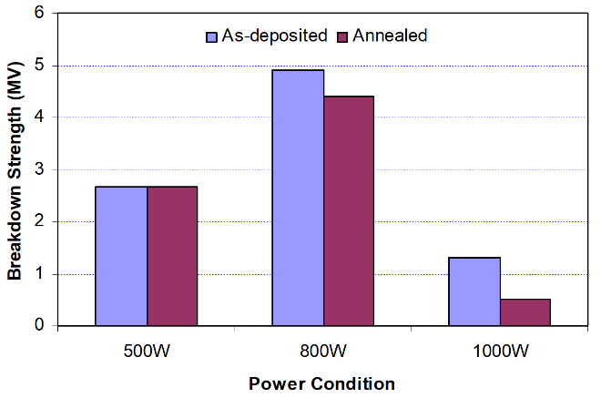

Figure 7: Breakdown strengths of the as-deposited and annealed SiNx films.

**4) Influence of interface charge trap levels and fixed charges**

There are two types of defects related to the imperfect chemical bonding structure of a dielectric film: fixed charges and interface traps. Fixed charges refer to localized charge centers that cannot change their charge states under the influence of an external electrical field. Interface traps refer to the interface sites that can change their electrons’ occupancy through an exchange of mobile carriers under the influence of an external electrical field. Each of interface traps has one or more energy levels. Because the chargeable interface sites are not close to one another enough to create a continuous energy band, they form a series of discrete energy levels within the silicon’s bandgap. As a result, interface traps are quantified as an interface trap level density per electron volt, which varies with the location in the bandgap. Interface trap levels below the Fermi level are full, and those above are empty. The density of interface trap energy levels is measurable near midgap of the silicon bandgap. Both fixed charges and interface traps must be controlled and minimized. Otherwise, they can adversely affect device performance.

Figure 8 shows the measured C-V curves of the as-deposited silicon nitride films that are produced under the three microwave power conditions of 500, 800, and 1000 W. The figure also includes the values of flatband shift and hysteresis width for each of the curves. All these three curves have a significant flatband shift, indicating the presence of high-density fixed charges. The silicon nitride films made at 500 and 1000 W are hardly able to reach the saturated capacitance at accumulation, indicating the existence of high-density interface trap levels near the edge of the silicon bandgap. These chargeable interface traps effectively screen out the external electrical field and prevent the silicon’s surface layer from reaching accumulation. There are significant differences in the hysteresis width. The hysteresis observed is related to the charge capture/release processes of the interface traps with a large time constant, i.e., the sluggish interface traps. The charge state of the sluggish interface traps cannot follow but lag behind the change in gate bias, leading to hysteresis. The narrow hysteresis of the high-frequency C-V curve of the 500 W silicon nitride film indicates a low level of sluggish traps at the SiNx/Si interface. The non-symmetry in hysteresis of the 800W’s C-V curve is because the kinetics of charge capture/release is asymmetrical and the capacitance value depends on the direction of the bias voltage variation.

 

(c)

(b)

(a)

Figure 8: C-V curves of the as-deposited low-temperature silicon nitride films produced at the microwave powers of (a) 500 W; (b) 800 W; and (c) 1000 W.

The densities of fixed charges and interface charge traps were calculated by using the curves in Figure 7. Table 1 summarizes the calculated results of the as-deposited silicon nitride films produced under the three microwave conditions.

**Table 1:** Calculated interface charge trap levels and fixed charges of the as-deposited SiNx films

|  |  |  |
| --- | --- | --- |
| Power Condition (W) | Interface States at midgap (cm-2eV-1) | Fixed Charges* (cm-2) |
| 500 | 3.47×1011 | 1.21×1012 |
| 800 | 8.80×1011 | 1.33×1012 |
| 1000 | 4.52×1011 | 1.06×1012 |

* Fixed charges include the charged interface states.

Figure 9 shows the measured C-V curves of the same silicon nitride films used for the measurements of Figure 8 but annealed. As compared with those in the as-deposited condition, the flatband shifts of all the three silicon nitride films in the annealed condition drastically decrease, indicating a significant decrease in the density of fixed charges. All the C-V curves become much more vertical, implicating a decrease in the density of interface charge trap levels across the silicon’s bandgap. The capacitance of the 1000 W silicon nitride now can readily reach the saturation value at accumulation, representing a low density of interface charge trap levels near the edge of the silicon bandgap. The silicon nitride film made at 500 W remains difficult to reach the saturated capacitance at accumulation. There are also significant changes in the hysteresis shape and width of these C-V curves. The asymmetrical hysteresis of the 800 W C-V curve becomes symmetrical. The hysteresis widths of the annealed 800 and 1000 W silicon nitrides are deceased to be nearly half of those values in the as-deposited condition. However, the hysteresis width of the annealed 500 W film increases significantly.



(c)

(b)

(a)

Figure 9: C-V curves of the annealed low-temperature silicon nitride films produced at the microwave powers of (a) 500 W; (b) 800 W; and (c) 1000 W.

Table 2 is the calculated results of the annealed silicon nitride films. By comparing with those in Table 1, the densities of both the interface charge trap levels and the fixed charges have been decreased significantly. The densities of the interface charge trap levels and the fixed charges of the 800 W and 1000 W silicon nitride films have reached the levels acceptable for practical applications in semiconductor devices.

**Table 2:** Calculated interface charge trap levels and fixed charges of the annealed silicon nitrides

|  |  |  |
| --- | --- | --- |
| Power Condition (W) | Interface States at Midgap (cm-2eV-1) | Fixed Charges (cm-2) |
| 500 | 1.63×1011 | 1.74×1011 |
| 800 | 2.60×1010 | 8.13×109 |
| 1000 | 3.26×1010 | 6.80×109 |

* Fixed charges include the charged interface states.

**Discussion**

The annealing treatment has a profound influence on the density and property of interface charge traps in the low-temperature silicon nitride films. The density of interface charge traps decreases significantly. The kinetics of charge capture/release becomes more symmetrical. The density of sluggish interface charge traps increases or decreases, depending on the microwave power conditions used for deposition. Like the silicon nitrides by all the other thermal, chemical and physical deposited approaches, the low-silicon nitride films by IC-PECVD incorporate hydrogen atoms in the form of N-H and Si-H bonds. It is known that N-H and Si-H bonds in silicon nitride play a role in determining the density of interface charge traps in the silicon nitride films. An amphoteric behavior for N-H and Si-H centers in silicon nitride has been suggested. The charge trapping role of these amphoteric bonds could be giving rise to the large stretch-out and hysteresis of the C-V curves observed in the low-temperature silicon nitride films.

FTIR analyses reveal that the N-H and Si-H bonds are not stable in the annealing treatment. After annealing, the concentrations of both N-H and Si-H bonds decrease and, meanwhile, a small concentration of Si-O bonds are formed. Although the chemical mechanism by which interface charge traps are deactivated and annihilated during annealing is unknown, it is believed that the change in the density and property of interface charge traps is related to the change in the concentrations of both N-H and Si-H bonds and the formation of Si-O bonds.

The density of fixed charges in the low-temperature silicon nitride films also decreases significantly after annealing. Fixed charges are generally related to unsaturated dangling Si bonds. The unsaturated dangling bonds usually happen at the interface due to the sudden structure termination of silicon nitride and silicon crystals. They also appear inside the silicon nitride films as a result of structure imperfects occurring during deposition. Similar to the interface charge traps, the exact mechanism that causes a decrease in the density of fixed charges during annealing is unidentified. It is generally believed that hydrogen plays an important role in passivating the unsaturated dangling Si bonds. The migration of hydrogen atoms during annealing is supported by the FTIR results. Also based on the FTIR analyses, the decrease in the density of fixed charges after annealing may be related to the oxidation reaction during annealing. The oxidation reaction is presumed to have saturated and neutralized the dangling bonds.

Among the low-temperature silicon nitride films made under the three microwave power conditions, the 800 W’s film possesses the best combination of the chemical, physical and electrical properties. The optimal electrical properties of a dielectric layer for most high-performance modern integrated circuits are a leakage current of ~10-6 A/cm2 at 2 MV/cm, a breakdown strength from 6 to 10 MV/cm, an oxide fixed charge density in the low 1010 cm-2 range, and an interface charge trap level density near midgap in the low 1010 cm-2 eV-1 range. Hence, the annealed 800 W’s SiNx film in this research is adequate for practical integrated circuits in terms of resistance, leakage current, breakdown strength, and the densities of fixed charges and interface charge traps.

**Conclusion**

The annealing treatment has limited influences on breakdown strength, leakage current and resistivity but significantly decreases the densities of fixed charges and interface states in all the SiNx films made under the three power conditions. After the annealing treatment, the concentrations of both N-H and Si-H bonds decrease and, meanwhile, a small concentration of Si-O bonds are formed. It is believed that the significant decreases in the densities of interface charge traps and fixed charges are related to the change in the concentrations of both N-H and Si-H bonds and the formation of Si-O bonds. Overall, the 800 W’s silicon nitride film in the annealed condition possesses the best combination of the chemical, physical and electrical properties good enough for practical device applications.

**Acknowledgment**

The author would like to thank for the support of a Morehead State University-funded creative production grant and a NSF MRI fund.

**References:**

1 Andringa, A.-M., Perrotta A., de Peuter, K., Knoops, H. C. M., Kessels, W. M. M. and Creatore, M. (2015). Low-Temperature Plasma-Assisted Atomic Layer Deposition of Silicon Nitride Moisture Permeation Barrier Layers. *ACS Appl. Mater. Interfaces*, V7, I40, 22525–22532.

2 Nyaupane, P., Bodas, D., Duttagupta, S. P. and Gangal, S. A. (2011). Deposition and characterization of low temperature silicon nitride films deposited by ICP-CVD., *Applied Surface Science*, 257, 5052-5058.

3 Stryahilev, D., Sazonov, A. and Nathan, A. (2002). Amorphous silicon nitride deposited at 120°C for organic light emitting display-thin film transistor arrays on plastic substrates. *Journal of Vacuum Science & Technology A Vacuum Surfaces and Films*, V20(3), pp.1087-1090.

4 Parka, K. J. and Parsons, G. N. (2004). Bulk and interface charge in low temperature silicon nitride for thin film transistors on plastic substrates. *Journal of Vacuum Science & Technology A: Vacuum Surfaces and Films*, V22(6), 2256-2260.

5 Hekmatshoara, B., Cherenack, K. H., Kattamis, A. Z., K. Wagner, L., S. and Sturm, J. C. (2008). Highly stable amorphous-silicon thin-film transistors on clear plastic. *Appl. Phys. Lett.*, V93, 032103-032105.3.

6 Li, F. M., Nathan, A., Wu, Y. and Ong, B. S. (2007). Organic thin-film transistor integration using silicon nitride gate dielectric. *Appl. Phys. Lett.*,V90(13), 133514-133516-3.

7. Sazonov, A., Striakhilev, D., Lee, C-H. and Nathan, A. (2005). Low-Temperature Materials and Thin Film Transistors for Flexible Electronics. *Proceedings of the IEEE*, V93, N8, 1420-1428.

8 Suzuki, N, Cervera, R. B., Ohnishi, T. and Takada, K. (2013). Silicon nitride thin film electrode for lithium-ion batteries. *Journal of Power Sources*, V231, N1, 186-189.

9 Shao, Z., Chen, Y., Chen, H., Zhang, Y., Zhang, F., Jian, J., Fan, Z., Liu, L., Yang, C., Zhou, L. and Yu, S. (2016). Ultra-low temperature silicon nitride photonic integration platform. Optics Express V24, I3, 1865-1872.

10 Cen, Z. H., Chen, T. P., Ding, L., Liu, Y., Wong, J. I., Yang, M., Liu, Z., Goh, W. P., Zhu, F. R. and Fung, S. (2009). Strong violet and green-yellow electroluminescence from silicon nitride thin films multiply implanted with Si ions. *Appl. Phys. Lett.,* V94(4); pp. 041102-041102.3.

11. Heya, A., Niki, T., Takano, M., Yonezawa, Y., Minamikawa, T., Muroi, S., Minami, S., Izumi, A., Masuda, A., Umemoto, H. and Matsumura, H. (2004). Effect of Atomic Hydrogen on Preparation of Highly Moisture-Resistive SiN*x* Films at Low Substrate Temperatures. *Japanese Journal of Applied Physics*, V43, N12A, L 1546–L 1548,

12. Takano, M., Niki, T., Heya, A., Osono, T., Yonezawa, Y., Minamikawa, T., Muroi, S., Minami, S., Masuda, A., Umemoto, H. and Matsumura, H. (2005). Preparation of Low-Stress SiN*x* Films by Catalytic Chemical Vapor Deposition at Low Temperatures. *Japanese Journal of Applied Physics,* V44, N6A, 4098–4102.

13. Huang, W., Wang, X., Sheng, M., Xu, L., Stubhan, F., Luo, L., Feng, T., Wang, X., Zhang, F., Zou, S. (2003). Low Temperature PECVD SiNx Films Applied in OLED Packaging. *Materials Science and Engineering*, B98, 248-254.

14. Jin, Z., Prost, W., Neumann, S., and Tegude, F.-J. (2004). Comparison of the Passivation Effects On Self- And Non-Self-Aligned InP/InGaAs/InP Double Heterostructure Bipolar Transistors By Low-Temperature Deposited SiNx. *J. Appl. Phys.*, V96, Issue 1, 777-783.

15. Lee, J. W., Mackenzie, K., Johnson, D., Shul, R. J., Pearton, S. J. and Ren, F. (1998). Low Temperature ECR-CVD of SiNx for III-V Device Passivation. *Solid-State Electronics*, V42, N6, 1031-1034.

16. Lee, J. W., Mackenzie, K., Johnson, D. D., Shul, R. J., Pearton, S. J., Abernathy, C. R. and Ren, F. (1998). Device Degradation During Low Temperature ECR-CVD. Part II: GaAs/AlGaAs HBTs. *Solid-State Electronics,* V42, N6, 1021-1025.

17. Lee, J. W., Mackenzie, K., Johnson, D. D., Shul, R. J., Pearton, S. J., Abernathy, C. R. and Ren, F. (1998). Device Degradation During Low Temperature ECR-CVD. Part III: GaAs/InGaP HEMTs. *Solid-State Electronics*, V42, N6, 1027-1030.

18. Jin, Z., Neumann, S., Prost, W., Tegude, F.-J. (2005). Passivation of InP/GaAsSb/InP Double Heterostructure Bipolar Transistors with Ultra Thin Base Layer by Low-Temperature Deposited SiNx. *Solid-State Electronics,* 49, 409–412.

19. Garcia, S., Martin, J. M., Martil, I., Fernandez, M., Gonzalez-Diaz, G. (1998). Deposition Of Low Temperature Si-Based Insulators By The Electron Cyclotron Resonance Plasma Method. *Thin Solid Films*, 317, 116–119.

20. Flewitt, A. J., Dyson, A. P., Robertson, J., and Milne, W. I. (2001). Low Temperature Growth Of Silicon Nitride By Electron Cyclotron Resonance Plasma Enhanced Chemical Vapour Deposition. *Thin Solid Films*, 383, 172-177.

21. Bae,S., Farber, D. G. and Fonash, S. J. (2000). Characteristics Of Low-Temperature Silicon Nitride (SiNx:H) Using Electron Cyclotron Resonance Plasma. *Solid-State Electronics*, 44, 1355-1360.

22. Delmotte, F., Hugon, M. C., Agius, B., and Courant, J. L. (1997). Low Temperature Deposition of SiNx:H Using SiH4–N2 or SiH4–NH3 Distributed Electron Cyclotron Resonance Microwave Plasma", J. Vac. Sci. Technol. B 15(6), 1919-1926.

23. Hugon, M. C., Delmotte, F., Agius, B., and Courant, J. L. (1997). Electrical Properties of Metal–Insulator–Semiconductor Structures with Silicon Nitride Dielectrics Deposited by Low Temperature Plasma Enhanced Chemical Vapor Deposition Distributed Electron Cyclotron Resonance", *J. Vac. Sci. Technol. A*, 15(6), 3143-3153.

24. Pool, F. S. (1997). “Nitrogen Plasma Instabilities and the Growth of Silicon Nitride By Electron Cyclotron Resonance Microwave Plasma CVD. *J. Appl. Phys.* V81, Issue 6, 839-2846.

25. Isai, G. I., Holleman, J., Wallinga, H. and Woerlee, P. H. (2004). Low Hydrogen Content Silicon Nitride Films Deposited at Room Temperature with an ECR Plasma Source. *Journal of the Electrochemical Society*, 151(10), C649-C654.

26. Zamboma, L. and Mansano, R. D. (2003). Silicon Nitride Deposited By Inductively Coupled Plasma Using Dichlorosilane and Ammonia. *Vacuum*, 71, pp.439–444.

27. Xu, Q., Ra, Y., Bachman, M. and Li, G. P. (2009). Characterization of low-temperature silicon nitride films produced by ICP-CVD. *J. Vac. Sci. Technol. A*, V27(1), pp. 145-156.

28. Muller, R. S. and Kamins, T. I. (1986). *Device Electronics for Integrated Circuits, 2nd ed*. (Wiley, New York).

29. Nicollian, E. H. and Brews, J. R. (1982). *MOS (Metal Oxide Semiconductor) Physics and Technology* (Wiley, New York).

30. Sze, S. M. (1981). *Physics of Semiconductor Devices, 2nd ed.* (Wiley, New York).

**Biographies**

**Qingzhou Xu** received a bachelor's degree in materials science and engineering from Harbin Institute of Technology in China in 1989. He earned a master's degree in materials science and engineering from Beijing University of Science and Technology in 1992, and his Ph.D. in materials science and engineering from the University of California, Irvine in 2000. He has worked as an engineer in the Chinese Academy of Science Mechanics Institute in Beijing, China and the Chinese National Engineering Center of Composites, both in Beijing, China and the RF Integrated Corporation in California. His early study and work experience includes structural materials (light alloys and refractory metals), engineering functional materials (hard/soft magnetic materials, hydrogen-storage materials for rechargeable battery and non-lead soldering materials) and thin films. His recent study and work experience are mainly on semiconductor materials and processing, III-V compound device passivation, high-speed transistor (HBTs and HEMTs) processing and characterization, micro-electro-mechanical systems (MEMS), magnetostatic actuators and electrostatic switches, nanolithography and nano-devices. His current interests focus on using materials science knowledge to solve the reliability issues in the areas of RF MEMS switches (thin-film stress control, reliable switch contacts and novel switch architecture with enhanced reliability) and III-V compound transistors (high-performance ohmic contacts and device passivation) as well as developing novel nano-layered and nanostructured materials. He has first authored more than 30 journal and conference papers.