059-T-20

Design and Implementation of a Novel Water Level Control System

Jean Jiang
Purdue University Northwest
jjiang@pnw.edu

Benjamin Solano
Purdue University Northwest
Bsolano@pnw.edu

Turki Olyan
Purdue University Northwest
Tolyan@pnw.edu

Abstract

We present our new water level control system by sensing the water level in a tank and using a microcontroller for water level control. The designed system will reduce human effort, consume less overall power, and create a simpler and more reliable way to monitor and control the water level of a tank. In addition, we will aim to complete this system with lower cost. This project is topical and significant in the way that it reduces human effort and increases safety because the microcontroller system directly controls the motor and the water level automatically. In addition, system will also consume less power than ordinary systems. It will also prove to be simpler and more reliable as the number of human error cases will be minimized. Specifically the system will detect and control the water level in an overhead tank or any other container, that is, the system monitors the water level of the tank and automatically switches ON the motor whenever tank is empty. The motor will be switched OFF when the overhead tank or container is FULL. The water level of the tank is indicated on a LCD (Liquid Crystal Display). Using this system, we can avoid overflow of the water. When the tank is empty, LCD will display the message LOW and motor runs automatically to pump the tank or container. When water level reaches to half level, the LCD displays HALF but the motor still runs. However, when the tank is full, LCD displays FULL and motor automatically stops the pump. The motor runs again whenever water level in the tank becomes LOW. We use an Arduino Nano (an inexpensive microcontroller) as the central controller to control the different units in the entire system including a sonar sensor (overhead tank sensor), a LCD display, a buzzer to notify when the sump tank is empty, and a water pump. Finally, the designed system can automatically monitor and detect the water level of the tank, control the water motor to pump the water into the tank to FULL level, and display the water level of the tank on a Liquid Crystal Display (LCD).

I. Introduction

In this paper, we will develop and design a novel water level control system which reduces human effort, consumes less overall power, and creates a simple and more reliable way to monitor and control the water level of a tank. The system monitors and controls the water level using a microcontroller. This design would be of particular use in big industry and/or buildings where manual monitoring is challenging and in any industry that requires automatic liquid level control. In addition, we will aim to complete this system while meeting the $600 constraint. The desired system will automatically control a water motor by sensing the water level in a tank. This system will detect and control the water level in an overhead tank or any other container. In particular, this system monitors the water level of a tank and automatically switches ON the motor whenever tank is empty. The motor will be switched OFF when the overhead tank or container is FULL. The water level of the tank is indicated on LCD (Liquid crystal Display). Using this system, we can avoid overflow of the water. When the tank is empty, LCD will display the message LOW and motor runs automatically. When water level reaches to half level, the LCD displays HALF and the motor still runs. When the tank is full, the LCD displays FULL and motor automatically stops. Then the motor runs when the water level in the tank becomes LOW.

The paper contains the following steps. We first present the system structure; then, we demonstrate the system layout and design. Finally, we propose possible improvement of the system and the future work.

II. Structure of the System

In this section, we describe an on/off water level control system which includes an Arduino Nano as a microcontroller, a 16x2 LCD display, a Piezo buzzer, 5V relays, a sonar sensor and a push button. The system block diagram is shown in Figure 1.

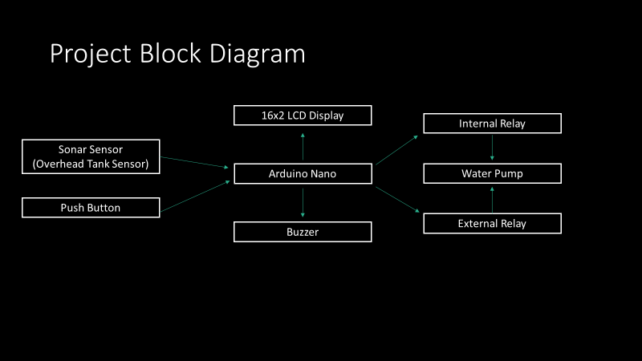

Figure 1. Block Diagram of an On/off Water Level Control System

Note that Arduino is the brain of this system. It will take input from the sensors and control all other units according to the value received. Arduino will directly control the water pump using the internal relay. The 16x2 LCD display will display the water level in percentage as well as in bar diagram, it will also show the pump status. This section will also notify us whenever the tank is empty. The sonar sensor unit is then used to measure the water level present on the overhead water tank. Basically, a sonar sensor emits an ultrasound at 40 kilohertz, which travels through the air, and if there is an object or obstacle on its path, the sound wave will bounce back to the module. Arduino will use the echo pin -- considering the travel time and the speed of the sound the distance can be calculated. The push button is also used to adjust the tank height in different increments. Therefore, this system should work on multiple size tanks. In addition, a buzzer is used to notify when the sump tank is empty.
Finally, a PCB (printed circuit board) screw terminal block at top is connecting to 1hp water pump.

III. System Layout and Design

We now focus on a real-time water level control system design. In the design below, we provide a visualization of the project on half size breadboards. As described in the block diagram notes above, the high-level components such as Arduino Nano, and the 16x2 LCD display will show the pump status and notify us whenever the tank is empty. The sonar sensor measures the water level present on the overhead water tank. The buttons are used to adjust the tank height in different increments. The buzzer is used to notify when the sump tank is empty. PCB Screw Terminal Block at the top is connecting to a1hp water pump.

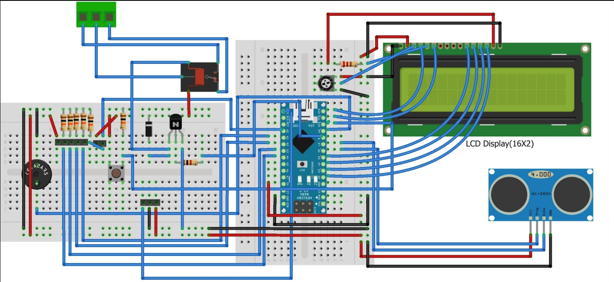
Figure 2. System layout and setup
- Printed Circuit Board (PCB)

We use a program called Fritzing to create a printed circuit board. The breadboard design was created using the Fritzing program, and the tab “breadboard” can be found in the image below. Clicking the PCB tab creates an optimized printed circuit board design based on your circuit design in the breadboard tab.

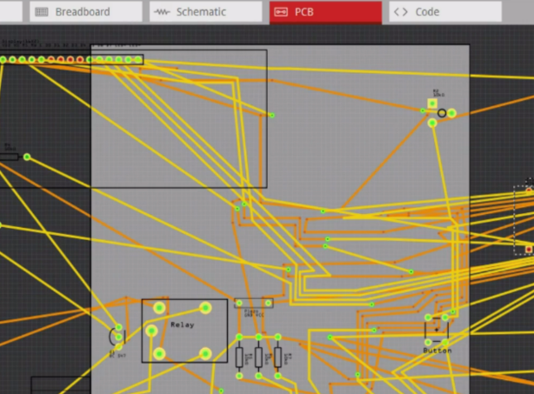

Figure 3. A Printed Circuit Board (PCB)

After saving this design, we can upload the file to a website such as JLCPCB.com. JLCPCB is a website that takes your pcb design from a website like Fritizing, and creates a custom order for you based on your design. Below is the website that we used, and an example of what the final printed circuit board will look like.

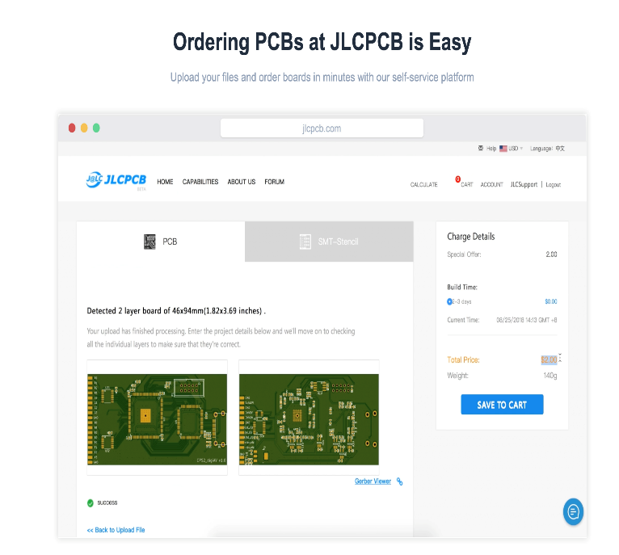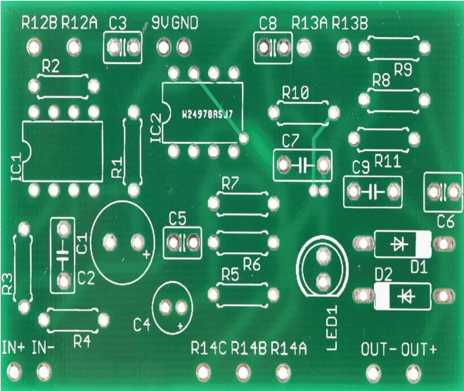

- Visualization of Completed Project

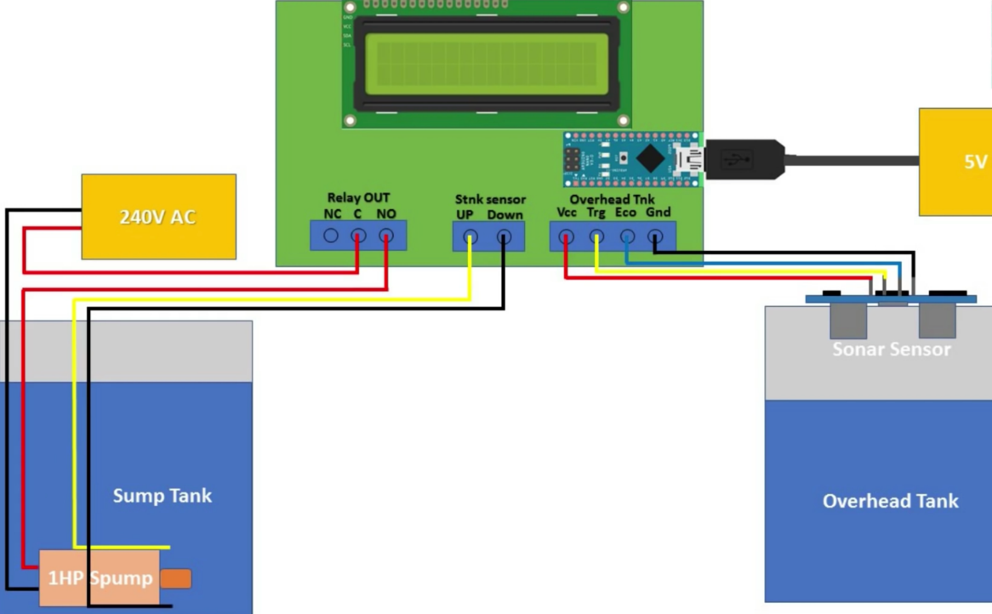

Figure 4. Project layout and setup

- Summary of Design and Function

The system has been designed to automatically control a water motor by sensing the water level in a tank and to monitor, detect, and control the water level of the tank automatically. In particular, the system switches ON motor when tank is EMPTY, and switches OFF motor when tank is FULL. The system also reads water level of tank on Liquid Crystal Display (LCD), i.e. when tank is empty, LCD displays LOW and motor is turned ON; but when tank is half-filled, LCD displays HALF and motor continues to run; finally, when tank is full, LCD displays FULL and motor automatically stops. Note that the motor only runs when water level in the tank reaches LOW.

IV. Conclusions and Possible Improvement

The real-time water level control system we proposed and designed in this paper functions well. The desired system automatically controls a water motor by sensing the water level in a tank. This project is topical and significant in the way that it reduces human effort and increases safety. To reduce human effort and allow the system to control the motor and ultimately the water level automatically is the goal of this design. This system aims to consume less power than ordinary systems. Its objective is to be simple and more reliable as the number of human error cases will be reduced. In addition, we aim to complete this system with a low cost of less than $600. On the other hand, based on the current industrial trend, we could improve the system by introducing more real-time processing techniques such as motor control by adaptive techniques and lower the system cost. To enhance our system functions, we could introduce more advanced data processing platforms with multi-channels or sensors.

Acknowledgment
This work was supported by 2019 Indiana Space STEM Research Grant.

References

[1]. L. Tan and J. Jiang, Digital Signal Processing: Fundamentals and Applications.
3rd Edition, Elsevier/Academic Press, 2018.
[2]. L. Tan, J. Jiang, “Teaching Advanced Digital Signal Processing with Multimedia
applications in Engineering Technology Programs,” ASEE Annual Conference, June
2009.
[3]. de Vegte, Joyce Van. Fundamentals of Digital Signal Processing, Prentice-Hall
Publishing, 2002.
[4]. https://www.arduino.cc/en/Guide/ArduinoNano.

Biographies

JEAN JIANG is an associate professor of Electrical Engineering Technology at Purdue University Northwest. She earned her Ph.D. degree in Electrical Engineering from University of New Mexico. Her research interests include digital and adaptive signal processing, active noise control and control systems. Dr. Jiang may be reached at jjiang@pnw.edu.

BENJAMIN SOLANO is an undergraduate student in Electrical and Computer Engineering Technology program at Purdue University Northwest. Mr. Solano may be reached at Bsolano@pnw.edu.

TURKI OLYAN is an undergraduate student in Electrical and Computer Engineering Technology program at Purdue University Northwest. Mr. Olyan may be reached at Tolyan@pnw.edu.

