# 187-T-20

Assessment of the Highway Safety Manual’s Empirical Bayes Method

Mandar Khanal
Boise State University
mkhanal@boisestate.edu

Mahamudul Hasan
Boise State University
mahamudulhasan@u.boisestate.edu

Abstract

The Highway Safety Manual (HSM), published by the American Association of State Highway and Transportation Officials (AASHTO), provides a comprehensive set of directions for managing and measuring safety (AASHTO, 2010). The expected average crash frequency, crash type, or crash severity for a freeway network can be predicted by using the HSM. The predictive method of the HSM enables us to figure the adjustment in accident recurrence or seriousness on a roadway because of changes in traffic volume or roadway geometry. This paper presents an overview of the predictive methodology of HSM with a discussion of its application to Interstate 84 from Milepost (MP) 41- MP 49 in Boise, Idaho. Because of the crash reporting thresholds, weather, terrains, and animals, which may have a significant impact on crashes in various ways, we also calibrated the result locally to account for local influence from these factors. The use of Crash Modification Factors (CMF) to account for deviations from base conditions is also illustrated. Data from 2011 to 2018 were used to calculate the predicted average crash frequency and estimated the expected crash frequency for 2018 using the period 2016-2017 as the crash period and compared it with the actual, observed crashes for 2018. The expected average crash frequency for fatal accidents in 2018 was 54.1 crashes/year, and the expected average crash frequency for property damage was 35.6 crashes/year. The actual, observed crash frequency was only 16 crashes/year in each category. This discrepancy is significant and it is recommended that the HSM recommendation of allowing a minimum of two years as the crash period be amended. The paper also highlights the potential difficulties that highway agencies may face when using the HSM with the hope that all agencies in the USA may benefit from this paper as they develop safety management systems for their jurisdictions.

Introduction

In July 2010, The American Association of State Highway Transportation Officials (AASHTO) published the first edition Highway Safety Manual (HSM) as a result of extensive road safety research conducted over the past few decades (AASHTO, 2010). The National Cooperative Highway Research Program of the United States of America sponsored seven independent research projects to develop different parts and chapters of this manual. All of the research projects were conducted between 1999-2007. The Transportation Research Board Joint Task Force for the Development of the Highway Safety Manual (ANB25T) guided the projects. In 2014 the supplement to the first edition of the HSM was published. The supplement provides safety performance functions (SPFs) for freeway and ramp facilities (AASHTO, 2014). This supplementary edition includes two new chapters that describe predictive methods to estimate the expected average crash frequency, crash type, or crash severity for freeways and ramps. The third chapter of this edition, Appendix B, describes two special procedures, Calibration of Predictive Models and the Empirical Bayes (EB) method, to be used with the predictive methods of the first two chapters. The EB method helps to combine observed crash frequencies with the estimates provided by the predictive methods.

The aim of the HSM is to be a definitive, science-based guidebook which provides quantitative methods for performing safety evaluations. It provides an opportunity to consider safety quantitatively along with other transportation measures.

There are four major parts in the HSM.

Part A: Introduction, Human Factors, and Fundamentals – Part A describes the purpose and scope of the HSM, explaining the relationship of the HSM to planning, design, operations, and maintenance activities. This part also includes the fundamentals of the processes and tools described in the HSM.

Part B: Roadway System Management Process- Part B presents suggested steps to monitor and reduce crash frequency and severity on existing roadway networks. It has six chapters, which can be used to reduce crash frequency and severity for an existing network. It also includes methods that are useful and effective for overall safety improvement.

Part C: Predictive Method- This part provides a predictive method for estimating the expected average crash frequency on a network, facility, or individual site based on different factors. It also introduces the concept of Safety Performance Functions (SPFs).

Part D: Crash Modification Factors- This part describes treatments and, where applicable, the associated Crash Modification Factors (CMF) for roadway segments, intersections, interchanges, individual facilities, and road networks. CMFs help to find the change in expected average crash frequency as a result of geometric or operational modifications to a site that differs from base conditions.

After estimating the expected crash frequency based on the methodology described in Part C of the manual the CMFs, described in Part D, will need to be developed. A past study found that the variation in the safety effects of the treatment over time cannot be represented by a single CMF (Sacchi & Sayed, 2014). Crash modification factors are available for various factors such as horizontal curves, lane change maneuvers, non-standard median width, and shoulder rumble strips. They all can have a significant impact on the prediction. For example, Elvik et al. found that the safety effectiveness of horizontal curves varies with the lengths of their radius (Elvik et al., 2009). In another study Turner found that shoulder rumble strips reduce injury crashes by around 23% (Turner et al., 2009). Gross and Jovanis estimated the safety effects of shoulder-width using Case-Control and Cohort methods (Gross & Jovanis, 2007). Both methods showed that crashes decrease as shoulder width increases.

Moreover, according to Pitale, the safety effects of paving shoulders, widening paved shoulders (from 2 ft to 4 ft), and installment of shoulder rumble strips on rural two-lane roadways have 16%, 7%, and 15% reductions in crash rates, respectively (Pitale et al., 2009). Kononov found that there was a lack of prior studies about the safety effects of the number of lanes on urban freeways (Kononov et al., 2008). Four-lane divided roadways were safer than two-lane roadways by a 40–60 percent reduction in total crashes in California, Michigan, North Carolina, and Washington State (Council & Stewart, 1999). Fitzpatrick also found that four-lane divided roadways in Texas show better safety performance when the average daily traffic (ADT) is higher than 10,000 (Fitzpatrick et al., 2005). On the other hand, Abdel-Aty and Radwan identified that the crash rate increases as the number of lanes on urban roadways increases (Abdel-Aty & Radwan, 2000).

The literature review revealed that many factors need to be considered for safety analysis and proper calculation of the calibration factors is needed. To improve the estimation of expected crash frequency, development of calibration functions has been explored in recent studies to improve local calibration (Claros et al., 2018)(Farid et al., 2018)(Hauer, 2015)(Srinivasan et al., 2016). A latest comprehensive study on HSM freeway and ramp calibration using Maryland crash data was done from 2008 to 2010 (Shin et al., 2016). The results of this study indicated the HSM methodology overpredicted both fatal and injury crashes and property damage only (PDO) crashes for all freeway and ramp facilities. Avoiding the site selection bias is also important. To avoid this issue, the site should be selected randomly, and after that, the crashes should be determined. The study time period is also important, and to limit the influence of the time period, the analysis should extend over several years, such as 5-7 years.

This study provides an overview of the predictive methodology of HSM with a discussion of its application to a segment of Interstate 84 in Boise, Idaho. The predicted crash frequency was estimated and compared with the observed crash frequency. The results were calibrated locally to get the most appropriate results. The expected crash frequency was also calculated by using the project level Empirical Bayes (EB) method. The data was analyzed based on different factors such as severity type, lighting conditions, and weather conditions. A brief description of lessons learned will also be provided for the benefit of the staff at highway agencies that plan to use the HSM methods in their jurisdictions.

Site Selection

The goal in this research was to work with a suitable site located in the state of Idaho. To avoid the site selection bias, the site was selected randomly and then the crash data was collected. A segment of Interstate 84 on the western edge of the city of Boise was found to be a good fit for the study. The section of the freeway used in study was from MP 41 to MP 49. This segment is used to enter Boise city in the morning by people coming from the western part of the Boise Valley. In the afternoon, the peak flow direction is reversed. This segment has a relatively high traffic volume; a high crash rate is also expected on this segment. Figure 1 shows the freeway segment with the locations of crashes on it.

Data Collection

Annual Average Daily Traffic (AADT) data. The influence of the study period over the crash data was sought to be minimized. Hence, this analysis was extended over 8 years to minimize the impact of short-term fluctuations that are possible in a short study period. The Annual Average Daily Traffic (AADT) data for the 2011-2018 period was downloaded from an Idaho Transportation Department (ITD) website. Data for the freeway segment as well as the ramps were available. The percentage of the AADT volume during high-volume hours throughout the study period for different segments was calculated. The AADT data are available from 1999 to date.
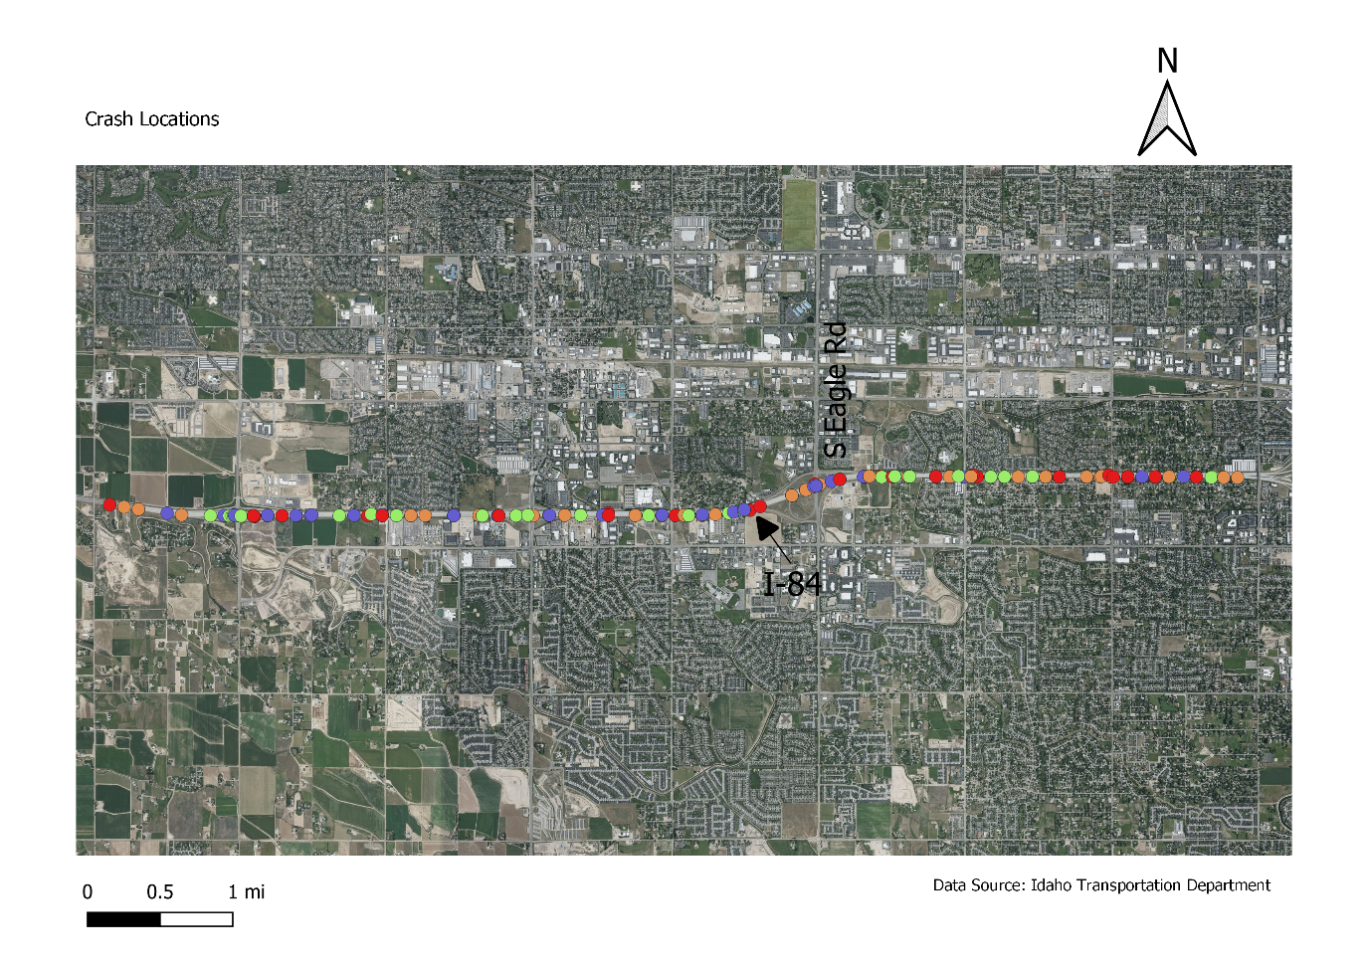
Figure 1: Study Area – Segment of I-84 in Boise, Idaho
Crash data. Crash data within this study area from 2011 to 2018 was collected from another ITD application named "Webcars" (Crash Analysis Reporting System - WEBCARS, n.d.). The segment code, desired milepost range, year range, counties, and severity type were entered on Webcars to get the reports. The reports were saved in excel files for the analysis. These reports had most of the necessary information, such as crash date, severity, location by mileposts, date, and time.

Infrastructure data. Data related to the road infrastructure such as the number of lanes, lane width, median width, rumble strips presence, and clear zone width, were also needed. Most of these data were collected using Google Maps; some of the data were obtained from ITD.

Analysis

The focus of all analyses was on freeway segments. Freeways have full access control and grade separation at all intersecting roadways. The study area can be classified as an urban area. As indicated by the Federal Highway Administration (FHWA), areas with population greater than 5000 persons and inside municipal boundaries are classified as urban areas.

The study segment was divided into four sections. Such division can be done based on different factors, such as, the number of lanes, lane width, outside shoulder width, inside shoulder width, median width, ramp presence, clear zone width, and so on. The presence of ramps was used as the basis for the division. Mileposts corresponding to the four segments, Segment 1, Segment 2, Segment 3, and Segment 4 were 41-41.63, 41.63-44.76, 43.67-45.43, and 45.43-49, respectively.

The expected average crash frequency for the freeway facility was estimated by applying the predictive method of the HSM. The crash frequency can be defined by total number of crashes, crash type, or by severity. The predictive method is completed in stages. The analyses started by characterizing the data as much as possible. These included characterizing the data according to the crash severity and location. The area of investigation was determined as explained earlier. The period of interest had to be determined next. All AADT values for the freeway segments and ramps (in both directions - increasing and decreasing mileposts) were collected. The observed crash data, which is essential for the Empirical Bayes (EB) method, was also collected.

The next step was to determine the geometric design of the road. These included the number of lanes, lane width, presence of streetlights, and shoulder width features. Appropriate safety performance functions (SPFs) from the HSM were then used to estimate the predicted average crash frequency for the site. The percentage of AADT occurring during high-volume hours for different sections in the different study periods had to be estimated. The freeway segments had eight lanes. By using the segment length, segment AADT volume, and appropriate values for the SPF coefficients as specified in the HSM, SPFs for multiple vehicles and single vehicle were calculated. Fatal and injury crashes, and property damage only crashes were found for both multiple vehicles and single vehicle. The estimated SPFs were:

- Multiple vehicles fatal and injury crashes
- Multiple vehicles property damage only crashes
- Single vehicle fatal and injury crashes
- Single vehicle property damage only crashes

The next step was to work with crash modification factors (CMFs). The CMFs applicable to the SPFs estimated previously were calculated. Several CMFs included a variable defining the proportion of the segment's length along with some features such as horizontal curve, rumble strip, and median barrier. All applicable CMFs were applied to estimate multiple-vehicle and single-vehicle crashes for fatalities, injuries, and property damage only.

The next step was to estimate the calibration factor based on local conditions. A calibration factor represents the ratio of the total number of observed crashes for selected sites to the total number of predicted crashes for the same sites within the study period using the applicable predictive model. If there were less observed crashes than predicted by the predictive model, then the computed calibration factor will be less than 1.00. The local calibration factor for the study area was calculated.

After that, the project level Empirical Bayes method was applied. Application of the EB method produces a more statistically reliable estimate of the project's expected average crash frequency. The EB method is described in detail in the Appendix of the 2014 Supplement of the HSM (AASHTO, 2014). There are two options of the EB method available: site-specific or project-level. The project-level EB method was used in this research. There are six steps required to estimate the expected average crash frequency for a future time period.

The year 2018 was selected as the future time period for which an estimate of the expected average crash frequency was desired. To do this the selection of a crash period is needed. The crash period needs to be at least two years for which observed crash data is available. In this research the period 2016 − 2017 was selected as the crash period. Then the study period needs to be identified. The study period consists of the consecutive years for which an estimate of the expected average crash frequency is desired. In this case 2018 was selected as the study period; it is the year for which an estimate of the expected average crash frequency was desired.

The details of the six steps are not reproduced here. The sixth step is where the expected average crash frequency for the study period is calculated using Equation (1).
$$N_{expected, 2018}=N_{expected,2016}×\frac{N_{predicted,2018}}{N_{predicted,2016}} (1)$$

Equation (1) was used to estimate the expected crash frequency for both fatal-and-injury and property-damage-only crashes. The estimates were then compared with the observed crash frequency for that year. The findings from this analysis are presented in the Results section later in the paper.

Other variable values found were the number of crashes each year, the percentage of crashes by severity type, and miscellaneous factors such as lighting conditions, road surface conditions, and weather conditions. The crashes by month and time of the day were also analyzed.

Results

The predicted average crash frequency for fatal-injury crashes and property damage crashes for the different segments within the study area were calculated. Using the available data on the number of observed crashes for the same time period the calibration factors for the two crash types wee computed as shown below:
- Calibration factor for fatal-and-injury crashes: 0.96
- Calibration factor for property damage crashes: 0.27

In both cases the calibration factor is less than 1.0. So, the predictive analysis used in this study over-predicted crashes, especially, property damage crashes. These calibration factors were used to compute the final predicted average crash frequencies for fatal-and-injury and property damage crashes.

Table 1 shows the total number of fatal-and-injury and property damage crashes predicted in our study area for the study period.

Table 1 Calculated and Observed Crashes for the Study Period
Year | Predicted Crashes |  | Observed Crashes
 | Fatal-and-Injury | Property Damage | Fatal-and-Injury | Property Damage
2011 | 37 | 25 | 20 | 53
2012 | 41 | 27 | 32 | 50
2013 | 42 | 29 | 40 | 56
2014 | 42 | 29 | 71 | 19
2015 | 42 | 28 | 67 | 18
2016 | 48 | 34 | 66 | 25
2017 | 51 | 37 | 46 | 14
2018 | 54 | 39 | 16 | 16

The expected average crash frequency for 2018 using the project level EB method described earlier were as shown below:

- Fatal-and-injury crashes = 54.1 crashes/year
- Property damage crashes = 35.6 crashes/year

It can be seen that the expected crashes for fatal-and-injury and property damage for 2018 are similar to the predicted crashes for 2018. However, the observed crashes were much lower than the predicted crashes. Even though the calibration factor for fatal crashes was 0.96, which is close to 1, for any given year the predicted or the expected crashes can differ significantly from the observed. Another interesting observation is that the predicted and expected crash frequency for property damage crashes for 2018 was closer to the observed frequency in 2018 compared to fatal-and-injury crashes despite the fact that the calibration factor for this severity type was 0.27, which is significantly lower that the factor of 0.96 obtaind for fatal-and-injury crashes.

Another observation is that from 2014, the observed crashes were consistently lower than the predicted crashes for property damage accidents. But for fatal-and-injury accidents, such a consistent pattern was not observed; the observed crashes were lower than the predicted crashes in 2011, 2012, 2017, and 2018 only. There might be many reasons behind this difference, such as the improvement of awareness of drivers. Also, some local factors such as weather, terrains, and many others might be responsible for this discrepancy.

The number of total observed crashes by year has been plotted in Figure 2. In 2013, there were 96 crashes in this corridor, which was the highest within this study period. The number of crashes decreased after that for two more years before increasing again in 2016 to 91 crashes. Then there was a drastic decrease until 2018, the last year of the analysis period. Overall, there was a decreasing trend in the total number of crashes per year on this corridor.

Figure 2. Number of Observed Crashes by Year
Fatal crashes are defined as crashes in which there is at least one fatality. A-injury crashes are crashes where the highest level of injury is an incapacitating injury. If the highest level of injury in non-incapacitating but visible, then the crash should be called as B-injury crash. Any crash reported or claimed in which, highest injury does not fall in the other categories such as momentary unconsciousness, limping, complaint of pain, nausea, hysteria, and/or claim of injuries is called C-injury crash. Figure 3 presents the percentage of crashes by severity type over the study period. There were only 1% of fatal crashes within this period. The highest rate of the crashes (46%) was property damage only crashes.

Figure 3. Percentage of Crashes by Severity Type
Figures 4 and 5 show the fatal crash and A-injury crash for different years that have occurred in the study area. The symbols “A” and “D” in the legend of these figures denote “Ascending” and “Descending” mileposts, respectively. Figure 6 represents the distribution of crashes by weather conditions, road surface conditions, lighting conditions, month, and time of day when the crashes occurred.
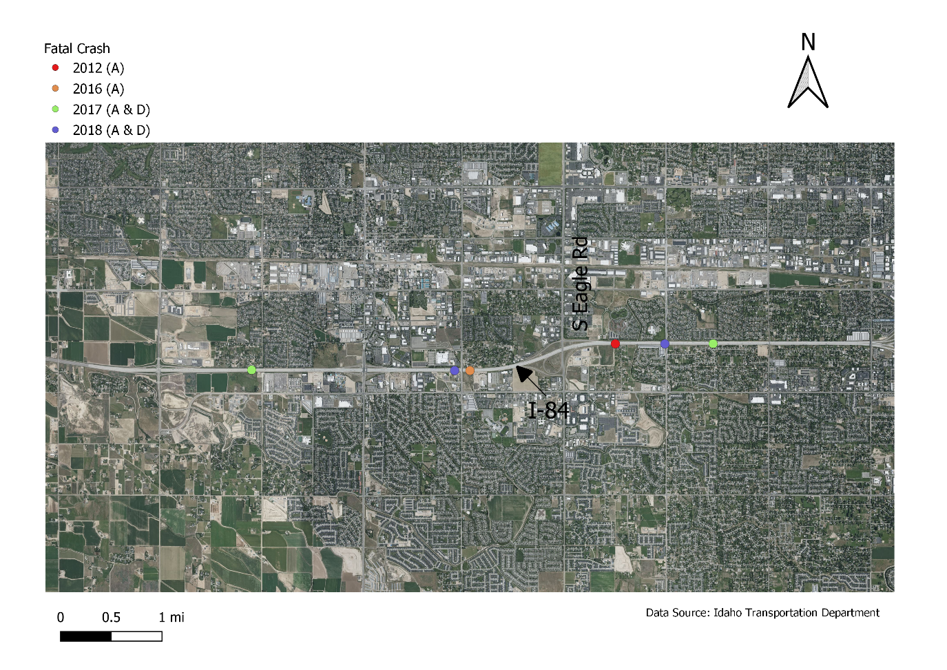
Figure 4. Fatal Crashes in the Study Area
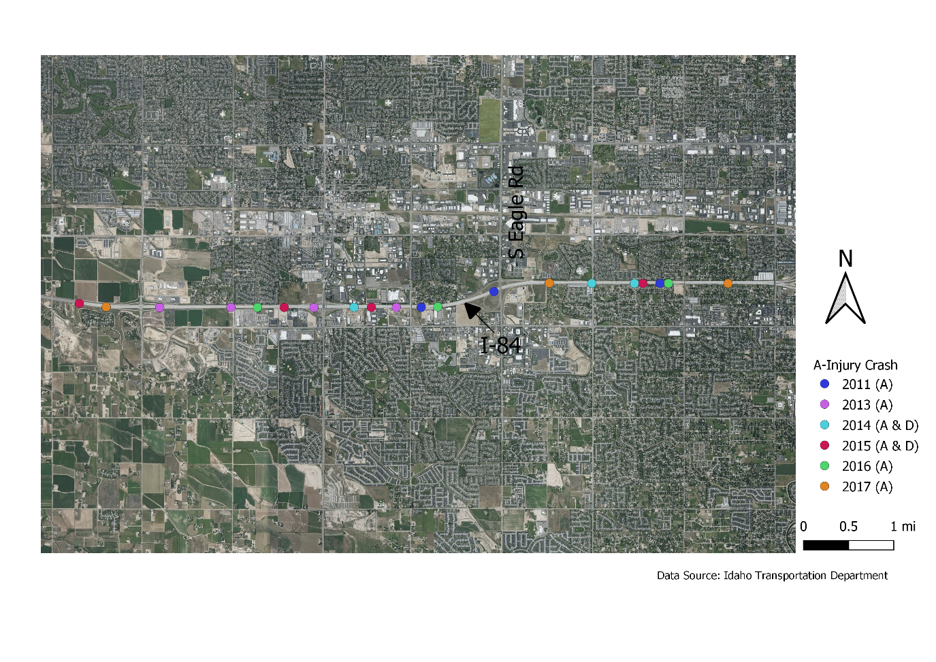
Figure 5. A-injury Crashes in the Study Area

(a) Percentage of Crashes by Weather (b) Percentage of Crashes by Road Surface
(c) Percentage of Crashes by Lighting (d) Number of Crashes by Month

(e) Number of Crashes by Time of Day
Figure 6. Crash Distribution on Various Factors
Discussion

This study revealed that it is important to calibrate the predicted crash frequency based on the observed crashes. It was found that the calibration factor for property damage was much more significant than the calibration factor for fatal-and-injury accidents. The expected crashes for fatal-and-injury crashes were 54.1 crashes/year and property-damage crashes were 35.6 crashes/year for the year of 2018 using the EB method. These numbers are close to the predicted crashes of 2018, which were 53.5 and 39.2 crashes/year for fatal-and-injury and property-damage crashes, respectively. The actual, observed crashes in the two categories were however were much lower; they were 16 crashes/year in each category.

Based on the discrepany between expected and observed crash frequencies described above, it can be concluded that the HSM method is not a reliable tool for forecasting expected crashes. No obvious reasons for the discrepany was found except perhaps the short crash period of two years that was used in the analysis. According to the 2014 HSM supplement (AASHTO, 2014) a period of two years can be used as the crash period. It appears that this recommendation needs to be changed. Looking at the fluctuation in crash frequencies for the period 2011 to 2018 as shown in Table 1, using only two years does not appear to be advisable. Had a longer crash period been used, say from 2011 to 2017, an expected crash frequency estimate for 2018 that was closer to the observed value would have perhaps been obtained. This is a topic that needs further research.

The road characteristic data developed for calibration can be preserved, and calibration factors can be updated for future years such as future observed crashes and future AADT values. The additional effort needed to do this will be lower if the base work as explained in this paper is completed beforehand.

The distribution of crashes revealed that most of the crashes occurred in dry road surface condition, clear weather condition, and daylight condition. Also, crash frequency was higher in the morning rush hours in this study area.

Figure 4 shows the locations of the six fatal crashes that occurred in the study period. Four of the six crashes were found to have occurred in the ascending MP direction. Most of the crashes occurred on Thursday, Friday, or Saturday. Figure 5 shows the A-injury crash locations. There were a total of 23 A-injury crashes in the study period. Only two of these occurred in the descending MP direction. Most of the severe crashes occurred in the ascending MP direction.

Figure 6(d) shows that higher number of crashes occurred in August (72), December (68), and January (63). More crashes are expected in winter months and the data that was collected for this study follows that trend. It is not clear why there were so many crashes in August. This is a topic that needs further research. Lower number of crashes occurred between May and July. So, there were fewer crashes in the summer time. Also, Figure 6(e) shows that most of the crashes (37.1%) occurred between 7-9 am in the morning, which is the peak travel time in the morning. Seventy-six percent of the crashes occurred when the road surface condition was dry. Sixty-one percent of the crashes occurred in clear weather condition. Sixty-three percent of the crashes occurred in daylight condition.

Conclusions

The primary benefit from the analysis presented in this paper is the better understanding of the expected crash frequency on this segment of I-84. This study also helped to identify the priority locations with high crashes. As motor vehicle crashes are one of the primary reasons for death in the United States, safety improvement for roadways is vital to improve the current condition. Studies like the one presented in this paper will help transportation agency personnel to implement low-cost safety improvements. They will also allow agency staff to foresee possible future impacts of improved roadway design.

Although the adaptation of the HSM calibration method is a straightforward procedure, the analyst has to be careful when selecting appropriate calibration factors because some data were not available. Also, the results of the estimated crash modification functions indicate that the CMFs vary across the segments with different roadway characteristics. For the years of 2018 and 2017, the total predicted crashes were found to be much higher than the observed crashes. But before that, total predicted crashes were lower than the observed crashes. There was no information about any special measures that may have been taken after 2016. This possibility should be investigated further as any special measure can reduce the number of crashes.

A major conclusion from this work is that the HSM recommendation of allowing a minimum of two years for crash period should be amended. The research presented in this paper showed that using only two years for the crash period resulted in an estimate of the expected crash frequency for a future year that was not close to the observed crash frequency. Further research is needed to determine the minimum number of years required for the crash period.

Limitations

The predictive method described in this paper does not account for the influence of urban freeways with 11 or more lanes, rural freeways with 9 or more lanes, high-occupancy vehicle (HOV) lanes, ramp metering, toll plazas, and reversible lanes. This strategy additionally does not check the contrasts between various barrier types such as cable barrier, guardrail, or bridge rail. In this analysis, these limitations were not present. Proper data for horizontal curves were not available for the study area. Hence the CMFs for the horizontal curve could not be computed. Calibration factors for local accidents were found; driving behavior was one of the factors behind using this factor. However, there was no information about the number of accidents that could be attributed to people who live outside the State. Such information will be needed to find the difference in crash rates between local drivers and outside drivers. The percentage of AADT data that occur during peak hours was calculated manually; this may have caused some small errors. Also, The CMFs provided in Part D of the HSM are primarily based on empirical studies conducted in the United States and these analyses would be more appropriate for US driver behavior and roadways. To apply these methods to areas outside the USA, further exploration will be needed. Also, collision types of different crashes were missing in the raw datasets. If these data were available, then more research could have been done based on the crash types.

References
AASHTO. (2010). Highway Safety Manual: 1st Edition. American Association of State Highway and Transportation Officials. http://www.highwaysafetymanual.org/Pages/default.aspx
AASHTO. (2014). Highway Safety Manual, First Edition, 2014 Supplement. American Association of State Highway and Transportation Officials. http://www.highwaysafetymanual.org/Pages/default.aspx
Abdel-Aty, M., & Radwan, E. (2000). Modeling traffic accident occurrence and involvement. Accident Analysis and Prevention, 32(5), 633–672.
Claros, B., Sun, C., & Edara, P. (2018). HSM calibration factor, calibration function, or jurisdiction-specific safety model- a comparative analysis. Journal of Transportation Safety and Security, 12(2), 309–328. https://doi.org/10.1080/19439962.2018.1477896
Council, F., & Stewart, J. (1999). Safety Effects of the Conversion of Rural Two-Lane Roadways To Four-Lane Roadways. www.tfhrc.gov
Crash Analysis Reporting System - WEBCARS. (n.d.). Idaho Transportation Department. http://apps.itd.idaho.gov/apps/webcars/
Elvik, R., Hoye, A., Vaa, T., & Sorensen, M. (2009). The handbook of road safety measures (Second). Emerald Group Publishing Limited. https://doi.org/10.1103/PhysRevD.79.051101
Farid, A., Abdel-Aty, M., & Lee, J. (2018). A new approach for calibrating safety performance functions. Accident Analysis and Prevention, 119(March), 188–194. https://doi.org/10.1016/j.aap.2018.07.023
Fitzpatrick, K., Schneider H, W., & Park Sug, E. (2005). Comparisons of Crashes on Rural Two-Lane and Four-Lane Highways in Texas. https://trid.trb.org/view/778720%5Cnhttp://tti.tamu.edu/documents/0-4618-1.pdf%5Cnhttps://trid.trb.org/view/782850
Gross, F., & Jovanis, P. (2007). Estimation of the safety effectiveness of lane and shoulder width: Case-control approach. Journal of Transportation Engineering, 133(6), 362–369. https://doi.org/10.1061/(ASCE)0733-947X(2007)133:6(362)
Hauer, E. (2015). The Art of Regression Modeling in Road Safety. Springer.
Kononov, J., Bailey, B., & Allery, B. (2008). Exploratory Analysis of Relationship between the Number of Lanes and Safety on Urban Freeways. Transportation Research Board Annual Meeting, 1–20.
Pitale, J. T., Shankwitz, C., Preston, H., & Barry, M. (2009). Benefit:Cost Analysis of In-Vehicle Technologies and Infrastructure Modifications as a Means to Prevent Crashes Along Curves and Shoulders. http://conservancy.umn.edu/handle/11299/150627
Sacchi, E., & Sayed, T. (2014). Accounting_for_heterogeneity_among_treat.pdf. Accident Analysis and Prevention, 72, 116–126.
Shin, H., Lee, Y. J., & Dadvar, S. (2016). The Development of Local Calibration Factors-Phase II: Maryland Freeways and Ramps.
Srinivasan, R., Colety, M., & Bahar, G. (2016). Estimation of calibration functions for predicting crashes on rural two-lane roads in Arizona. Transportation Research Record, 2583, 17–24.
Turner, B., Affum, J., Tzoitis, M., & Jurewicz, C. (2009). Review of iRAP risk parameters. www.arrb.com.au

Biographies

MANDAR KHANAL is an associate professor of civil engineering at Boise State University.He specializes in transportation engineering and has over 20 years of experience as an engineer, researcher, and educator. He is a registered professional engineer in California and Idaho. Dr. Khanal may be reached at mkhanal@boisestate.edu.

MAHAMUDUL HASAN recently graduated with a master’s degree in Civil Engineering at Boise State University. At Boise State he was involved in various research projects under the supervision of Dr. Khanal. His master’s thesis was related to the use of remotely sensed data in developing terrain models for road design. Mr. Hasan may be reached at mahamudulhasan@u.boisestate.edu.

