# 163-T-20

Construction of 3D Printed Masks, Face shields and Disinfection Booth for COVID-19 Community Relief Efforts

Ulan Dakeev
Sam Houston State University
dakeev@shsu.edu

Y Luong
Sam Houston State University
yll003@shsu.edu

Reg Pecen
Sam Houston State University
regpecen@shsu.edu

Faruk Yildiz
Sam Houston State University
fxy001@shsu.edu

Abstract

Since the beginning of March 2020, the World Health Organization (WHO) has declared the novel coronavirus (COVID-19) outbreak a global pandemic. While the crude mortality rate, as well as the morbidity associated with COVID-19, has rapidly increased worldwide, yet neither therapeutics nor vaccinations have been proven to treat or prevent this contagious disease. Because this novel coronavirus can spread easily and sustainably through person-to-person close contact, primarily in respiratory droplets from infected individuals, or contact with contaminated surfaces, the global outbreaks have growth at an exponential rate. Besides practicing personal hygiene, maintaining social distance (about 6 feet) is essential to decrease the possibility of being infected or spreading COVID-19. Many countries have slowed down the COVID-19 transmission by population-level physical distancing measures and movement restrictions, often referred to as “shutdowns” and “lockdowns.” However, these measures have negatively affected the national economy and society. They might cause a widespread socio-economic recession. Thus, a transition away from such restrictions has been urgently necessary for countries to enable the resumption of economic and social life partially, while suppressing the disease transmission at a low level. However, there have been multiple obstacles associated with the transition phase. As community-wide mask-wearing has been proven to slow down the transmission by blocking the shedding of respiratory droplets, there has been a shortage in surgical face mask products, especially for the medical personnel. To relieve this shortage, we have applied the 3D printing technique to print facemask and face shields with 3D printing materials. Furthermore, infectious respiratory droplets lasting on surfaces can also transmit the virus. Consequently, to reduce the contact with the contaminated surfaces, a disinfection booth has been constructed in order to minimize the individual contaminated rate on surfaces such as clothes and shoes.

Introduction

In December 2019, clusters of reported cases of the novel coronavirus SARS-CoV-2 (COVID-19) in Wuhan quickly gained worldwide public attention. Shortly after the COVID-19 outbreak became an epidemic in China and then spread globally, it has become a global pandemic since the beginning of March 2020, declared by WHO. While several countries have attempted to slow the spread of the disease, the crude mortality and morbidity rate has rapidly soared. As this contagious virus can transmit easily and sustainably through

respiratory droplets of infected individuals or contacting contaminated surfaces, the COVID-19 pandemic has been growing at an exponential rate, yet neither vaccinations nor therapeutics have been verified to prevent or treat this contagious disease successfully. During the beginning of the COVID-19 global breakout, many countries all over the world have applied the nationwide physical distancing measurements, such as “shelter-in-place,” “social distancing” and even “lockdowns” in order to slow down and minimize the community spread. While some countries still remain “lockdowns,” most of countries have moved towards the transition phase, often referred as “new normal,” in order to avoid socio-economic recessions. Besides remaining hand hygiene and disinfecting frequently touched surfaces, wearing face covering is a highly recommended preventive measurements to eliminate any bigger outbreak during the transition phase.
Global governments, the United States included, issued the official recommendation to wear facemasks when leaving home and in public places. In January 2020, the World Health Organization (WHO) published the Interim Guidance which provided a general, but confusing, advice on wearing merely medical masks in affected areas to keep individuals from infection with respiratory viruses, including COVID-19. There has been a severe shortage in supply of surgical face masks for the most exposed personnel which are frontline healthcare and community workers, even though WHO eventually modified its recommendations on the use of fabric masks in general public. While WHO and public health agencies across the world have been working together to clarify effectiveness and efficiency of nonmedical masks, a prioritization and rationalization of the distribution of personal protective equipment (PPE) such as medical masks is critical to ensure the protection of public healthcare professionals and frontline community workers. Amidst the rising of COVID-19 globally, 3D-printed filtering facepiece respirators (FFR) made of generic filaments have been designed and printed to ease the shortage of general medical masks.
On the other hand, the Centers of Disease Control and Prevention (CDC) also released the statement on the possibility of fomite transmission in May 2020. In other words, infectious respiratory droplets can last on surfaces which causes the surfaces contaminated, thus possibly leading to the disease transmission to human through touching those surfaces and then touching their own mouth, nose, or possible their eyes. As a result, cleaning and disinfecting highly-touched surfaces is vital to reduce the risks in all situations associated with the transmission of the contagious respiratory viruses generally and COVID-19 specifically. A disinfection booth has been designed and constructed in order to contribute to the community relief in the transition phase by minimizing the possibility of being exposed to the disease through contaminated surfaces, focusing on clothes and shoes in this case.

Literature Review

Several studies have been conducted to investigate and report on the infection control since 2013 the severe acute respiratory syndrome (SARS) outbreak (Wei & Li, 2016, Chen et al., 2020, Brankston et al., 2020, Liang et al., 2020). In fact, short-range airborne route has been the most potential transmission associated with respiratory disease viruses such as SARS-CoV-2, which means that the spread of those viruses from human-to-human often happens among close contact (within 6 feet) with infected subjects through droplets (CDC). Significantly, even mildly ill and asymptomatic infected subjects were reported to be able to transmit the SARS-CoV-2 (Bai et al., 2020, Klompas et al., 2020). Face covering has been recommended to general public, both symptomatic and asymptomatic, especially in countries moving towards transition phase after lockdowns. Consequently, universal masking in general public has been associated with a lower rate of the positivity among the community. Notwithstanding, while fabric facemasks have been taken into account by health agencies and researchers worldwide on its effectiveness of multiple respiratory diseases prevention (Macintyre et al., 2015, Ho et al., 2020, Davies et al. 2020), there has been little to no evidence to prove that fabric masks can be an alternative to medical masks for protection of health workers. Thus, both healthcare and community frontline workers rely on specialized facemasks which are PPE or FFR to protect themselves and patients from getting the viruses and infecting others (Wang et al., 2020, Macintyre & Chughtai, 2020). Although WHO and CDC have advised general public to limit and rationale the use of PPE such as surgical facemask and filtering facepiece respiratory (FFR) such as N95 face masks in their Interim Guidance, the shortage of those PPE and FFR has soared due to panic buying (WHO, 2020, Secon, 2020). Taken that into account, we have adopted the innovative technology, which is 3D-printer with generic filaments, to construct the design of facemasks integrated with the filter which can meet the requirements of the filtration and breathability. With that being said, this method is proposed to ease the shortage in supply of medical masks for local healthcare worker sufficiently.
Moreover, CDC has reported that COVID-19 can live on surfaces where people frequently touching and be transmitted to subjects by the fact that subjects touch their mouth, eyes and nose, which considers fomite transmission a possible transmission. Although there has been little data supporting fomite transmission as a main way the SARS-CoV-2 spreads, a cluster of COVID-19 cases has been associated with touch the contaminated surface or virus aerosolization (Cai et al., 2020, Brlek et al., 2020). Furthermore, metal and plastic, as garments of clothes, can be an environment where the virus stability is feasible (Doremalen, 2020). Thus, together with maintain hygiene by disinfecting and cleaning surrounding environment, a disinfecting booth has been constructed as a proposed prevention method for virus transmission. Especially, when being placed at the entrance of public places such as school and hospital, disinfecting booth is proposed to be effective in removing any virus in airborne or contaminated surfaces on most common touched areas, such as metal and plastic garments on clothes and accessories. Consequently, it might be able to reduce the possibility of fomite transmission in highly infected area

Methodology

The disinfecting booth has been in progress of design and construction by engineering technology (ET) students as seen in Figure 1. It is proposed that the booth will have a support mechanism which is portable and easy to construct from basic components. Particularly, PVC pipes have been utilized in this study as seen in Figure 2. The booth model composes of the sterilization chamber with a misting system and the attached disinfectant tank containing medical-grade, non-irritating to skin disinfectant. Furthermore, the disinfecting booth can be easily installed and relocated at the entrance of multiple public spaces, especially where general public can access during the transition phases of the pandemic such as schools, public centers, hospitals, clinics, shopping malls, and grocery stores.

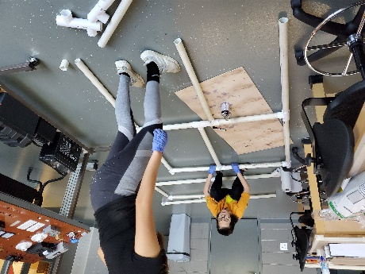
Figure 1: ET students working on the frame of the disinfecting booth

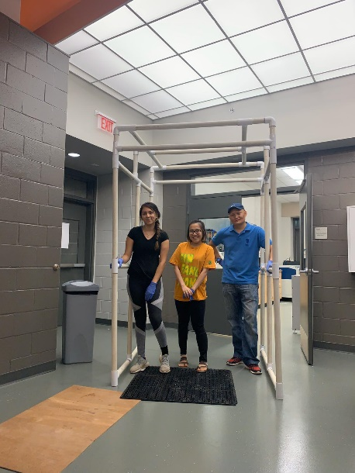
Figure 2: Completed frame of the disinfecting booth

The disinfection booth project is an ongoing work and an electrical motor controlled 360-degree rotational hand-block that includes multiple nuzzles will be installed. The medical-grade disinfectant solution stored in a tank inside the booth will be applied to multiple nuzzles to be sprayed providing a safe misting environment to a human standing on the center of the booth. Multiple motion sensors attached on the rotating hand are also planned for safe movement. We also plan to install a non-touch infrared temperature sensor that will measure the human temperature and provides an audio response as OK or alarming signal for high temperature value similar to model shown in Figure 3. Besides, plastic curtain will be used to cover the entrance and exit of the booth to maintain the hygiene inside the booth.
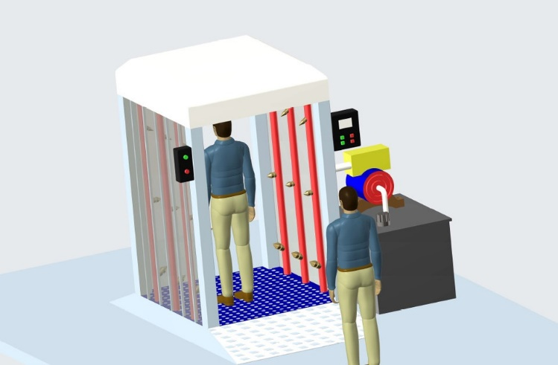
Figure 3: Proposed Disinfection Booth with Infrared T measurement and 360 degree rotational nuzzle hand inside (Modified from grabcad).

Researchers have also designed prototypes of the contoured face masks and face shields initially as CAD model with Creo – PTC and SolidworksTM, then printed the prototypes promptly with 3D printer as shown in Figure 4. The face coverings were designed to be face-fitting and integrated with a filter pocket. Thus, the qualified filters, such as carbon filter, are removable and can be replaced sustainably. Moreover, as the 3D printed masks are made of ABS and PLA, they are lightweight and can be printed expeditiously. The products are also proposed to be durable and reusable as users can wash, disinfect, and reuse them as well as easy to manufacture (Figures 5a,b). Hence, the large quantity of 3D printed masks can become a temporary solution for the shortage of face masks and PPE during the pandemic, especially for medical personnel, frontline workers, and students that have forgotten their masks prior to coming to the classroom.
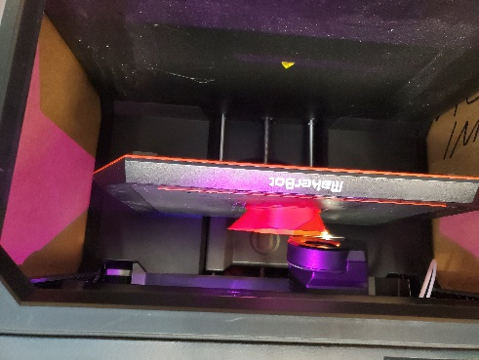
Figure 4: 3D printing in progress

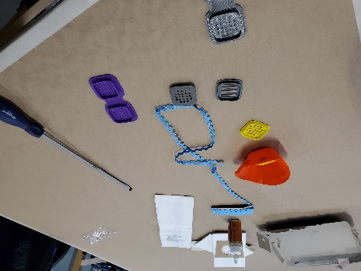
Figure 5a: Mask assembly components

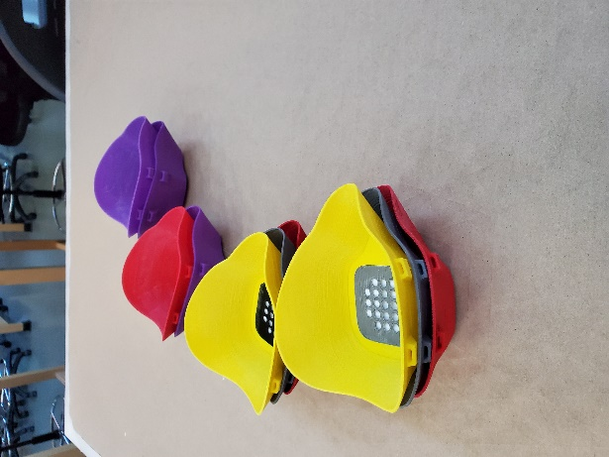
Figure 5b: Assembled 3D printed facemasks

In addition to the disinfection booth and the 3D printed masks, the researchers have developed face shields to provide additional protection against COVID 19 as shown in Figure 6.

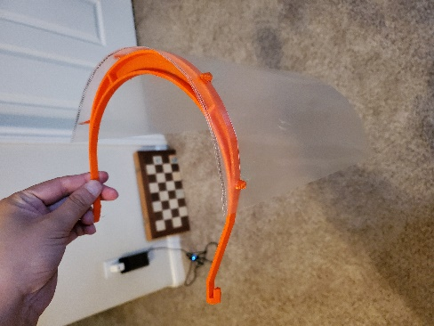

Figure 6: 3D printed face shield frame

Result

During testing period, the 3D printed masks have received many feedbacks, including negative and positive ones. Users have reported that the edges of the 3D printed masks could cause discomfort while wearing due to its rigid material (generic filaments). Even though the masks have been designed to be contoured and face fitting, face shapes can differ among users which results in the improper sizing and gaps between users’ face and the 3D printed face masks. Thus, the effectiveness in preventing airborne and droplet transmission could decrease significantly as the airflow can be leak into the masks through the gaps. To solve this problem, researchers have proposed to modify the design by adding rubber foam, or similar materials, along the edges to ensure that the airflow would only circulate through the filter and also create better fitting for all users. Also, the required replaceable filters of the masks varies due to the utilizing purpose. For example, if users work with the environment with highly infected possibility such as hospitals, N95 or HEPA filters are required. In some cases, activated carbon filters can also be utilized. Furthermore, most filters, such as N95 (3M Product), are recommended to be replaced after a period of wearing from 40 hours of wearing up to a month, whichever is first.
Homemade masks have become available to provide protection as well as to stay compliant with local regulations on mask wearing in the public. In this regard, number of masks have skyrocketed on online marketplaces such as amazon an ebay, where individuals are providing homemade masks for purchase. Fischer et al. (2020) have tested 14 face masks and identified Fleece masks were equal to no mask and bandanas were the least effective, among others. The 3D printed masks have filter cartridge housing, which receives commonly available carbon filters, which cost $5.97 per 10 pieces, that is almost 6 times more cost effective than the 3M N95 mask with a single filter.
Regarding the cost for 3d-printed mask, one large spool of PLA which costs $60 generally, material used in the study, can be used to print approximately 250 masks. Together with the cost of the filter, which is $5.97 each, the cost for each 3d-printed mask can be less than $10 for monthly usage.

Conclusions

Although the worldwide pandemic is still present, with no existing proven vaccine, and schools, businesses, private and public institutions, and parks are being opening and in some cases closing again, the need for social distancing as well as protecting from viruses is rising. Proposed free 3D printed masks can provide protection from viruses, to students, faculty, and staff, cost effectively and can be disinfected with a regular hand sanitizer or alcohol. This work is in progress, therefore, with he start of Fall 2020 semester, more 3D printed masks will be distributed to students and more data will be collected to report future findings in terms of types of filters students are using, number of hours the mask is worn, comfort level, and longevity. Based on the aforementioned design considerations and observations, there is no doubt that the proposed disinfection booth, masks, and face shields designed by faculty and students will serve effectively to millions of citizens to make their lives healthier, better, more secure and resilient against Covid-19 and other genetically similar viruses and harmful bacteria that may arise today and in future.

References

3M Products. (n.d.). Retrieved August 09, 2020, from https://www.3m.com/3M/en_US/company-us/all-3m-products/~/3M-Particulate-Filter-5N11-N95-100-EA-Case/?N=5002385+3294776438
Bai, Y., Yao, L., Wei, T., Tian, F., Jin, D., Chen, L., & Wang, M. (2020). Presumed Asymptomatic Carrier Transmission of COVID-19. Jama, 323(14), 1406. doi:10.1001/jama.2020.2565
Brankston, G., Gitterman, L., Hirji, Z., Lemieux, C., & Gardam, M. (2007). Transmission of influenza A in human beings. The Lancet Infectious Diseases, 7(4), 257-265. doi:10.1016/s1473-3099(07)70029-4
Brankston, G., Gitterman, L., Hirji, Z., Lemieux, C., & Gardam, M. (2007). Transmission of influenza A in human beings. The Lancet Infectious Diseases, 7(4), 257-265. doi:10.1016/s1473-3099(07)70029-4
Brlek, A., Vidovič, Š, Vuzem, S., Turk, K., & Simonović, Z. (2020). Possible indirect transmission of COVID-19 at a squash court, Slovenia, March 2020: Case report. Epidemiology and Infection, 148. doi:10.1017/s0950268820001326
Cai, J., Sun, W., Huang, J., Gamber, M., Wu, J., & He, G. (2020). Indirect Virus Transmission in Cluster of COVID-19 Cases, Wenzhou, China, 2020. Emerging Infectious Diseases, 26(6), 1343-1345. doi:10.3201/eid2606.200412
Centers for Disease Control and Prevention (CDC). (2020). Advice on the use of masks in the community, during home care and in health care settings in the context of the novel coronavirus (‎‎‎‎‎‎2019-nCoV)‎‎‎‎‎‎ outbreak. Retrieved from https://apps.who.int/iris/bitstream/handle/10665/330987/WHO-nCov-IPC_Masks-2020.1-eng.pdf?sequence=1&isAllowed=y
Centers for Disease Control and Prevention. (2020). Advice on the use of masks in the context of COVID-19. Retrieved from https://apps.who.int/iris/bitstream/handle/10665/331693/WHO-2019-nCov-IPC_Masks-2020.3-eng.pdf?sequence=1&isAllowed=y
Centers for Disease Control and Prevention. (2020). Advice on the use of masks in the context of COVID-19. Retrieved from https://apps.who.int/iris/bitstream/handle/10665/332293/WHO-2019-nCov-IPC_Masks-2020.4-eng.pdf?sequence=1&isAllowed=y
Centers for Disease Control and Prevention. (2020). CDC updates COVID-19 transmission webpage to clarify information about types of spread. Retrieved from https://www.cdc.gov/media/releases/2020/s0522-cdc-updates-covid-transmission.html
Chen, W., Zhang, N., Wei, J., Yen, H., & Li, Y. (2020). Short-range airborne route dominates exposure of respiratory infection during close contact. Building and Environment, 176, 106859. doi:10.1016/j.buildenv.2020.106859
Davies, A., Thompson, K., Giri, K., Kafatos, G., Walker, J., & Bennett, A. (2013). Testing the Efficacy of Homemade Masks: Would They Protect in an Influenza Pandemic? Disaster Medicine and Public Health Preparedness, 7(4), 413-418. doi:10.1017/dmp.2013.43
Doremalen, N. V., Bushmaker, T., Morris, D. H., Holbrook, M. G., Gamble, A., Williamson, B. N., . . . Munster, V. J. (2020). Aerosol and Surface Stability of SARS-CoV-2 as Compared with SARS-CoV-1. New England Journal of Medicine, 382(16), 1564-1567. doi:10.1056/nejmc2004973
Ho, K., Lin, L., Weng, S., & Chuang, K. (2020). Medical mask versus cotton mask for preventing respiratory droplet transmission in micro environments. Science of The Total Environment, 735, 139510. doi:10.1016/j.scitotenv.2020.139510
Klompas, M., Baker, M. A., & Rhee, C. (2020). Airborne Transmission of SARS-CoV-2. Jama. doi:10.1001/jama.2020.12458
Liang, M., Gao, L., Cheng, C., Zhou, Q., Uy, J. P., Heiner, K., & Sun, C. (2020). Efficacy of face mask in preventing respiratory virus transmission: A systematic review and meta-analysis. Travel Medicine and Infectious Disease, 101751. doi:10.1016/j.tmaid.2020.101751
Macintyre, C. R., & Chughtai, A. A. (2020). A rapid systematic review of the efficacy of face masks and respirators against coronaviruses and other respiratory transmissible viruses for the community, healthcare workers and sick patients. International Journal of Nursing Studies, 108, 103629. doi:10.1016/j.ijnurstu.2020.103629
Macintyre, C. R., Seale, H., Dung, T. C., Hien, N. T., Nga, P. T., Chughtai, A. A., . . . Wang, Q. (2015). A cluster randomised trial of cloth masks compared with medical masks in healthcare workers. BMJ Open, 5(4). doi:10.1136/bmjopen-2014-006577
Secon, H. (2020). People are racing to buy face masks amid the coronavirus outbreak, but they probably won't protect you from illness. Business Insider. Retrieved August 1, 2020, from https://www.businessinsider.com/wuhan-coronavirus-face-masks-not-entirely-effective-2020-1
Wang, X., Ferro, E. G., Zhou, G., Hashimoto, D., & Bhatt, D. L. (2020). Association Between Universal Masking in a Health Care System and SARS-CoV-2 Positivity Among Health Care Workers. Jama. doi:10.1001/jama.2020.12897
Wei, J., & Li, Y. (2016). Airborne spread of infectious agents in the indoor environment. American Journal of Infection Control, 44(9). doi:10.1016/j.ajic.2016.06.003
World Health Organization. (2020). Shortage of personal protective equipment endangering health workers worldwide [Press release]. Retrieved August 1, 2020, from https://www.who.int/news-room/detail/03-03-2020-shortage-of-personal-protective-equipment-endangering-health-workers-worldwide

Biographies

ULAN DAKEEV is an assistant professor of Engineering Technology at Sam Houston State University. He earned his BS in Industrial Engineering from International Black Sea University in 2004, M.S. degree in Industrial Management from the University of Northern Iowa in 2011, and PhD in Technology from the University of Northern Iowa in 2013. Dr. Dakeev’s research interests include student engagement and motivation, virtual and augmented reality. Dr. Dakeev may be reached at dakeev@shsu.edu

REG PECEN is currently a Quanta Endowed Professor of the Department of Engineering Technology at Sam Houston State University in Huntsville, Texas. Dr. Pecen was formerly a professor and program chairs of Electrical Engineering Technology and Graduate (MS and Doctoral) Programs in the Department of Technology at the University of Northern Iowa (UNI). Dr. Pecen served as 2nd President and Professor at North American University in Houston, TX from July 2012 through December 2016. He also served as a Chair of Energy Conservation and Conversion Division at American Society of Engineering Education (ASEE). Dr. Pecen was recognized by State of Iowa Senate on June 22, 2012 for his excellent service and contribution to state of Iowa for development of clean and renewable energy and promoting diversity and international education since 1998.Dr. Pecen may be reached at regpecen@shsu.edu

FARUK YILDIZ is currently a Professor of Engineering Technology at Sam Houston State University. His primary teaching areas are in Electronics, Computer Aided Design (CAD), and Alternative Energy Systems. Research interests include low power energy harvesting systems, renewable energy technologies and education. Dr. Yildiz may be reached at fxy001@shsu.edu

