**065-M-20**

**Chaotic Behavior of Flexible Rotor System under the Influence of Mass Unbalanced**

Lawrence Atepor

Cape Coast Technical University, GHANA

[lawrence.atepor@cctu.edu.gh](mailto:lawrence.atepor@cctu.edu.gh) & [ccprector@gmail.com](mailto:ccprector@gmail.com)

Francis Davis

Kwame Nkrumah University of Science and Technology, GHANA

[fdavis.coe@knust.edu.gh](mailto:fdavis.coe@knust.edu.gh)

Paul M. Akangah

North Carolina Agricultural and Technical State University

[pmakanga@ncat.edu](mailto:pmakanga@ncat.edu)

**Abstract**

The nonlinear behavior of a flexible rotor bearing system subjected to transverse harmonic excitations due to mass unbalance is considered in this paper. The equations of motion are obtained and the behavior of the Rotor System is examined around the resonant region. In making the system strongly nonlinear the mass unbalance value is increased to various multiples of the actual value. The nonlinear dynamical systems analysis of this model is by a study of the bifurcation that are observed from the analysis trajectories, and the calculation of the Lyapunov. This leads to the emergence of strange attractors of fractal dimensions, the evolution of periodic orbits into chaos, and to the observation that in this system seemingly chaotic behavior can emerge from perfectly deterministic origins. In this study the computational method using *Dynamics 2* software is employed. Results show that the system’s response can be extremely sensitive to changes in some control parameters like the mass unbalance, and that chaos is evident as the system becomes more nonlinear due to the increase in mass unbalance and that with the deliberate introduction of parametric excitation terms the system’s motion becomes periodic resulting in the elimination of vibration.

*Keywords:*flexible rotor system, mass unbalanced,nonlinear, parametric excitation, bifurcation.

**Introduction**

In nonlinear dynamical systems analysis, exact solutions are hard, if not impossible to find. In addition to relying on analytical solutions for the flexible rotor system, emphasis can also be placed on its qualitative behavior. The analysis methods employed in this study are inclusive of the dynamic trajectories of the rotor and bifurcation diagrams. Maximum Lyapunov exponent analysis is also used to determine the onset conditions for chaotic motion. If a system falls into a chaotic regime, its behavior is difficult to predict and control. Hence identifying chaotic motions and preferably taking steps to avoid generating the conditions which induce it are both highly important. Chaos is defined as a type of irregular, unpredictable behavior observable in deterministic nonlinear dynamic systems. Mathematically, it is defined as a phenomenon seen in a dynamical system that has a sensitive dependence on its initial conditions. Chaos as a theory began as a field of physics and mathematics dealing with the structures of turbulence and the self-similar forms of fractal geometry. The French mathematician Henri Poincaré (1854-1912), first noticed that many simple nonlinear deterministic systems can behave in an apparently unpredictable and chaotic manner.

Scientists such as Birkhoff (1844-1944), Andronov (1901-1952), Kolmogorov (1903-1987), Cartwright (1900-1998) and Smale (1930-present) among others also did early pioneering work in the field of chaotic dynamics found in the mathematical literature. In spite of this, the importance of chaos was not fully appreciated until the widespread availability of digital computers for numerical simulations and the demonstration of chaos in various real time systems. [1] used artistic techniques to represent phase space structures and bifurcation diagrams in three dimensions. [2] developed a technique which estimated the non-negative Lyapunov exponents from experimental data. Lyapunov exponents quantify the average rate of convergence or divergence of nearby trajectories generally, in a global sense. A positive exponent implies divergence and implies chaos, a negative one convergence, signifying a periodic orbit and a zero exponent for a marginally stable orbit. Any system containing at least one positive Lyapunov exponent is defined to be chaotic or having a strange attractor, with the magnitude of the exponent reflecting the time scale on which systems dynamics become unpredictable. Numerically, the nonlinear flexible rotor bearing system equations were integrated through the use of an approximate method. The motion normally starts periodically and eventually becomes chaotic with time by the increase of the mass unbalance value. The chaotic motions eventually become periodic i.e. automatically shifted resulting in stable periodic motions, with the introduction of parametric excitations into the rotor system at the principal resonance frequency. Good numerical results are obtained, which showed that when a rotor system is excited at a resonant frequency due to mass unbalance, linear, nonlinear and chaotic responses can be obtained by varying the mass unbalance, and stable periodic motions can be achieved through deliberate introduction of parametric excitations into the system at the principal parametric frequency.

Understanding the dynamics of an analytically modeled system can be extended further by recourse to techniques based on specialized numerical investigations. Over the years, numerous softwares namely, Dynamics Solver, XPPAUT, AUTO, and DynPac among others have been specifically designed for the analysis of dynamical systems. These software packages can be employed to generate plots of equilibra, limit cycles, bifurcation diagrams and Lyapunov exponents. [3] has developed numerical analysis software, *Dynamics*, for computational numerical analysis of systems dynamics. [4], [5] and [6] have used this software for calculating bifurcation diagrams, basins of attraction, and Lyapunov exponents for a range of physically interesting systems. A newer edition, *Dynamics 2*, also developed by [7] has since been in use. In this study the *Dynamics 2* software is being employed here as computational basis for the qualitative assessments of bifurcation and to acquire the bifurcation set that expresses the boundary of the stable and unstable motions, with and without the introduction of parametric force terms into the governing equations developed for the study.

**A Model of the Rotor System**

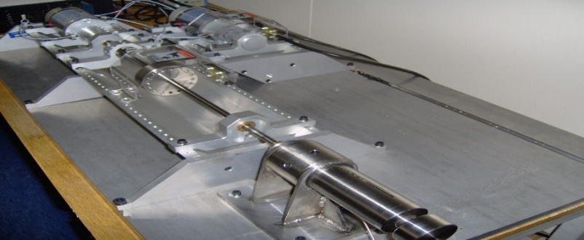

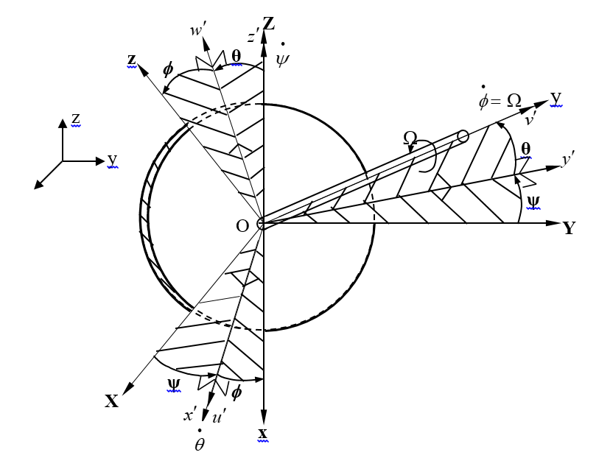

1. (b)

Figure 1: (a) Image of the rotor system, (b) Reference frames for a disk on a rotating flexible shaft-3-D view of the rotor

The model of the rotor system that is shown in Figure 1 is in the form of a Duffing equation containing cubic nonlinear terms, to represent the behavior of this dynamical system from nonlinear transition to chaos, and is solved by the use of *Dynamics 2* – a tool for bifurcation analysis. Therefore, we can write the Duffing equation of the flexible rotor system in the following form. The detailed description of these equations is in [8].

 **(1)**

 **(2)**

 **(3)**

 **(4)**

Where,, –linear stiffness coefficient, -damping coefficient, -displacements, -natural frequency, -nonlinear cubic stiffness coefficient, -excitation frequency, -mass unbalance, -characteristic equation coefficient, -external applied force,  are the axial excitation force terms and the dots denote differentiation with respect to t.

The models of the flexible rotor system equations (1) and (2) are used after some modifications for analyzing the behavior of the dynamical system using the Dynamics 2 software. We therefore write Model equations (1) and (2) in the following form:

 **(5)**

 **(6)**

 **(7)**

 **(8)**

Where, ; ; ;  ; and 

**Nondimensionalization**

Nondimensionalization of the timescale in Equations (5) to (8) is introduced by putting, where,  is the natural frequency of the first mode of the flexible rotor system and the prime  denotes differentiation with respect to dimensionless time . Also splitting the resultant second order ordinary differential equations into first order ordinary differential equations making them more compact we equations (5) to (8) becoming

 **(9)**

 **(10)**

 **(11)**

 **(12)**

 **(13)**

 **(14)**

where,;;;; ;-damping coefficient; -Gyroscopic term;-linear stiffness coefficient; -nonlinear cubic stiffness coefficient;  -actuator force;-excitation amplitude and . Similarly, the parameter values for the program codes are presented in Tables 1 and 2 for the models of coupled equations with and without the parametric force term.

**Bifurcation Analysis**

In the study of dynamical systems, a sudden qualitative or topological change can occur under the variation in a parameter of the system. These changes occurring in the dynamics of the system are called bifurcation. It is often desirable to know where in the parameter space nonperiodic motion exists. Bifurcation diagrams can be used to indicate such domains. A bifurcation diagram provides a summary of the essential dynamics of systems and is therefore a useful way of observing nonlinear dynamic behavior [9]. [10] used bifurcation diagrams in studying the nonlinear dynamics of the marine rotor-bearing system under yawing motion to show that yawing motion significantly affects the dynamic characteristics of the rotor-bearing system, which makes the rotor system to be dominated by the quasi-period. In performing bifurcation and chaos analysis of gear pair systems based on crack rotor-bearing system with rub-impact effect, [11] employed the use of bifurcation diagrams and Lyapunov exponent to identify the onset of chaotic motion. To investigate the conditions that lead to nonperiodic phenomena and to avoid irregular vibration, the properties and performance of the dual-directional coupled aerodynamic bearing system were explored in detail by [12] using bifurcation phenomenon and the maximum Lyapunov exponent. A periodic motion may become unstable if the control parameters are allowed to vary, a scenario signifying dynamic deterioration of stability that could lead to eventual chaos. In literature, there are various types of bifurcations, however, in the present analysis a period doubling bifurcation can mostly be observed and is analyzed in the following section in detail. It is a bifurcation in which the system’s behavior changes at integer multiples of the periodicity of the original response. If the control parameter is further varied, the motion may become chaotic. Appearance of multi-periodic motion indicates the set-in of dynamic instability. Bifurcation helps in identifying instabilities in dynamical systems and provides theoretical and practical ideas for controlling these systems and optimizing their operation.

***Dynamics 2* Program Parameters**

**Table 1: Data used for numerical simulations-dimensional parameters**

Stiffness Damping Actuator Stiffness Excitation

(Linear) Coefficient Force (Cubic) Amplitude

[] [] [] [] [m]

    

Gyroscopic term;

Reference frequency: ; Parametric frequency: 

**Table 2: Data used for numerical simulations-nondimensional parameters**

Stiffness Damping Actuator Stiffness Excitation

(Linear) Coefficient Force (Cubic) Amplitude

    

Gyroscopic term; rad/s;  rad/s

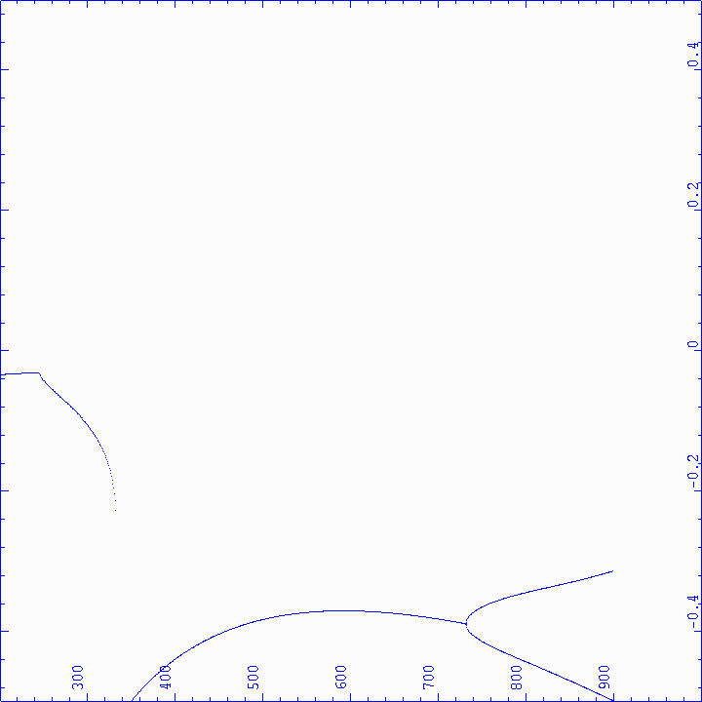 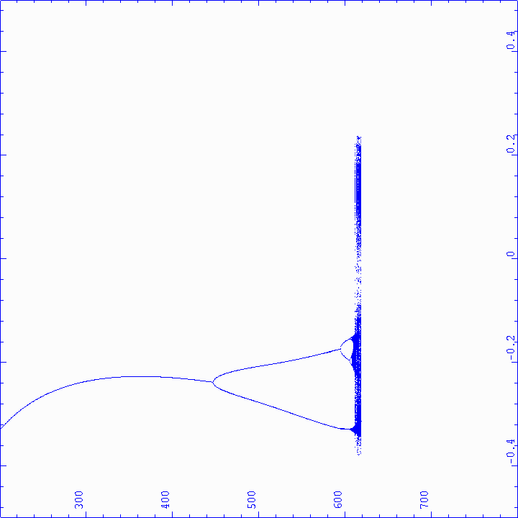

L

y

a

p

u

n

o

v

E

x

p

o

n

e

n

t

L

y

a

p

u

n

o

v

E

x

p

o

n

e

n

t

**x**

**x**

250

40**0**

46**0**

505

250

618

84**0**

40**0**

46**0**

50**5**

618

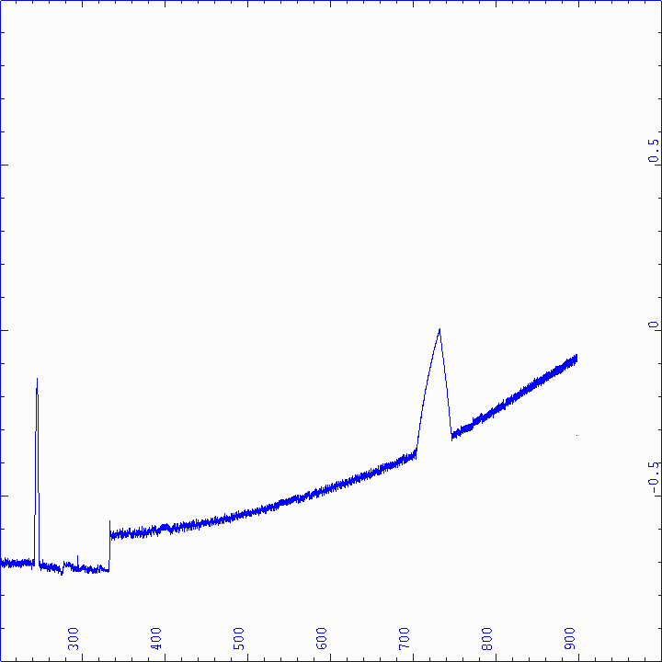 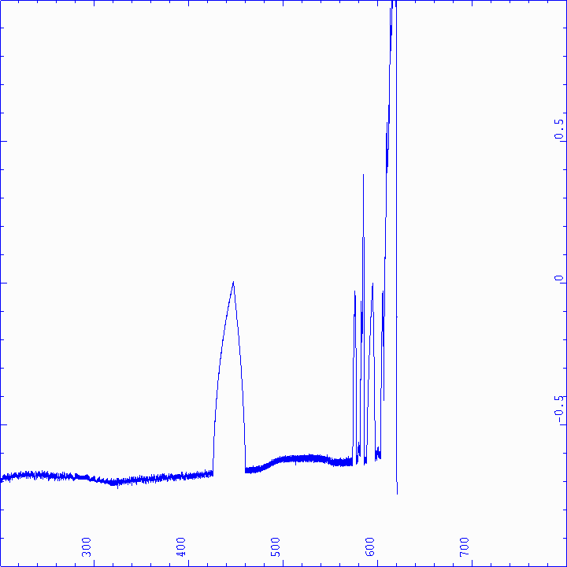

(2a)  (2b) 

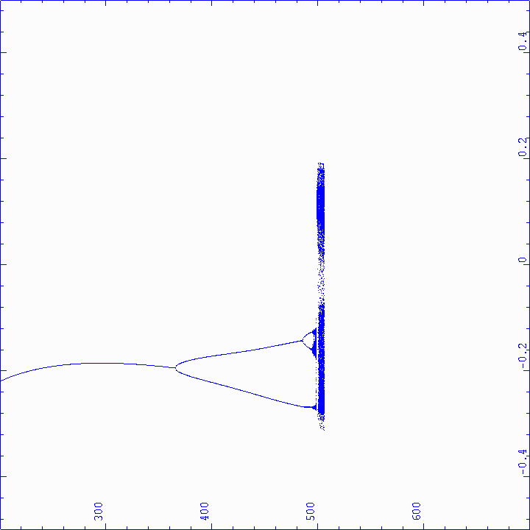 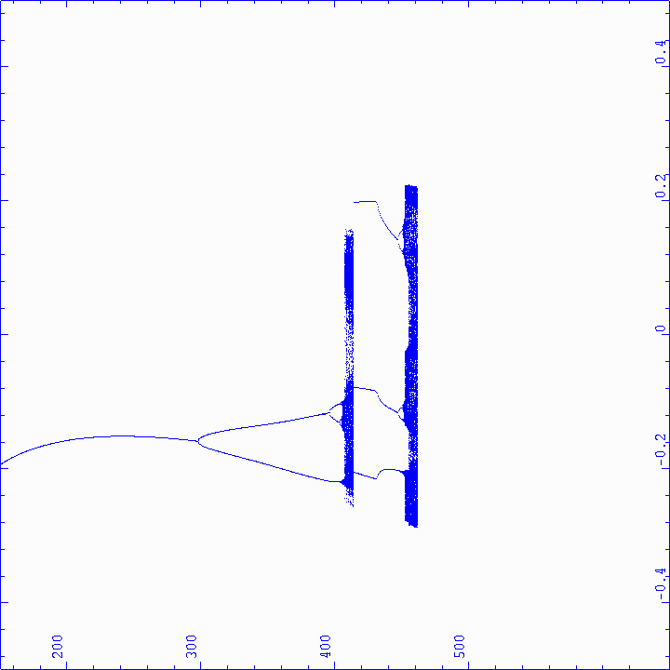

**460**

**400**

**250**

**505**

**460**

**400**

**250**

x

x

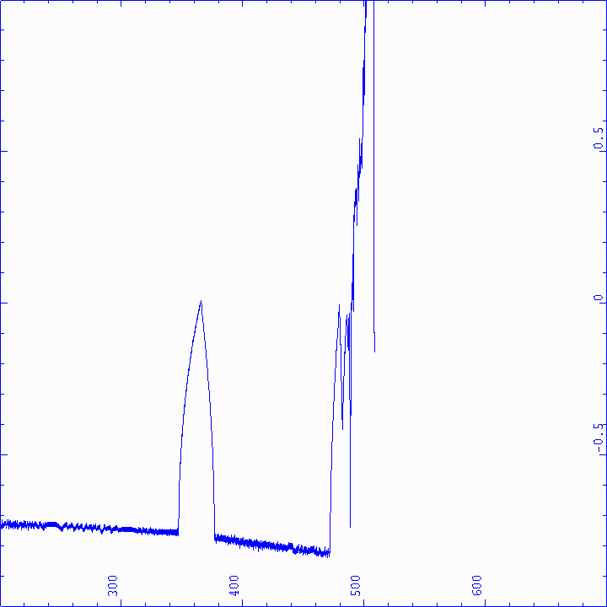 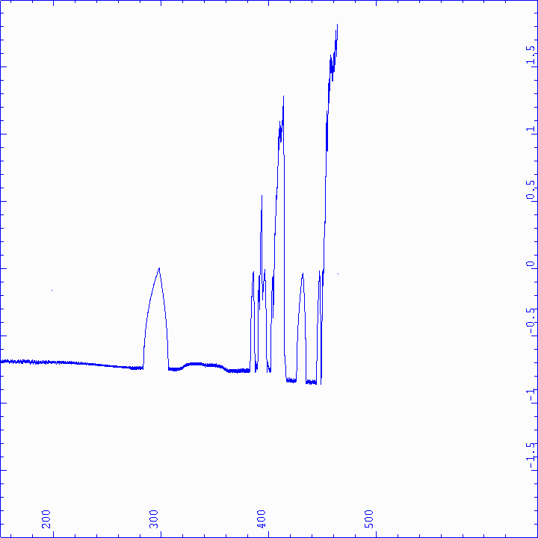

L

y

a

p

u

n

o

v

E

x

p

o

n

e

n

t

L

y

a

p

u

n

o

v

E

x

p

o

n

e

n

t

(2c)  (2d) 

Figure 2: Lyapunov exponent and Bifurcation diagrams of amplitude as a function of the normalized excitation acceleration in the horizontal direction.

In understanding the dynamics within the models in section 2, the *Dynamics 2* software was used to plot the bifurcatory behavior of the amplitude responses as a function of normalized excitation acceleration and the Lyapunov exponent, and these are illustrated in Figures 1(a, b, c, d) and 2(a, b, c, d). All data used for these plots are system parameters taken from an experimental rig and graphs are plotted using nondimensionalised parameters tabulated in Table 2. All the figures are plotted using certain necessary *Dynamics 2* commands and are presented in [8]. In this study a weakly nonlinear system is being investigated, and for the physical system to become more intrinsically nonlinear the excitation acceleration and the nonlinear cubic coefficient values have to be increased either by increasing the mass unbalance or by making the shaft more flexible, or both. Therefore in order to obtain and investigate the situation when the system is more strongly nonlinear the mass unbalance value is artificially increased to various multiples of the actual value. This manipulation increases the excitation value to a high level driving the weakly nonlinear system into more nonlinear reaches of the response range making the effect of the nonlinear terms proportionally greater than they would otherwise be. This effect causes the system to show possible bifurcations to chaos.

**Results and Discussions**

The Bifurcation behavior of the rotor system for the case of different mass unbalances are plotted in terms of (i) Amplitude of response, X, as a function of nondimensionalised excitation acceleration and the Lyapunov exponent in the horizontal direction and (ii) Amplitude of response, X, as a function of nondimensinalised excitation acceleration and the Lyapunov exponent for the Model with Parametric Force Term in the horizontal direction.

(a) Amplitude of response, X, as a function of nondimensionalised excitation acceleration and the Lyapunov exponent in the horizontal direction.

1. At nondimensionalized excitation acceleration of 250, all the bifurcation diagrams for the different values of mass unbalance in Figures 2 (a), (b), (c) and (d) show periodic and stable motions with negative Lyapunov exponents.
2. At nondimensionalized excitation acceleration of 400, the bifurcation diagrams in Figures 2 (a) and (b) show period one motion whereas Figures 2 (c) and (d) show period two and period four motions respectively.
3. At nondimensionalized excitation acceleration of 460, the bifurcation diagram in Figure 2(a) shows period one motion with negative Lyapunov exponent whereas Figures 2 (b) and (c) show period two motions with negative Lyapunov exponents and Figure 2 (d) shows chaotic motion with positive Lyapunov exponent.
4. At nondimensionalized excitation acceleration of 505, the bifurcation diagrams in Figures 2 (a) and (b) show period one and period two motions respectively with negative Lyapunov exponents whereas Figure 2 (c) show chaotic motions with positive Lyapunov exponents.
5. At nondimensionalized excitation acceleration of 618, the bifurcation diagrams in Figure 2 (a) shows period one motion with negative Lyapunov exponent and that in Figure 2 (b) shows chaotic motions with positive Lyapunov exponent.
6. At nondimensionalized excitation acceleration of 840, the bifurcation diagram in Figure 2 (a) shows period two motions with negative Lyapunov exponent.

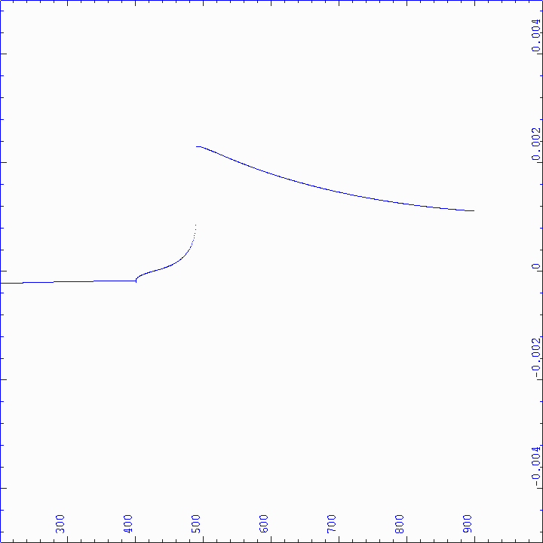 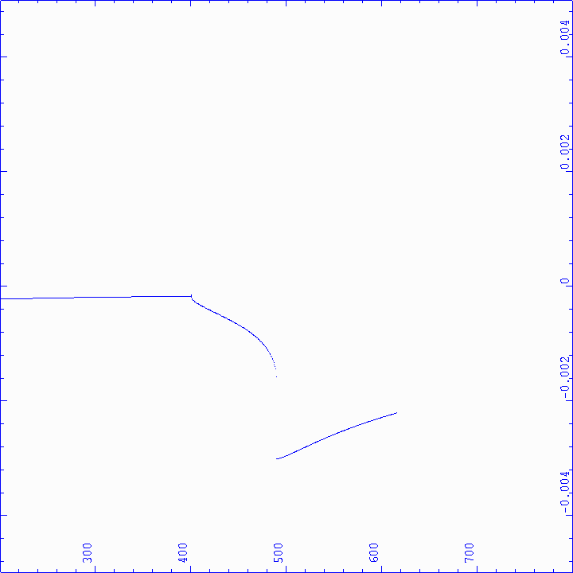

x

x

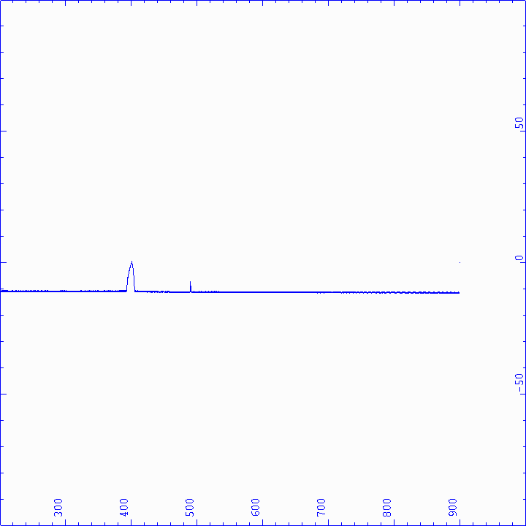 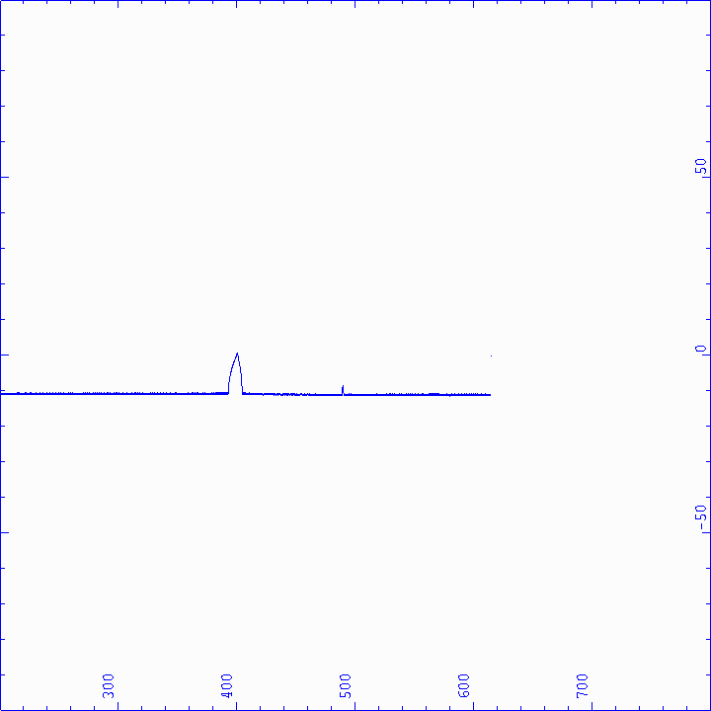

L

y

a

p

u

n

o

v

E

x

p

o

n

e

n

t

L

y

a

p

u

n

o

v

E

x

p

o

n

e

n

t

(3a)  (3b) 

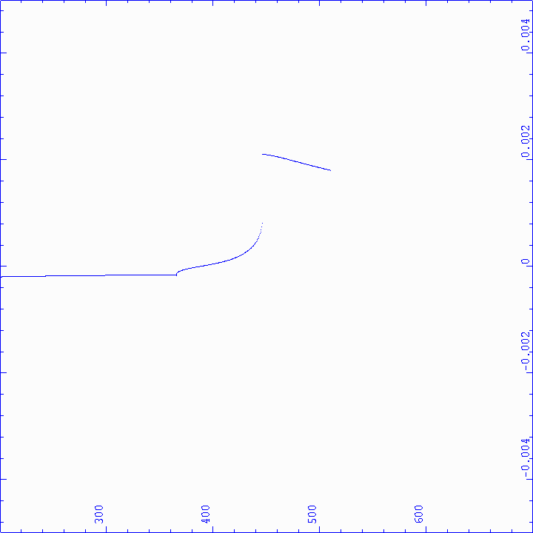 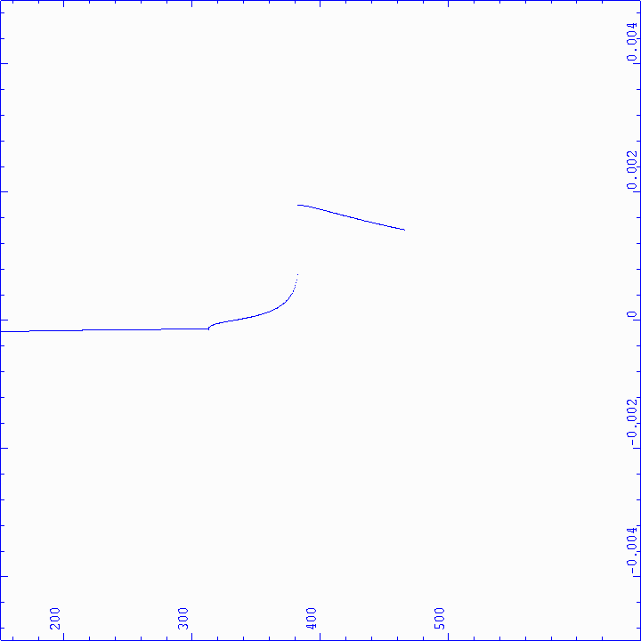

x

x

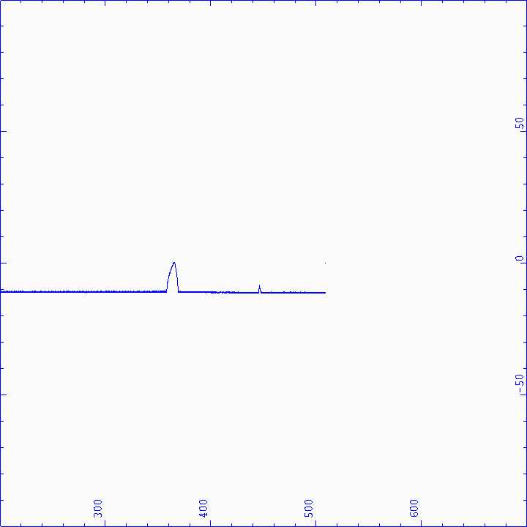 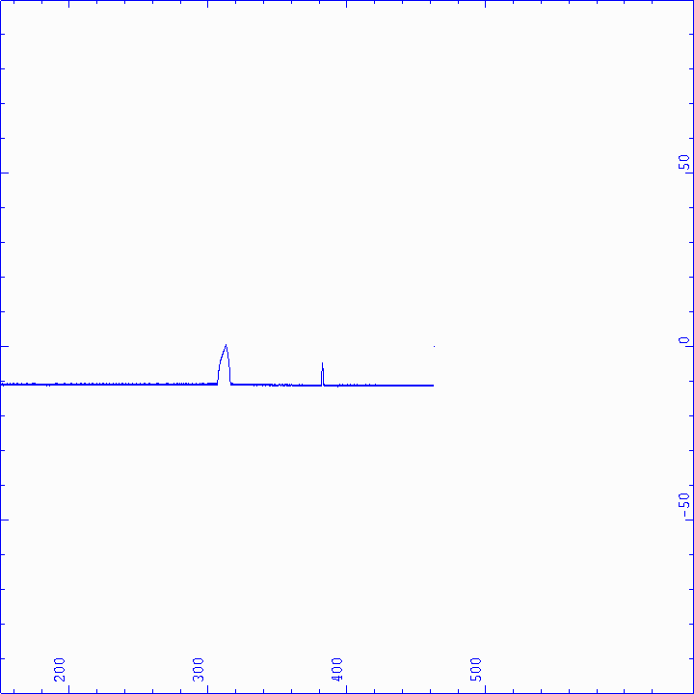

L

y

a

p

u

n

o

v

E

x

p

o

n

e

n

t

L

y

a

p

u

n

o

v

E

x

p

o

n

e

n

t

(3c)  (3d) 

Figure 3: Lyapunov exponent and Bifurcation diagrams of amplitude as a function of the normalized excitation acceleration for the Model with Parametric force terms in the horizontal direction**.**

From the analysis (i) the periodic response for the case based on the smallest mass unbalance in Figure 2 (i.e. the most weakly nonlinear response), bifurcates to chaos as the mass unbalance increases. Positive Lyapunov exponents for Figure 2(a)-(d) respectively show clear indication of chaos, while the negative Lyapunov exponents show stable motion. Also from these graphs, as the response become chaotic, less excitation acceleration is required in each of the four cases successively. One finds that five kinds of system motion exits over the range of excitation acceleration values. These are stable single period motion, stable period two motion, stable period four motion, stable quasi-periodic or multiperiod motion, and chaotic motion. (ii) It can also be observed from Figure 2(a-d) that any time the system bifurcates to higher multiples of periodic motion, a jump up to the zero level in the Lyapunov exponent plot occur, which is also an indication that the system moves to higher multiples of the period.

(b) Amplitude of response, X, as a function of nondimensionalised excitation acceleration and the Lyapunov exponent for the Model with Parametric Force Terms in the horizontal direction.

1. At all the nondimensionalized excitation acceleration levels, all the bifurcation diagrams in Figure 3 show stable periodic motions with negative Lyapunov exponents.

From the analysis (i) Figure 3 shows the bifurcation as controlled by normalized excitation acceleration in the horizontal direction, and using the first mode resonance frequency value, when a parametric force term is included at a parametric frequency of twice the first mode resonance frequency value. By increasing the mass unbalance values, the periodic responses remain periodic. The bifurcation diagrams do not change qualitatively, while the negative Lyapunov exponents show stable periodic motion. This means upon introducing the parametric force terms into the system all the period doubling and chaotic motions present in the system, and observed in Figure 3, become stable. This indicates that the period doubling and chaotic motions, which is bounded by the bifurcation set, is automatically shifted resulting in stable periodic motions, and the complete elimination of chaos, noise and vibration.

**Conclusion**

The aims of this study were to analyze the dynamic behavior of the flexible rotor system operating under the influence of mass unbalance, to identify stable and chaotic operation areas of operation and also to analyze the rotor system’s behavior upon deliberate introduction of parametric excitation terms into the system’s dynamics. The system’s equations in the form of Duffing equation containing cubic nonlinear terms were solved using Dynamics-2 software, which is a tool for bifurcation analysis. The vibration analysis results indicate that the trajectory of the rotor system changes significantly with changes in the mass unbalance of the rotor system. The changes in the mass unbalance produce various behaviors including period one, period two and unstable nonlinear chaotic motions. The study further shows that upon introducing parametric force terms into the system all the period doubling and chaotic motions present in the system became stable. This indicates that the period doubling and chaotic motions, which are bounded by the bifurcation set, are automatically shifted resulting in stable periodic motions, and the complete elimination of chaos, noise and vibration. These findings can be used in tackling real vibrational issues encountered by manufacturers in the design of new rotating machines amongst which hydraulic turbines and generators feature very importantly. They therefore serve as useful sources of reference for engineers in designing and controlling such systems.

**Acknowledgement**

The authors would like to acknowledge the support of Prof. P. M. Cartmell formerly of University of Glasgow, the Mechanical Engineering Department of University of Glasgow, EPSRC grants EP/C 531892/1 and EP/C 531906/1.

**References**

[1] Abrahams R., and Shaw C., (1982). Dynamics: The geometry of behaviour, Arial Press, Sancta Cruz.

[2] Wolf A., Swift J. B., Swinney H. L., and Vastano J. A., (1985). Determining Lyapunov exponents from a time series. *Physica*, **16D**, pp. 285-317.

[3] Nusse H.E., and York J.A., (1994). Dynamics: Numerical Explorations, Springer-Verlag: New York.

[4] Nusse H.E., Ott E., and York J.A., (1994).Border-collision bifurcations: An explanation for observed bifurcation phenomena. *Physical Review*, **E49 (2)**, pp. 1073-1076.

[5] Nusse H.E., Ott E., and York J.A., (1995). Saddle-node bifurcations on fractal basin boundaries. *Physical Review Letters*, **75 (13)**, pp. 2482-2485.

[6] Chin W., Ott E., Nusse H.E., and Grebogi C., (1994*).* Grazing bifurcations in impact oscillations. *Physical Review*, **E50(6)**, pp. 4427-4444.

[7] Nusse H.E., and York J.A., (1998). Dynamics: Numerical Explorations (2nd Edition). Springer-Verlag: New York.

[8] Atepor L., (2008). Vibration Analysis and Intelligent Control of Flexible Rotor Systems using Smart Materials, *Ph.D. Thesis,* University of Glasgow, U.K.

[9] Chang-Jian Cai-Wan and Chen Chao-Kuang, (2007).Bifurcation and chaos analysis of a flexible rotor supported by turbulent long journal bearings. *Chaos, Solutions and Fractals*, **34**, pp.1160-1179.

[10] Shi Yangxu, Li Ming and Li Ming, (2020). Study on nonlinear dynamics of marine rotor-bearing system under yawing motion. *MMEAT 2020. Journal of Physics: Conference series, 1676(2020)012156.*

[11] Chang-Jian Cai-Wan, Wang Cheng-Chi and Chu Li-Ming, (2018). Bifurcation and chaos analysis of gear pair system based on crack rotor-bearing system with rub-impact effect: *MATEC Web of Conference***, 202**, 01008(2018).

[12] Wang Cheng-Chi and Lin Chih-Jer, (2020). Bifurcation and nonlinear behaviour analysis of dual-directional coupled aerodynamic bearing systems. *Symmetry*, **12(1521)**, pp. 1-23.

**Biographies**

**LAWRENCE ATEPOR** is an Associate Professor of Mechanical Engineering (Dynamics). He had his M.Sc. in Mechanical Engineering from Tashkent Institute of Engineers of Irrigation and Agricultural Mechanization, Tashkent, Uzbekistan, U.S.S.R in 1992. He had his PhD in Mechanical Engineering from University of Glasgow, Glasgow, UK. in 2009. He is now with the School of Engineering, Mechanical Engineering Department of Cape Coast Technical University, Ghana. His research interests are in Vibration Analysis and Control of Structures, Linear and Nonlinear Dynamics of Structures, Mechatronics/ Automobile Control, Renewable Energy and Applied Human Factors and Ergonomics. He has published 10’s of research papers in international journals and conferences and has authored 3 books. Dr. Atepor may be reached at [lawrence.atepor@cctu.edu.gh](mailto:lawrence.atepor@cctu.edu.gh) or [ccprector@gmail.com](mailto:ccprector@gmail.com).

**FRANCIS DAVIS** is an Associate Professor in Mechanical Engineering (Design and Manufacturing) at the Department of Mechanical Engineering, Kwame Nkrumah University of Science and Technology (KNUST), Kumasi. He holds a PhD in Mechanical Engineering from North Carolina Agricultural & Technical State University, Greensboro, USA, and an MPhil in Mechanical Engineering, and a BSc (Hons) Degree in Mechanical Engineering, each from the KNUST, Kumasi, Ghana. His research interests are: design of experiment and modeling; design, analysis, and manufacturing of engineering product; monitoring of machining operations using acoustic emission; maintenance and production engineering. Dr. Davis may be reached at [fdavis.coe@knust.edu](mailto:fdavis.coe@knust.edu).

**PAUL AKANGAH** is currently a Teaching Associate Professor of Mechanical Engineering at the North Carolina A&T State University. He earned his B.S. degree from Kwame Nkrumah University of Science & Technology, Kumasi, Ghana, MS (Energy Engineering, 2005) from The Royal Institute of Technology (KTH), Stockholm, Sweden, and Ph.D. (Mechanical Engineering, 2011) from the North Carolina A&T State University, Greensboro, NC. Dr. Akangah interests are in engineering pedagogy, metallic forms for structural and thermal applications, and advanced composites materials. Dr. Akangah may be reached at [pmakanga@ncat.edu](mailto:pmakanga@ncat.edu).