# 136-x-20

A Set of Interdisciplinary Activities for Utilizing Smart Colored
Windows in Contemporary Architecture

Negar Heidari Matin
University of Oklahoma
negar.matin@ou.edu

Forough Z. Shahraki
Eastern Michigan University
fzareans@emich.edu

Ali Eydgahi
Eastern Michigan University
aeydgahi@emich.edu

Abstract

Collaborations between different disciplines provides unique opportunities for integrating ideas and methods, infusing skills, sharing tools, utilizing teamwork, improving cognitive abilities, and thinking critically to develop and form new knowledge and products.

The process of designing, prototyping, and evaluating the performance of a contemporary building with smart colored windows can assist the students in architecture programs to be more involved in interdisciplinary projects that are inspired by use of knowledge from other fields.

This paper presents interdisciplinary activities that can be used in senior design projects, independent studies, and graduate theses by both undergraduate and graduate students in architecture and interior design programs. The proposed hands-on activities include design and implementation of smart color coating for glass windows, determination of optical properties and characteristics of the colored windows by using ultraviolet-visible spectroscopy method, and performance evaluation of the designed colored windows by using Rhino software along with its Grasshopper and DIVA plug-in modules.

In the proposed activities, students gain practical interdisciplinary experience by utilizing the data obtained from design and implementation in laboratory environment for testing and evaluating the design in simulation environment. These activities also improve students professional and team work skills that are crucial attributes in contemporary working environments.

Introduction

Innovation arises from the intersections of different disciplines, as it is declared by the U.S. National Innovation Initiative [1]. The training of students as innovative thinkers in dealing with today’s complexity of global challenges requires interdisciplinary education, which integrates information, data, techniques, tools, perspectives, concepts and theories from two or more disciplines and answers questions beyond the scope of a single discipline [2]–[12].

Materials science by promoting smart materials that can improve energy efficiency, users’ comfort and well-being, and decreasing CO₂ emission in build environment can be considered as one of the frontiers in sustainability [13]-[14]. Working closely with materials scientists can provide an opportunity for architectures to generate, synthesize, and implement innovative sustainable ideas in design practices [15]-[16].

The building responsive facade is one of the main contributors of providing users’ comfort and well-being in sustainable indoor environment [17]–[21]. The implementation of advanced material-based technologies have provided a capability for responsive facade systems to continuously change its own functions, features, or behavior over time in response to environmental stimuli and occupants’ preferences in order to improve facade thermal and visual performance [22].

Different types of smart materials such as electrochromic [23]-[25], thermochromic [26], gasochromic [27], liquid crystal [28], and photochromic [29] have been utilized to develop smart windows for responsive facade systems. The coating of photochromic materials can be applied on the surface of window glass as a thin film to provide a capability for glass to dynamically adjust its own color, transparency, and consequently its reflective properties upon exposure to various intensity of sunlight [29]-[31].

The range of colors created with photochromic materials not only decrease the transmittance of visible light, but also reduce the transmittance of ultraviolet (UV) and Infrared (IR) wavelengths, which are considered harmful to human skin, furniture materials, and paints up to 60% compared to the standard float glasses [29], [31]-[32].

In an effort to provide students of interior design program at Eastern Michigan University an opportunity to get involved in an interdisciplinary project that promotes sustainable concepts in building design, a set of hands-on modules for the process of designing, prototyping, and evaluating the performance of responsive facade system utilizing smart colored windows have been developed. The proposed modules are designed for use by both undergraduate and graduate students in architecture and interior design programs as independent studies, senior design projects, or graduate theses.

The Proposed Interdisciplinary Activities

The proposed activities consist of four modules that provide students with hands-on experience of working on the design, implementation, and performance evaluation of a responsive facade system using colored windows as an interdisciplinary project. The relationship between the modules and the activities is demonstrated in Figure 1.

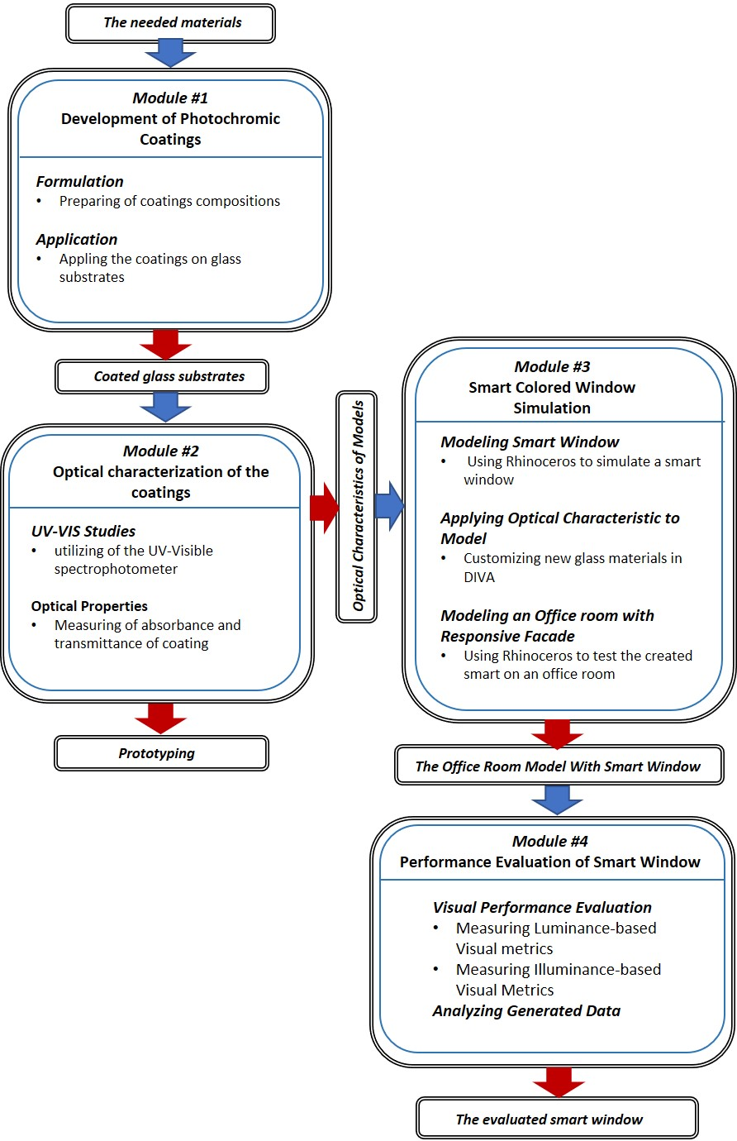
Figure 1. The relationship between proposed hands-on modules

The first two modules concentrate on the design and development of smart windows with photochromic coating formulation and the optical properties and characteristics of the coated glass substrates of the windows in a laboratory environment. The last two modules use the laboratory data obtained in the first two modules to design and simulate a responsive facade system with the designed smart color windows and then evaluate performance of the facade system by utilizing various software.

The goals of the activities are:
- To enable students to identify smart coating materials,
- To enable students to understand the smart coating formulation process,
- To introduce optical properties and how these affect the thermal and visual performance of the facade,
- To enable students to characterize the optical properties of coated glass substrates using Ultraviolet-visible spectroscopy method,
- To improve students’ skills in evaluating the performance of colored smart windows using the optical properties,
- To engage students in analyzing the data obtained from the performance evaluation of a facade system with smart colored windows,
- To improve student’s collaboration skills in multidisciplinary groups,
- To increase students’ skills in written and oral presentations,

Module #1: Development of coatings

The purpose of this module is to familiarize students with primary principles of coating and how these principles are applied to develop a colored glass. In this activity, students are introduced to the theoretical concepts related to coatings, photochromic dyes, and development of photochromic coating glasses prior to practical experimentation.

Coatings are thin films applied on the surfaces of objects for two primary functions, enhancement of aesthetics aspects and surface protection. They can be found everywhere from interior applications such as walls, furniture, kitchen appliances, and electronic devices to exterior uses such as facades, automobiles, power cables, air crafts, roads, etc. [33]–[36].

Coatings formulations usually comprise of four main ingredients [36]. First, a binder, which acts as a film former and holds all the ingredients together. Second, pigments and/or dyes, which provide color and opacity. Third, additives, which are used in very small quantities to enhance special properties. Finally, solvents, which are usually used to adjust the flow of the coatings. Photochromic coatings are a specific class of smart coatings, which typically contain a photochromic dye in their formulation. Photochromic dyes are in crystalline powder form that could reversibly change color when dissolved in proper solvents and exposed to ultraviolet light.The entire activities are designed to be completed within a laboratory period of about 2.5 hours as presented in Table 1.

Table 1. Overview of the main experimental activities in the first module
Activity #1: Description |  | Time  (min)
1 | Introduce students to coatings, photochromic dyes, color perception, and smart windows through a brief lecture | 30
2 | Describe the safety lab rules, and experimental procedure; assign students into groups and distribute tasks among group members | 15
3 | Label the vials, prepare the dye solutions with various colors | 30
4 | Formulate the coatings by blending the dye solutions with resins and additives | 15
5 | Clean the glass substrates and application of coatings using square film applicators | 30
6 | Safely Organize/clean the glassware, equipment, and supplies | 30
Total time for all activities |  | 150

It should be mentioned that these experiments could be easily performed in modern university laboratories to provide a brief overview of the smart coatings landscape. Furthermore, nearly all of the experiments can be conducted on the benchtop without the need for specialized equipment.

Module #2: Optical characterization of the coatings

Visible light is composed of a range of wavelengths of light. The color of an object is determined by what wavelengths of light the object absorbs and reflects. According to additive Red-Green-Blue (RGB) [30], [37] and subtractive Cyan-Magenta-Yellow (CMY) color models [38], the color we perceive is complementary to the light colors absorbed by an object. Complementary colors are two colors that are on opposite sides of the color wheel as shown in Figure 2. For instance, a cyan dye solution absorbs red (the complementary color to cyan), leaving the green and blue light to reflect.

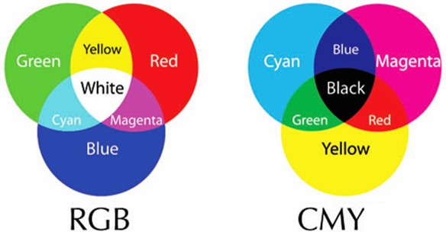
Figure 2. Complimentary colors in RGB and CMY systems [retrieved from http://jesusgilhernandez.com/2012/10/19/color-systems-and-color-wheels/

Ultraviolet-visible (UV-VIS) spectroscopy is a popular analytical method used to quantify the optical characteristics of materials. The instrument used in UV-VIS spectroscopy is called UV-VIS spectrophotometer. It measures the intensity of light after passing through a material (I) and compares it to the intensity of light before it passes through the sample, I₀.

The ratio, I/I₀, is called Transmittance (T) and is usually expressed as a percentage (%T), which is equal to 100T. Transmittance is mathematically related to absorbance (A) as demonstrated in equation (1) [39].

A = - log (%T/100) = 2 – log %T (1)

Then, the Transmissivity is calculated using equation (2).

Transmissivity = (sqrt (0.8402528435 + 0.0072522239 * T²) - 0.9166530661) / 0.0036261119 / T) (2)

This module deals with how to run the UV-VIS spectroscopy in order to study the optical characteristics of the photochromic coatings. To start this activity, first Toluene as the baseline is charged into a quartz cuvette, which is a small tube-like container used in UV-VIS spectrophotometer. A baseline measurement is similar to a "zero" measurement in which a "baseline" measures a "zero" correction for each wavelength in a scan. After scanning the baseline, the cuvette is charged with the photochromic solution and is scanned (bleach state).

Next, the solution is irradiated with a UV-lamp for 30 seconds, and immediately is scanned (color state). This process is performed for each color that has been used. Then, the data is imported into Excel spreadsheets and the transmittance and transmissivity variables using equations (1) and (2) are calculated. Then, the calculated data is imported to the simulation in the next module. This module is also designed to be completed within a laboratory period of about 2.5 hours as indicated in Table 2.

Table 2. Overview of the main experimental activities in the second module
Activity#2: Description |  | Time  (min)
1 | Introduce students to the fundamentals of color perception and UV-VIS spectroscopy | 30
2 | Review the safety lab rules and experimental procedure | 15
3 | Instruct each group to run UV-VIS spectroscopy on the photochromic solutions | 60
4 | Import the UV-VIS data into an excel spreadsheet and plot it | 15
5 | Calculate the variables needed for simulation | 30
Total time for all activities |  | 150

Module #3: Simulation process

The purpose of this module is to use Rhinoceros software to simulate two-pane windows made of low-e glass for exterior and photochromic coated glass for interior sides. In this module, the data obtained from UV-visible spectroscopy is utilized for the simulation of three shades of photochromic glasses.

Prior to use of this activity, students are required to study high-performance facade systems by focusing on responsive facades with material-based control technologies. This would educate them how one could integrate sensors, actuators, and control systems of a responsive facade system into the body of a photochromic glass. Students also need to learn about how to customize material in DIVA-for-Rhinoceros, how to characterize two-pane windows using the transmittance and transmissivity, and how to evaluate the performance of coated glasses. This module is designed to be completed in about 2 hours as shown in Table 3.

Module #4: Evaluating the performance

This activity provides an opportunity for students to evaluate performance of the designed two-pane windows in a responsive facade system. It starts by simulating a simple office room located in a desired location by using Rhinoceros software. Then, visual performance evaluation are determined by utilizing DIVA-for-Rhinoceros to measure indoor illuminance, Useful Daylight Illuminance (UDI) and Daylight Glare Probability (DGP).

Table 3. Overview of the main simulation activities in the third module
Activity#3 Description |  | Time  (min)
1 | Study and learn about high-performance buildings, responsive facades, facade control technologies, material-based control systems, low-e windows and photochromic windows | 20
2 | Simulate two-pane windows constructed from exterior low-e glass and interior photo chromic glasses using Rhinoceros | 20
3 | Utilize DIVA-for- Rhinoceros for Characterizing two-pane windows using the transmittance and transmissivity | 30
4 | Students learn about visual comfort concepts, visual metrics, and their related formulas. In addition, students learn how to measure visual metrics using DIVA such as UDI and DGP | 50
Total time for all activities |  | 120

The visual performance of various colored photochromic windows are evaluated and compared to identify the best photochromic shades for controlling daylight. The building performance considering Energy Plus Weather files (EPW), sky condition, sunlight patterns, and time parameters are obtained. In addition, glare discomfort effects are evaluated by utilizing the measured hourly DGP in the specific point of the simulated office. This module is designed to be completed in about 3 hours as shown in Table 4.

Table 4. Overview of the main simulation activities in the fourth module
Activity#4 Description |  | Time  (min)
1 | Utilize Rhinoceros to simulate a simple office room and apply three designed two-pane windows to its facade in order to evaluate its visual performance | 20
2 | Set-up building performance simulation considering EPW climate files, sky condition and sunlight patterns, time parameters and façade orientations | 10
3 | Run performance evaluation by using DIVA to measure selected metrics, indoor illuminance, UDI and DGP. | 50
4 | Use Microsoft Excel for importing, interpreting, analyzing, visualizing and recording the generated data. | 50
5 | Analysis the data and propose advices for improving the designed responsive facade for future research | 60
Total time for all activities |  | 190
Test of the Proposed Modules

An interdisciplinary team of students from the interior design and polymers and coating programs at Eastern Michigan University used the proposed modules to develop and create seven different shades of smart photochromic coated glass windows.

For module #1, after a lecture on the coatings principles, the students started the experiment by preparing the photochromic dye solutions to make different color shades. This was done by dissolving the required amounts of dyes in Toluene solvent and storing the resulting solutions in the labeled vials. Next, they prepared the coating formulations by mixing the different coating ingredients according to Table 5 as shown in Figure 3-a. Then, they were instructed how to apply a film of photochromic coating on the glasses using a square film applicator as shown in Figure 3-b. After the application, the coated glasses were kept at room temperature in a closed cabinet to prevent dirt pick-up during the drying period.

Table 5. Formulation of the photochromic coatings
Ingredients | Weight (gr)
Binder | 93.5
Photochromic dye solution | 4
UV absorber | 2
light stabilizer | 1
Leveling agent | 0.5
Total weight | 100

One attractive and exciting feature of photochromic phenomenon during the preparation of the coated glasses was observation of the color change upon exposure to UV-light, which was conducted using a 40 watt UV lamp as presented in Figure 3-c. In this experiment, seven different coated glass substrates was created as depicted in Figure 4.

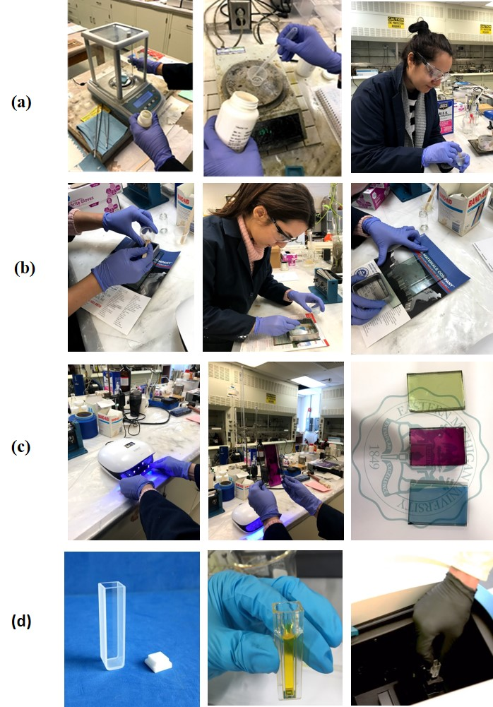
Figure 3. Illustration of the total procedure: (a) Preparation of the photochromic coating formulations; (b) Application of the coatings on glass; (c) Photochromic activity of coatings by light exposure.

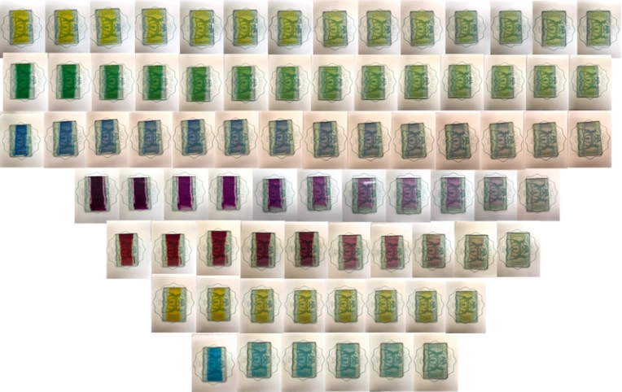
Figure 4. The developed photochromic coatings upon exposure to UV for a specific time
For module #2, after review of the safety rules, experimental procedures, fundamentals and use of UV-VIS spectroscopy for obtaining the optical characteristics of the photochromic coatings, the experiment started with charging Toluene, as the baseline, into a quartz cuvette.

After scanning the baseline, the cuvette was charged with the photochromic solution and was scanned. Then, the solution was irradiated with the UV-lamp for 30 seconds and was immediately scanned. This process was performed for three of the developed photochromic coatings, namely red, blue, and yellow colors. The absorbance as a function of wavelength for the red photochromic solution is demonstrated in Figure 5. As discussed before, since this solution absorbs light in the green region (495–570 nm), its color is perceived as red.

Figure 5. UV-VIS spectrum of the red photochromic solution

Next, students imported the data of optical characteristic of the coatings into Excel spreadsheets and calculated the transmittance and transmissivity using equations (1) and (2) as presented in Table 6.

Table 6. Transmittance and transmissivity values of three photochromic solutions
Color | % Transmittance | Transmissivity
Red | 56 | 61.04
Blue | 48 | 52.32
Yellow | 70 | 76.3

For module #3, after students educated themselves about responsive facade systems with material-based control technologies, they utilized Rhinoceros software and the data in Table 6 to simulate three different two-pane windows for the designed photochromic glasses.

Students defined red colored photochromic glass with a 56% of transmittance in DIVA-for-Rhinoceros. Then, rtn, gtn, and btn factors, which are representatives of transmissivity at red, green, and blue wavelengths were derived from the transmittance of the glass, respectively. The definitions of photochromic glasses used in DIVA are shown in Figure 6.

At the final stage of this activity, students worked on an experiment workflow for evaluating the visual performance of two-pane windows and visualizing it with diagrams.

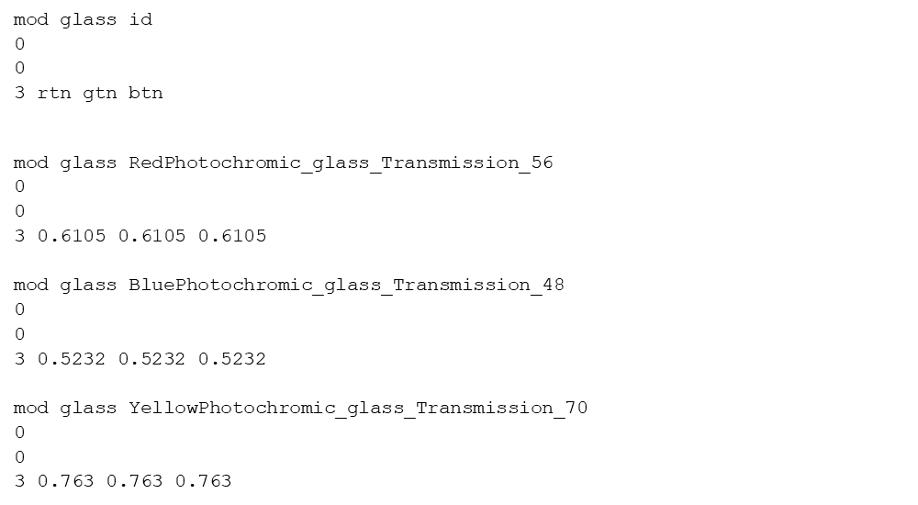
Figure 6. The definition of photochromic glasses in DIVA

For Module #4, students started by simulating a simple office room located in Ann Arbor, Michigan by utilizing Rhinoceros 0.6. The dimensions of the designed office were 4.0 m wide, 9.0 m deep, and 3.0 m high (floor-to-floor). It was assumed that simulated office room has a south faced opening with 2.6 m width and 3.6 m length for a window.

Then, three different windows were designed for testing. The exterior pane of all three windows was made from low-e, clear glass with a visible light transmittance of 50%. The interior pane of the windows was made from photochromic glasses for three colors of red, blue and yellow. All three developed windows were individually tested as a part of the responsive facade system of the office room.

At the next step, students used DIVA-for-Rhinoceros to measure indoor illuminance metrics of UDI and DGP. Then, they generated hourly indoor illuminance for June 21 and compared the performance of all three two-pane windows as shown in Figure 7.

Indoor illuminances in the range of 300 to 2000 Lux are perceived as desirable for office spaces [40], [41]. Student used UDI metric to identify percentage of time in an entire year for the comfort zone range of 300Lux-2000Lux for various areas of the office room. The result of UDI metrics showed red and blue coating colors had higher amount of useful daylight illuminance compare to yellow coating, respectively. This indicates that red coating glasses provide higher percentages of comfort time.

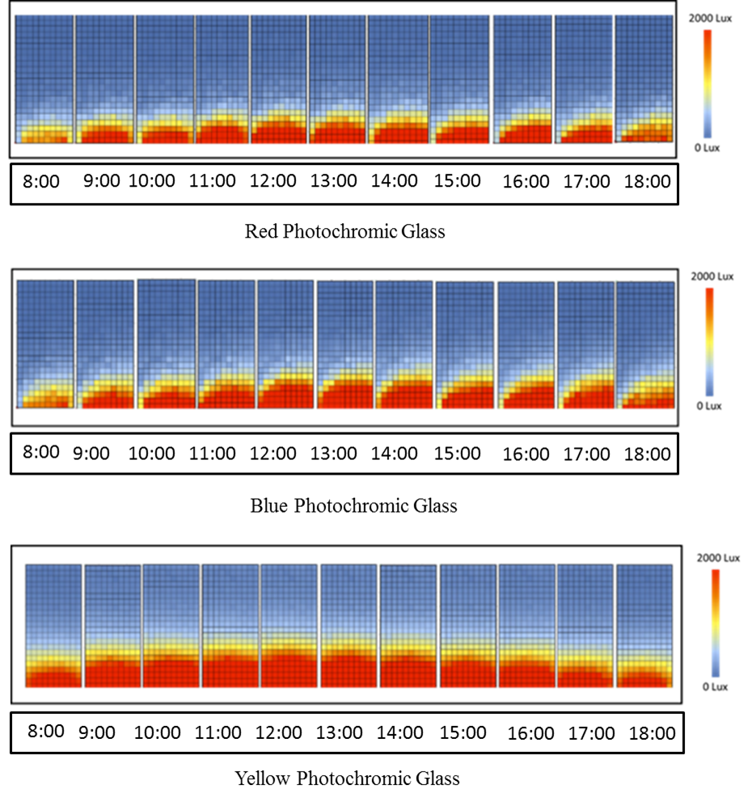
Figure 7. Hourly indoor illuminance for photochromic glasses on June 21

Next, student run annual glare test, which was calculated by measuring hourly DGP in the specific point of room. The results of annual glare in four different ranges of DGP are shown as heat-maps in Figure 8, which indicates that blue photochromic coating had the desirable performance in controlling glare during summer time from April to September.

It should be noted that daylight glare probability has been classified in four ranges containing 30-35 (imperceptible), 35-40 (perceptible), 40-45 (disturbing), and 45-100 (intolerable) [42].

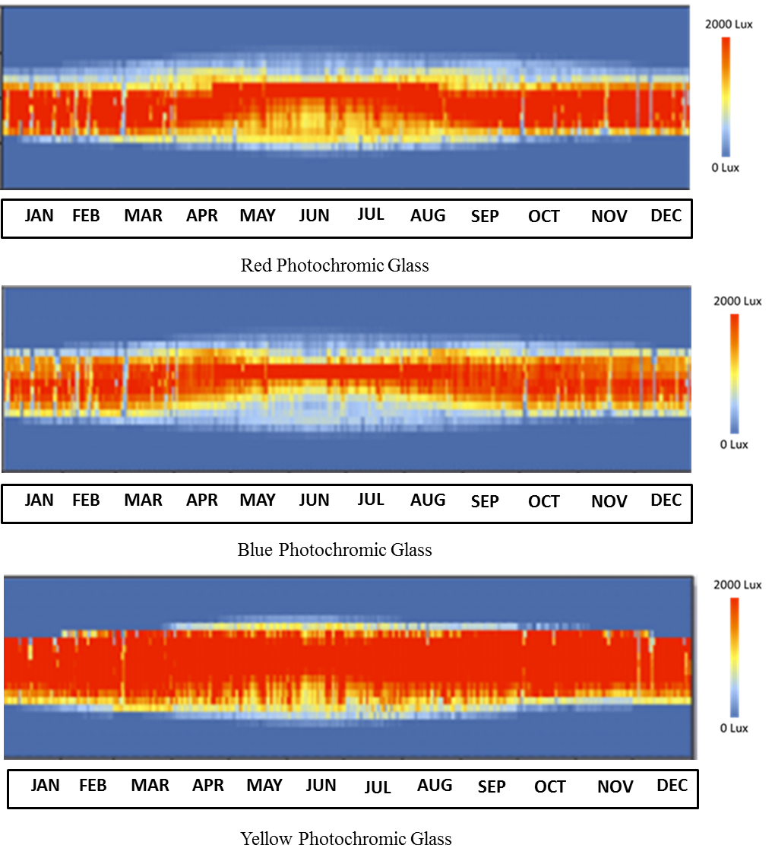
Figure 8. Annual glare analysis of photochromic glasses
In addition, students repeatedly tested point-in-time glare during occupancy hours of 8:00 AM to 6:00 PM on 21th of June and 21th of December as shown in Figure 9. The values of DGP related to red and blue photochromic glasses were reported in the range of imperceptible on June 21 and perceptible on December 21. While the DGP of yellow photochromic glasses were reported intolerable in solar noon on 21th of June and 21th of December.

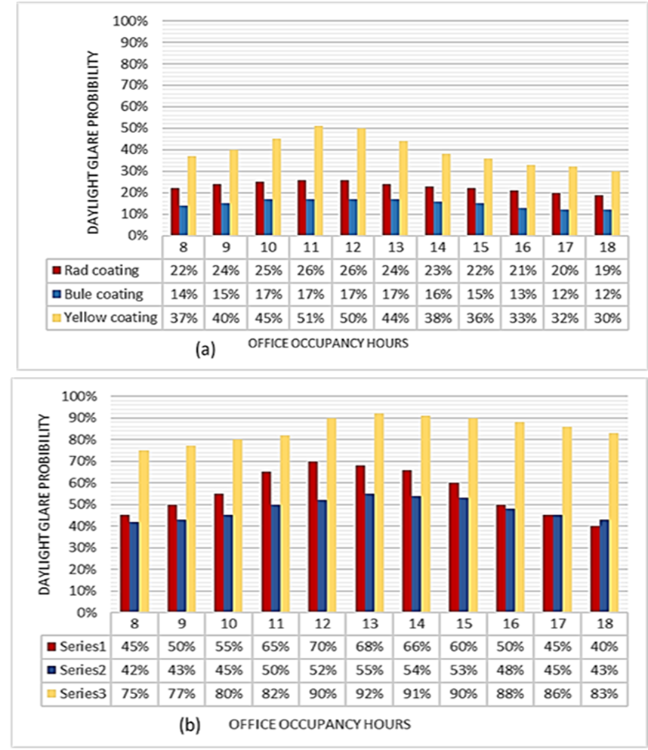
Figure 9. Hourly Daylight Glare probability on (a) June 21 and (b) December 21

Finally, students generated fish-eye images for glare analysis in DIVA, which provide DGP values of specific point of room at specific time of year as is shown in Figure 10. The blue and red colors approximately met imperceptible rate for glare that is less than 35% of DGP value. The blue color coating indicates high ability to decrease glare in comparison to red color. Yellow color is almost placed in the intolerable area with DGP above 45%.

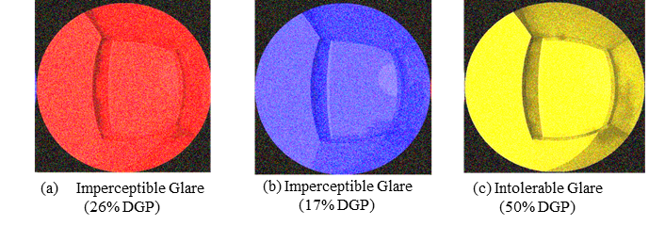
Figure 10. Fish-eye images of photochromic glasses on June 21 at 12:00 PM

Conclusions

In this paper, a number of educational activities have been presented that are suitable for architecture, interior design, chemistry, and polymer/coating students who want to gain hands-on learning experience in the design process of an interdisciplinary project on using photochromic glasses for responsive material-based façade systems.

The presented activities consist of educational modules for the smart photochromic coating formulation, optical properties and characterization of the developed coated glass, and the performance evaluation of the designed colored windows. These activities can be utilized in senior design projects, independent studies, and graduate theses by both undergraduate and graduate students.

References

[1] “Innovate America - Council on Competitiveness.” https://www.compete.org/reports/all/202 (accessed Jul. 26, 2020).
[2] D. M. Richter and M. C. Paretti, “Identifying barriers to and outcomes of interdisciplinarity in the engineering classroom,” Eur. J. Eng. Educ., vol. 34, no. 1, pp. 29–45, Mar. 2009, doi: 10.1080/03043790802710185.
[3] I. of Medicine, National Academy of Sciences, Committee on Facilitating Interdisciplinary Research, E. Committee on Science and Public Policy, and National Academy of Engineering, Facilitating interdisciplinary research. National Academies, 2005.
[4] I. Hargittai, “Handbook of the Undergraduate Curriculum: A Comprehensive Guide to Purposes, Structures, Practices, and Change (Gaff, Jerry G.; Radcliffe, James L.),” J. Chem. Educ., vol. 74, no. 5, p. 493, May 1997, doi: 10.1021/ed074p493.
[5] A. F. Edwards and Association for Integrative Studies, Interdisciplinary undergraduate programs: a directory, 2nd ed. Acton, MA: Copley Publishing Group, 1996.
[6] A. Jutraz and T. Zupancic, “The Role of Architect in Interdisciplinary Collaborative Design Studios,” Igra Ustvarjalnosti - Creat. Game, vol. 2014, no. 2, pp. 34–42, 2014, doi: 10.15292/IU-CG.2014.02.034-042.
[7] J. T. Klein, Crossing boundaries: knowledge, disciplinarities, and interdisciplinarities. Charlottesville, Va: University Press of Virginia, 1996.
[8] K. Yocom, G. Proksch, B. Born, and S. K. Tyman, “The Built Environments Laboratory: An Interdisciplinary Framework for Studio Education in the Planning and Design Disciplines,” J. Educ. Built Environ., vol. 7, no. 2, pp. 8–25, 2012, doi: 10.11120/jebe.2012.07020008.
[9] J. K. Ochsner, “Behind the Mask: A Psychoanalytic Perspective on Interaction in the Design Studio,” J. Archit. Educ., vol. 53, no. 4, pp. 194–206, 2000, doi: 10.1162/104648800564608.
[10] B. D. Wortham, “The Way We Think about the Way We Think: Architecture is a Paradigm for Reconsidering Research,” J. Archit. Educ., vol. 61, no. 1, pp. 44–53, 2007, doi: 10.1111/j.1531-314X.2007.00127.x.
[11] N. Heidari Matin, A. Eydgahi, and S. Shyu, “Comparative Analysis of Technologies Used in Responsive Building Facades,” presented at the The american society of engineering education conference, Colombus, Ohio, Jun. 2017, [Online]. Available: https://www.researchgate.net/publication/318213712_Comparative_Analysis_of_Technologies_Used_in_Responsive_Building_Facades.
[12] “Intergovernmental panel on climate change report,” 2018. [Online]. Available: https://www.ipcc.ch/site/assets/uploads/2018/11/pr_181008_P48_spm_en.pdf.
[13] M. Bechthold and J. C. Weaver, “Materials science and architecture,” Nat. Rev. Mater., vol. 2, no. 12, Art. no. 12, Dec. 2017, doi: 10.1038/natrevmats.2017.82.
[14] N. H. Matin et al., “Evaluating Visual Comfort Metrics of Responsive Facade Systems as Educational Activities,” presented at the 2018 ASEE Annual Conference & Exposition.
[15] R. Arens, “Material libraries: promoting materiality and interdisciplinary collaboration,” 2008.
[16] S. E. Wilkes and M. A. Miodownik, “Materials library collections as tools for interdisciplinary research,” Interdiscip. Sci. Rev., vol. 43, no. 1, pp. 3–23, Mar. 2018, doi: 10.1080/03080188.2018.1435450.
[17] K. Dewidar, “The role of intelligent façades in energy conservation,” p. 23.
[18] Y. J. Grobman, I. G. Capeluto, and G. Austern, “External shading in buildings: comparative analysis of daylighting performance in static and kinetic operation scenarios,” Archit. Sci. Rev., vol. 60, no. 2, pp. 126–136, Mar. 2017, doi: 10.1080/00038628.2016.1266991.
[19] A. Karanouh and E. Kerber, “Innovations in dynamic architecture,” J. Facade Des. Eng., vol. 3, no. 2, pp. 185–221, Jan. 2015, doi: 10.3233/FDE-150040.
[20] N. H. Matin and A. Eydgahi, “Learning Modules for Geometric Pattern Identification and Mathematical Modeling of Facade Systems,” presented at the 2019 ASEE Annual Conference & Exposition, 2019.
[21] N. H. Matin and A. Eydgahi, “Factors affecting the design and development of responsive facades: a historical evolution,” Intell. Build. Int., vol. 0, no. 0, pp. 1–14, Jan. 2019, doi: 10.1080/17508975.2018.1562414.
[22] N. Heidari Matin and A. Eydgahi, “Technologies used in responsive facade systems: a comparative study,” Intell. Build. Int., pp. 1–20, Mar. 2019, doi: 10.1080/17508975.2019.1577213.
[23] S. Geoff, G. Angus, A. Matthew, and C. Michael, “Nanophotonics-enabled smart windows, buildings and wearables,” Nanophotonics, vol. 5, no. 1, pp. 55–73, Jun. 2016.
[24] C. G. Granqvist, “Electrochromics for smart windows: Oxide-based thin films and devices,” Thin Solid Films, vol. 564, pp. 1–38, Aug. 2014, doi: 10.1016/j.tsf.2014.02.002.
[25] F. Gugliermetti and F. Bisegna, “A model study of light control systems operating with Electrochromic Windows,” Light. Res. Technol., vol. 37, no. 1, pp. 3–19, Mar. 2005, doi: 10.1191/1365782805li123oa.
[26] M. M. Seyfouri and R. Binions, “Sol-gel approaches to thermochromic vanadium dioxide coating for smart glazing application,” Sol. Energy Mater. Sol. Cells, vol. 159, pp. 52–65, Jan. 2017, doi: 10.1016/j.solmat.2016.08.035.
[27] W. Feng, L. Zou, G. Gao, G. Wu, J. Shen, and W. Li, “Gasochromic smart window: optical and thermal properties, energy simulation and feasibility analysis,” Sol. Energy Mater. Sol. Cells, vol. 144, pp. 316–323, Jan. 2016, doi: 10.1016/j.solmat.2015.09.029.
[28] H. Hosseinzadeh Khaligh, K. Liew, Y. Han, N. M. Abukhdeir, and I. A. Goldthorpe, “Silver nanowire transparent electrodes for liquid crystal-based smart windows,” Sol. Energy Mater. Sol. Cells, vol. 132, pp. 337–341, Jan. 2015, doi: 10.1016/j.solmat.2014.09.006.
[29] Q. Meng, G. Wang, H. Jiang, Y. Wang, and S. Xie, “Preparation of a fast photochromic ormosil matrix coating for smart windows,” J. Mater. Sci., vol. 48, no. 17, pp. 5862–5870, Sep. 2013, doi: 10.1007/s10853-013-7382-x.
[30] M. W. Schwarz, W. B. Cowan, and J. C. Beatty, “An Experimental Comparison of RGB, YIQ, LAB, HSV, and Opponent Color Models,” ACM Trans Graph, vol. 6, no. 2, pp. 123–158, Apr. 1987, doi: 10.1145/31336.31338.
[31] L. Y. L. Wu, Q. Zhao, H. Huang, and R. J. Lim, “Sol-gel based photochromic coating for solar responsive smart window,” Surf. Coat. Technol., vol. 320, pp. 601–607, Jun. 2017, doi: 10.1016/j.surfcoat.2016.10.074.
[32] C. K. Khoo, J. Burry, and M. C. Burry, “Soft responsive kinetic system: An elastic transformable architectural skin for climatic and visual control,” 2011.
[33] F. Zareanshahraki, H. R. Asemani, J. Skuza, and V. Mannari, “Synthesis of non-isocyanate polyurethanes and their application in radiation-curable aerospace coatings,” Prog. Org. Coat., vol. 138, no. Journal Article, p. 105394, 2020, doi: 10.1016/j.porgcoat.2019.105394.
[34] S. M. Mirabedini, F. Zareanshahraki, and V. Mannari, “Enhancing thermoplastic road-marking paints performance using sustainable rosin ester,” Prog. Org. Coat., p. 105454, Nov. 2019, doi: 10.1016/j.porgcoat.2019.105454.
[35] F. Zareanshahraki, J. Lu, S. Yu, A. Kiamanesh, B. Shabani, and V. Mannari, “Development of sustainable polyols with high bio-renewable content and their applications in thermoset coatings,” Prog. Org. Coat., vol. 147, p. 105725, Oct. 2020, doi: 10.1016/j.porgcoat.2020.105725.
[36] F. N. Jones 1936, Organic Coatings: Science and Technology, Fourth;4; HOBOKEN: John Wiley, 2017.
[37] S. Westland and V. Cheung, “RGB Systems,” in Handbook of Visual Display Technology, J. Chen, W. Cranton, and M. Fihn, Eds. Cham: Springer International Publishing, 2016, pp. 171–177.
[38] A. Verikas, K. Malmqvist, L. Malmqvist, and L. Bergman, “A new method for colour measurements in graphic arts,” Color Res. Appl., vol. 24, no. 3, pp. 185–196, 1999, doi: 10.1002/(SICI)1520-6378(199906)24:3<185::AID-COL5>3.0.CO;2-1.
[39] H. Förster, “UV/VIS Spectroscopy,” in Characterization I: -/-, H. G. Karge and J. Weitkamp, Eds. Berlin, Heidelberg: Springer, 2004, pp. 337–426.
[40] L. Giovannini, F. Goia, V. Verso, and V. Serra, “A Comparative Analysis of the Visual Comfort Performance between a PCM Glazing and a Conventional Selective Double Glazed Unit.,” Sustainability, vol. 10, no. 10, p. 3579, 2018.
[41] Mardaljevic, Andersen, Roy, and Christoffersen, “Daylighting, artificial lighting and non-visual effects study for a residential building.,” Loughborough University, School of Civil and Building Engineering., Loughborough, 2012.
[42] C. K. Khoo and F. D. Salim, “A soft kinetic material for morphing architectural skins and organic user interfaces,” in Proceedings of the 2013 ACM international joint conference on Pervasive and ubiquitous computing, Zurich, Switzerland, Sep. 2013, pp. 53–62, doi: 10.1145/2493432.2494263.

Biographies

NEGAR HEIDARI MATIN is an Assistant Professor in Interior Design at the Gibbs College of Architecture at the University of Oklahoma. She holds PhD in Technology with concentration on Interior Design from the College of Engineering and Technology at Eastern Michigan University (EMU) where she was selected as a doctoral fellow for five continues years working on high-performance building systems and their impact on occupants’ comfort and building energy consumption. Her research interest is an interdisciplinary area between interior architecture, building science, and advanced technology. She is the recipient of various awards such as EMU Outstanding PhD Student of the Year, GRC Outstanding Poster Presentation, and Jones-Beckwith Advanced Graduate Studies scholarship. Dr. Matin may be reached at negar.matin@ou.edu.

FOUROGH Z. SHAHRAKI has more than seven years of academic and industrial experience in polymers and coatings. She is currently a PhD candidate and graduate research assistant at Eastern Michigan University (EMU), majoring in polymers and coatings technology. Forough’s current research at EMU is mainly focused on environmentally-benign coatings for various applications. Prior to studying at EMU, she has completed her Bachelor and Masters in paints and coating Engineering at Tehran Polytechnique Institute for color science and technology, respectively. She has also first-hand industrial experience in companies such as Ford Motor Company. Mrs. Shahraki may be reached at fzareans@emich.edu.

ALI EYDGAHI started his career in higher education as a faculty member at the Rensselaer Polytechnic Institute in 1985. Since then, he has been with the State University of New York, University of Maryland Eastern Shore, and Eastern Michigan University. During 2006-2010, he was Chair of the Department of Engineering and Aviation Sciences at the University of Maryland Eastern Shore. In 2010, he joined Eastern Michigan University as an Associate Dean in the College of Technology and currently is a Professor in the School of Engineering. Dr. Eydgahi has served as a member of Advisory and Editorial boards for many International Journals in Engineering and Technology, as a member of review panel for NASA and Department of Education, as a regional and chapter chairman of IEEE, SME, and ASEE, and as a session chair and as a member of scientific and international committees for many international conferences. Dr. Eydgahi may be reached at aeydgahi@emich.edu.

