**# 181-M-20**

**Surface Composition Studies of CdZnTe Material Using X-Ray**

**Photoelectron Spectroscopy**

Mebougna L. Drabo

Alabama A&M University

[mebougna.drabo@aamu.edu](mailto:mebougna.drabo@aamu.edu)

Alexander A. Egarievwe

Alabama A&M University

[alexegar21@gmail.com](mailto:alexegar21@gmail.com)

Richard M. Lagle

Alabama A&M University

[richard.lagle@aamu.edu](mailto:richard.lagle@aamu.edu)

Stephen U. Egarievwe

Alabama A&M University

[stephen.egarievwe@aamu.edu](mailto:stephen.egarievwe@aamu.edu)

Ezekiel O. Agbalagba

Federal University of Petroleum Resources, NIGERIA

[agbalagba.ezekiel@fupre.edu.ng](mailto:agbalagba.ezekiel@fupre.edu.ng)

Utpal N. Roy

Savannah River National Laboratory

[utpal.roy@srnl.doe.gov](mailto:utpal.roy@srnl.doe.gov)

Ralph B. James

Savannah River National Laboratory

[ralph.james@srnl.doe.gov](mailto:ralph.james@srnl.doe.gov)

**Abstract**

High-resistivity zinc cadmium telluride (CdZnTe) semiconductor is a popular material for room-temperature nuclear detection applications. It is used for the detection of X-rays and gamma rays in many areas: nuclear and radiological threat detection, medical imaging, gamma spectroscopy, and astrophysics. Mechanical stability at the interface of electrical contacts and the detector material is an important factor in terms of durability and shelf life of detector devices. This is also important in thermal expansion due to temperature changes and vibrations that may result from certain applications. The surface composition of the material play an important role in the surface stability of the material. The stoichiometric composition of the detector surfaces also affects its surface current which in turn contributes to the electronic noise. High electronic noise is detrimental to the energy resolution of the detector device. X-ray photoelectron spectroscopy (XPS) is a good technique for determining dominant surface composition of materials. In this study, we used XPS to look at the dominant composition materials on CdZnTe wafer surface. The experiments involved loading CdZnTe wafers into the XPS machine and recording the peaks of the binding energies of elements and compounds present on the surfaces. The XPS results show the presence of Zn, Te, O, Cd, C, Cl, and Si, and TeO2.

Keywords: Binding Energies, CdZnTe, Nuclear Detectors, Surface Composition, X-ray photoelectron Spectroscopy (XPS).

**Introduction**

Zinc cadmium telluride (CdZnTe) is one of the most widely used materials for detecting X-rays and gamma rays at room-temperature without cryogenic cooling. It has many applications in the areas of nuclear and radiological threat detection, medical imaging, gamma spectroscopy, and astrophysics (James et al., 1995; Zhang et al., 2013; Bradford et al., 1999; Verger et al., 2001). The composition of the detector wafer surfaces is an important factor in detector device fabrication (Egarievwe, et al., 2016). It is important to have very low surface current to reduce noise in the detector signal. The stoichiometric composition of the detector surfaces also affects its surface current, which in turn contributes to the electronic noise. High electronic noise is detrimental to the energy resolution of the detector device. The mechanical stability at the interface of the electrical contacts and the detector material is an important factor in terms of durability and shelf life of detector devices. It is also important in thermal expansion due to temperature changes and vibrations that may result from certain applications. The surface composition of the material play an important role in the stability of the wafer surfaces.

**Experiments and Methods**

X-ray photoelectron spectroscopy (XPS) is a good technique for determining dominant surface composition of materials. In this study, we used XPS to look at the dominant composition materials on CdZnTe wafer at and near the surface. The experiments involved loading CdZnTe wafers into the XPS machine and recording the peaks of the binding energies of elements and compounds present on the surfaces. The XPS system is shown in Figure 1. It is equipped with software that identifies the binding energies of the surface species.

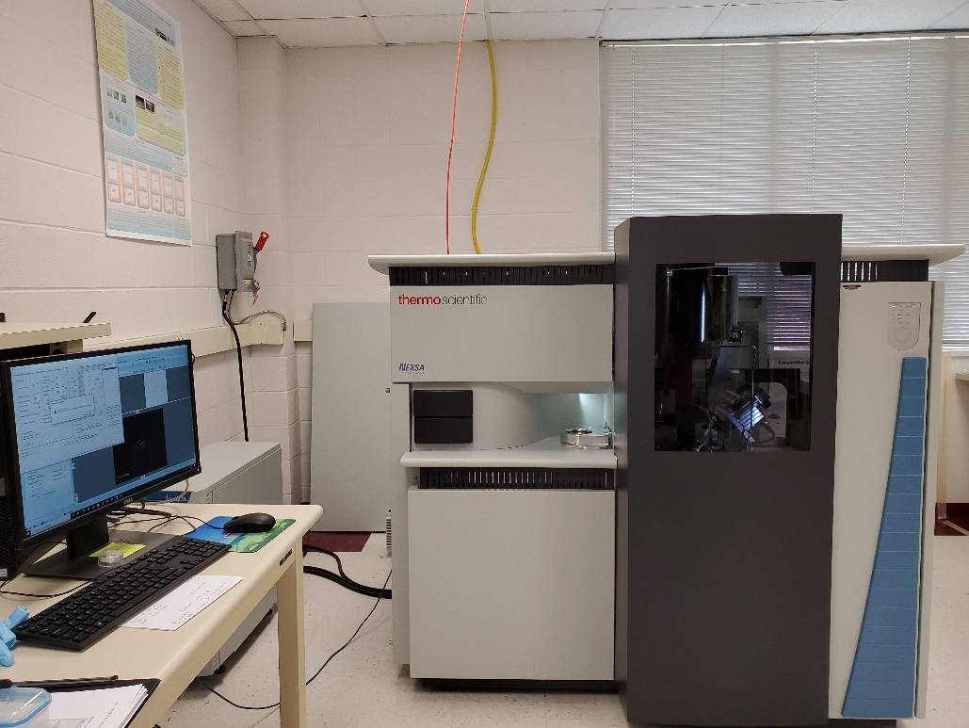

Figure 1. High-performance XPS surface analysis system by Thermo Fisher.

Prior to the XPS measurements, the CdZnTe sample of size 6.4 x 6.9 x 2.4 mm3 was cut using a machine equipped with a diamond impregnated mire saw. Water is used for as lubricant and coolant during the cutting process. After cutting, the sample was mechanically polished on a silicon carbide abrasive paper using distilled water. Large grain of 800-grit paper was first used, followed by polishing on 1200-grit paper. The wafer was further polished on a MultiTex paper using alumina power and distilled water to get mirror-shine surfaces. A 3.0-µm alumina powder was first used, followed by successive polishing in decreasing sizes of powder down to 0.1 µm. A separate MultiTex pad was used for each alumina powder size. After each polishing, the sample is thoroughly rinsed in distilled water.

The CdZnTe wafer was mounted on a sample holder and loaded to the XPS machine equipped with an X-ray source gun type Al-K-Alpha. A spot size of 400 µm was used on the sample. The photoelectrons ejected from the sample surface are collected in the analyzer. A survey analysis was first made to scan for all elements that could be present on the surface. This is followed by looking at specific energy regions of the dominant species. In the survey scan, the analyzer mode was set at a pass energy of 200.0 eV, and the energy step size was 1.00 eV. The scan took 68 seconds. The specific elements of interest studies in this experiment include Zn, Cd, and Te. The analyzer mode for these scans was set at a pass energy of 50.0 eV, and the energy step size was 0.100 eV.

**Results and Discussion**

Figure 2 show the survey spectrum for the CdZnTe wafer as recorded by the XPS system. It shows the presence of zinc, tellurium, oxygen, cadmium, carbon, chlorin, and silicon. The survey scan was in the biding energy range 0 – 1350 eV. The scans that focus Cd, Zn, and Te are shown in Figures 3, 4, and 5, respectively.



Figure 2. XPS survey scan showing the presence of Zn, Te, O, Cd, C, Cl, and Si.

Figure 3. XPS scan showing the Cd3d5/2 and Cd3d3/2 peaks of cadmium.

Figure 4. XPS scan showing the Zn2p5/2 and Zn2p3/2 peaks of zinc.

Figure 3 shows the Cd3d5/2 and Cd3d3/2 peaks at the binding energies of about 405.08 eV and 411.78 eV respectively, corresponding to the elemental state of cadmium. The two peaks in Figure 4 correspond to Zn2p3/2 and Zn2p1/2 at 1021.58 eV 1044.98 eV respectively. Figure 5 shows the peaks for Te and TeO2. This implies some oxidation on the CdZnTe wafer. The Te3d5/2 and Te3d3/2 are at the binding energies of about 572.78 eV and 583.18 eV respectively, corresponding to the elemental state of tellurium. The other two peaks are at approximately 575.08 eV and 586.38 eV are near the Te3d doublet peaks, and they show the formation of the TeO2 species that are derived from the Te species present on the surfaces of the CdZnTe wafer. The heights of the peaks are summarized in Table 1.

Figure 5. XPS scan showing the Te3d5/2 and Te3d3/2 peaks of tellurium and Te3d5/2O2 and Te3d3/2O2 peaks of TeO2.

Table 1. Heights of the binding energy peaks identified for Cd, Zn, Te, and TeO2.

|  |  |  |
| --- | --- | --- |
| Peak | Binding Energy (eV) | Peak Height Raw Counts |
| Cd3d5/2 | 405.08 | 323697 |
| Cd3d3/2 | 411.78 | 245079 |
| Zn2p3/2 | 1021.58 | 200017 |
| Zn2p1/2 | 1044.98 | 190753 |
| Te3d5/2 | 572.78 | 178127 |
| Te3d5/2O2 | 575.08 | 451401 |
| Te3d3/2 | 583.18 | 174938 |
| Te3d3/2O2 | 586.38 | 376005 |

**Conclusion**

We have used XPS to determine the dominant elements on CdZnTe wafer surface. The XPS results showed the presence of Zn, Te, O, Cd, C, Cl, and Si, and TeO2. The XPS scans focused on the binding energies in the regions of Cd, Zn, and Te showed that these elements are significantly present as expected. The XPS scan for Te also showed TeO2 peaks. This is an indication of the formation of TeO2 on the surfaces of the CdZnTe wafers. In future studies, we plan to investigate the near-surface compositional variation by using high-speed ions to remove very thin surface layers of the CdZnTe wafer.

**Acknowledgment**

This work was supported in part by the National Science Foundation Major Research Instrumentation through award number 1726901; in part by the U.S. Department of Homeland Security, Domestic Nuclear Detection Office through award number 2012-DN-077-ARI065-05; in part by the NSF HBCU-UP Program through award number 1818732; in part by the U.S. Nuclear Regulatory Commission through award 31310018M0035; and in part by U.S. Department of Energy, Office of Defense Nuclear Nonproliferation Research and Development, the DNN R&D (NA-22).

**References**

Barber, H. B. (1999). Applications of semiconductor detectors to nuclear medicine. *Nuclear Instruments and Methods in Physics Research Section A: Accelerators, Spectrometers, Detectors and Associated Equipment*, *436*(1-2), 102-110.

Egarievwe, S. U., Hossain, A., Okwechime, I. O., Egarievwe, A. A., Jones, D. E., Roy, U. N., & James, R. B. (2016). Effects of chemical treatments on CdZnTe x-ray and gamma-ray detectors. *IEEE Transactions on Nuclear Science*, *63*(2), 1091-1098.

James, R. B., Schlesinger, T. E., Lund, J. C. & Schieber, M. (1995*). Semiconductors for room temperature radiation detector application*. Academic.

Verger, L., Boitel, M., Gentet, M. C., Hamelin, R., Mestais, C., Mongellaz, F., & Sanchez, G. (2001). Characterization of CdTe and CdZnTe detectors for gamma-ray imaging applications. *Nuclear Instruments and Methods in Physics Research Section A: Accelerators, Spectrometers, Detectors and Associated Equipment*, *458*(1-2), 297-309.

Zhang, Q., Zhang, C., Lu, Y., Yang, K., & Ren, Q. (2013). Progress in the development of CdZnTe unipolar detectors for different anode geometries and data corrections. *Sensors*, *13*(2), 2447-2474.

**Biographies**

MEBOUGNA L. DRABO is an associate professor of mechanical engineering at Alabama A&M University. His research interests include material characterization, advanced flash atomization technology, burner/atomizer integration, biofuels, computational fluid dynamics analysis, heat transfer, and energy conservation in building. He has participated in engaging and mentoring many STEM students in on-campus research and internships at Brookhaven National Laboratory. He successfully participated in developing the Nuclear Engineering and Radiological Science Center at Alabama A&M University. He also participated, as Co-Principal Investigator, in many writing several successful grant proposals that funded the center. He is an ABET IDEAL Scholar (Excellence in Assessment Leadership).

ALEXANDER A. EGARIEVWE is presently a graduate student in the Department of Physics at Alabama A&M University. He serves as a Graduate Research Assistant in the Nuclear Engineering and Radiological Science Center at Alabama A&M University.

EZEKIEL O. AGBALAGBA EZEKIEL AGBALAGBA is an Associate Professor of Nuclear and Radiation Health Physics at the Federal University of Petroleum Resources, Effurun, Nigeria. From 2003 to 2010, he lectured at Bayelsa State College of Arts and Science, Yenagoa, Bayelsa State, Nigeria, and served as a Research Assistant at the University of Port Harcourt. Dr. Agbalagba has authored three books and four book chapters. He coauthored over 60 scientific papers in learned reputable international and local journals. He has presented and coauthored over 40 papers in conferences.

RICHARD M. LAGLE is presently a Mechanical Engineering/ Nuclear Laboratory Technician in the College of Engineering, Technology, and Physical Science at Alabama A&M University, Normal, AL.

STEPHEN U. EGARIEVWE is the Director of the Nuclear Engineering and Radiological Science Center, and Professor in the Department of Electrical Engineering and Computer Science, at Alabama A&M University where he served as the immediate former Chair of the Department of Engineering, Construction Management and Industrial Technology. Prior appointments include Assistant and Associate Professorships at Fisk University, Lecturer-I at Usmanu Danfodiyo University, Nigeria, Assistant Lecturer at Ambrose Alli University, Nigeria, and Laboratory Assistant at the University of Nigeria. He has authored 1 book, co-authored more than 100 scientific publications, and served as co-editor of 1 book. His current research interests are in nuclear security and safety, materials science, nanotechnology, data analytics and visualization, Internet-based remote laboratory instrumentation, petroleum and gas workforce, and STEM education. He serves as a Guest Scientist at Brookhaven National Laboratory since 2008. He has R&D 100 Award.

UTPAL N. ROY currently works in DOE’s Savannah River National Laboratory as Senior Advisory Scientist. Prior appoints include Scientist at Brookhaven National Laboratory, Upton, NY, Physicist at FLIR (Formerly ICx) Radiation Inc., Oak Ridge, TN, and Research Associate at Fisk University, Nashville, TN. His R&D efforts have focused on basic and applied materials research devoted to lasers hosts, semiconductor materials, radiation detector materials, and detector systems. He has co-authored about 120 publications in peer reviewed journals, and one patent. He is co-recipient of two R&D 100 awards and two times R&D 100 finalist from Discover Magazine Innovator of the Year. His current interest is focused on development of new materials for radiation detector applications.

RALPH B. JAMES currently serves as the Associate Laboratory Director for Science and Technology and the Chief Research Officer with DOE’s Savannah River National Laboratory. His R&D efforts have focused on basic and applied research devoted to semiconductor materials, radiation detectors, and imaging systems. He has co-authored more than 650 scientific publications, served as editor of 34 books, and holds 27 patents. Dr. James has received numerous international honors for his work on detectors and imaging, including Discover Magazine Innovator of the Year, 7 R&D100 awards, IEEE Outstanding Radiation Instrumentation Award, IEEE Harold Wheeler Award, Room-Temperature Semiconductor Scientist Award, Battelle Innovation Award, Frost & Sullivan Invention of the Year in prostate cancer, Long Technology Hall of Fame Inductee, among many others.