# 134-T-20

Preparation of MET Students for the NCEES FE Exam - Lessons Learned

Kevin Johnson
Michigan Technological University
kevinj@mtu.edu

John L. Irwin
Michigan Technological University
jlirwin@mtu.edu

Abstract

The National Council of Examiners for Engineering and Surveying (NCEES) provides professional licensure for engineers and surveyors. The Fundamentals of Engineering (FE) exam is the first step in the process to becoming a professional licensed engineer (PE), which is required for professional engineering positions governed by the GS-0800 policy for individual occupational requirements. Private companies may also require having a certified PE on staff for liability protection. There are some obstacles in place in the United States for Engineering Technology graduates, even if they successfully pass the FE exam. Engineers are licensed at the state level by professional licensing boards each having different regulations even though the examinations to become a PE are the same in all states. The purpose of this study is to investigate the process used to prepare students for the FE Mechanical exam in an ETAC/ABET accredited Manufacturing and Mechanical Engineering Technology (MMET) department. Data gathered from 2014-19 has influenced program improvement efforts and professional practice teaching course methodology. FE exam results increased over time, but some factors influencing the increase remain unknown. Methods used to teach the professional practice course include creating question banks developed from sample course exam questions in the University Learning Management System (LMS), utilizing the PPI resources such as FE Review Manuals [1] [2] and access to the practice problems and exams for students online [3]. FE results can assist in program improvement efforts and these credentials provide many students advantages in the job market. Support for baccalaureate graduates from ETAC/ABET accredited Engineering Technology programs to become Licensed Professional Engineers without additional requirements is evidenced by the 2020 ASEE Position Statement on Professional Licensure of Baccalaureate ETAC/ABET Graduates.

Introduction

In the Department of Manufacturing and Mechanical Engineering Technology (MMET) at Michigan Technological University (Michigan Tech), there is a BS Mechanical Engineering Technology (MET) degree. This degree enrollment has fluctuated from 75 to 169 students in the years that span this study (see Figure 1).

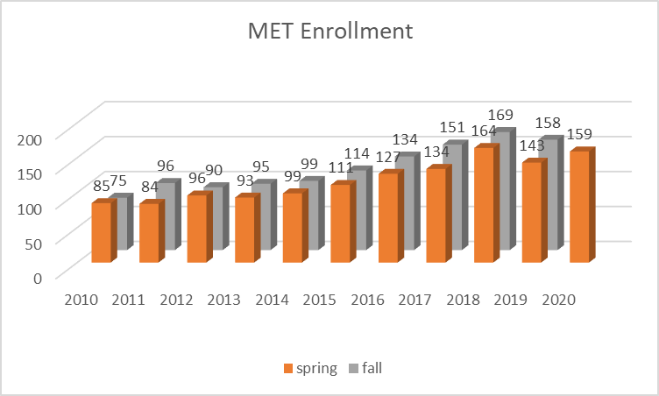
Figure 1 – MET Enrollment 2012-2020

The exit exam for program assessment accreditation purposes from 2013-2020 is the National Council of Examiners for Engineering and Surveying (NCEES) Fundamentals of Engineering (FE) Mechanical exam, also referred to as the Engineer in Training (EIT) exam. The exam is given to students during the fall or spring prior to their graduation. Students enroll in a required Professional Practice Seminar course used to prepare and provide practice sample problems similar to those on the exams. This course has a pass/fail grading system with the grading criteria based on 25% for attendance, 25% for in class quizzes, and the remaining 50% on the exam score. Students must achieve at least 70% to pass the course. Students have the option to either retake the exam or redo quizzes to raise their score above the passing level. The quizzes are FE practice questions completed online in a computer lab with the use of the electronic FE Reference Handbook [4] as the only reference material. This is done to provide students practice using the FE Reference Handbook which is their only reference material during the FE Exam.
This study investigates the data from exit exams to determine what factors influence student performance. Also, it will be explained how the methods of delivery of the Professional Practice Seminar course are related to student success on the FE exam.

Background

Exit exam data is widely used as a direct measure for program assessment purposes. Both ABET (Criterion 4. Continuous Improvement) and ATMAE (7.19 Outcome Measures Used to Improve Program) require that programs have a continuous improvement plan that is documented and that data supports decision making. Also, the first step for graduates from an undergraduate engineering or engineering technology degree from an EAC or ETAC/ABET accredited program in the process to becoming a professional licensed engineer (P.E.) is the FE exam. The decision to use the FE exam was made in 2013 to provide an increased emphasis on engineering fundamentals in response to the ASME Vision 2030 Recommendations for Mechanical Engineering Education [5], and was also expressed as a need by MET program employers and alumni. Michigan is among the 18 most restrictive states that prohibit ETAC/ABET accredited MET graduates to receive professional licensure, although 33 states are less restrictive with 12 of those requiring no additional requirements for MET graduates.

The purpose for this study relates to how a person perceives the value of obtaining professional certifications. The P.E. designation is required for engineers pursuing a career as an independent consultant, owning an engineering firm, and employment as a government engineer (federal, state, and municipal agencies). Also, in academia many states require that engineering faculty be licensed, or at least this is a preferred qualification. Another factor to consider in the preparation of engineering and engineering technology students for professional certification is that on average, PEs tend to have higher salaries than their non-licensed counterparts according to an American Society of Mechanical Engineers (ASME) 2017 salary [6] survey earning nearly $16,000 more than those without a PE license. The number of PEs in the United States has been declining over the years, which could put the safety, health and welfare of Americans at risk. Therefore, providing methods for preparation of students for taking the FE exam is important to include in any engineering program Professional Practice Seminar course.

In a study by Koehn [6], finds that high pass rate on the FE are a result of well‐motivated students who complete a comprehensive review course. Although, according to Watson [7] the overall value of the NCEES reporting of results is compromised by variable student motivation and the confidentiality of the questions used in the exam. The results do not provide the questions that were correct or incorrect for each student taking the exam. Only the students that do not pass the exam receive a report showing percent of missed questions in each category.

Methodology

The subjects in this study are the Michigan Tech MET graduates that have taken the FE exam in the semesters from Fall 2013 through Fall 2019. This is a total of 136 senior students that took this exam in their final semester of the ETAC/ABET accredited program. The FE exam results are arranged by topical categories. The data from each category is correlated to individual courses using a matrix. Not every course in the curriculum is directly related to the FE exam, but many of the MET student outcomes are included. The NCEES supplies a report that can be used for assessment purposes that compares the level of attainment of each category in the test to the other ETAC students that have completed the exam that year. As explained by Nirmalakhandan et al. [8], the student’s score is converted to a scaled score, which adjusts for any minor differences in difficulty across the different exam forms. This scaled score represents a student’s ability level and is compared to the minimum ability level for that exam, which has been determined by subject-matter experts through psychometric statistical methods. NCEES does not publish the passing score. The exam is electronically scored and results are transmitted in 15 categories in a report from NCEES.
1 Mathematics
2 Probability and Statistics
3 Computational Tools
4 Ethics and Professional Practice
5 Engineering Economics
6 Electricity and Magnetism
7 Statics
8 Dynamics, Kinematics, and Vibrations
9 Mechanics of Materials
10 Material Properties and Processing
11 Fluid Mechanics
12 Thermodynamics
13 Heat Transfer
14 Measurements, Instrumentation, and Controls
15 Mechanical Design and Analysis

Results

The target set by the MET faculty was that at least 70% of students pass the exam. This goal has not yet been met in any of the semesters, but the percent passed has been above the national average in most semesters. Also, in most all semesters the average ratio score is above the target of 1.00. It should be noted that the NCEES report for recent years differ from the student reports provided by NCEES at the completion of the semester. The reason for these differences may be that when the students register for the FE they may incorrectly code that they are EAC ME program students rather than an ETAC MET program students.

Table 1 - MET NCEES FE exam results 2013-19
Semester/instructor | Number students Passed |  | Total students | Percentage of students passed | Average Ratio Score/Target | Percent Passed/ABET Comparator  (NCEES does not publish the passing score)
Fall 2013 (pilot) | 2 |  | 3 | 67 | NA | 67/NA
Spring 2014 (pilot) | 1 |  | 2 | 50 | NA | 50/NA
Fall 2014 | 3 |  | 11 | 27 | 1.03/1.00 | 27/32
Fall 2015 | 4 |  | 8 | 50 | 1.01/1.00 | 50/47
Spring 2016 | 6 |  | 15 | 40 | 1.04/1.00 | 40/40
Fall 2016 | 6 |  | 11 | 55 | 1.09/1.00 | 55/38
Spring 2017 | 4 |  | 15 | 27 | .98/1.00 | 27/36
Fall 2017 | 4 |  | 11 | 36 | 1.05/1.00 | 36/27
Spring 2018 | 7 |  | 23 | 30 | 1.00/1.00 | 30/41
Fall 2018 | 13 (*14) |  | 20 (*21) | 65 (*67) | 1.08/1.00 | 65 (*67)/38
Spring 2019 | 4 (*5) |  | 13 (*14) | 31 (*36) | 1.01/1.00 | 31 (*36)/33
Fall 2019 | 7 |  | 14 (*16) | 50 (*44) | 1.01/1.00 | 50 (*44)/41
Totals: 2013-2019 | 61 |  | 136 | 45 | NA | NA
(* Indicates the number reported by NCEES to the students at the completion of the semester which are provided by the course instructor.)

Individual topics for the FE are recorded to provide a longitudinal look at student performance over time (see Figures 2&3). It should be noted that NCEES results do not provide a percentage of questions that were correct for each topic. The values represented in the graphs are the average ratio scores for each topic area. This is a ratio of the group of students from this institution taking the exam compared to all students from similar institutions, which in this case are ABET ETAC accredited institution students taking the Mechanical FE.

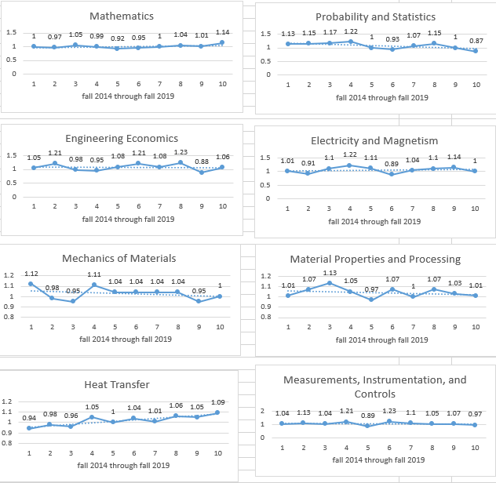
Figure 2 – MET NCEES FE topics 1-8 from 2014-19

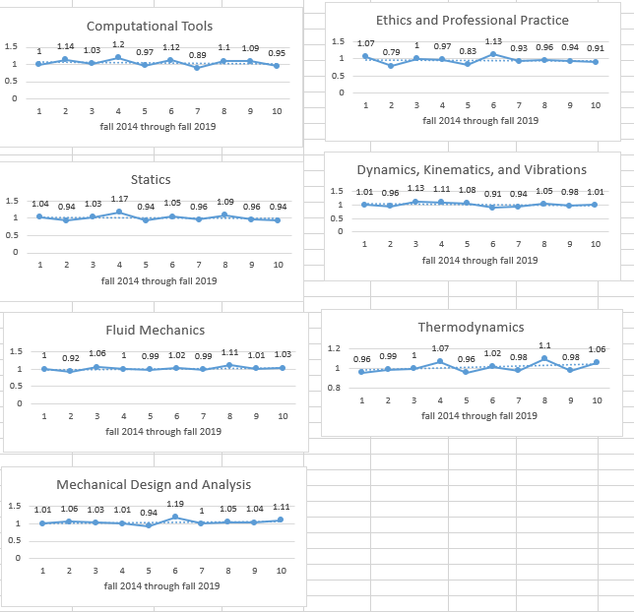
Figure 3 – MET NCEES FE topics 9-15 from 2014-19

The NCEES FE results are also used to see how well students are scoring on each subject as shown in Figure 4. For the semesters from fall 2018 to spring 2020 the scores on the core engineering courses of Statics and Mechanics of Materials were lower than the other engineering courses currently taught in the department. As a result of this it was decided to break up the single semester combined Statics and Strength of Materials class into two separate semester long classes. This change started in the fall 2020 semester.
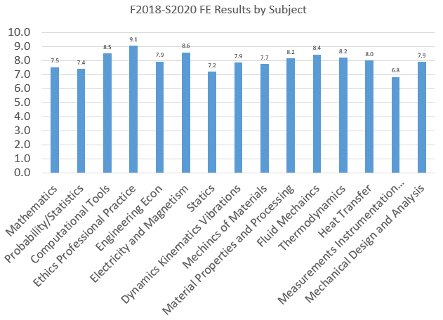

Figure 4 – F2018 thru S2020 FE Exam Results by Subject

Discussion

Various MET faculty have taught the Professional Practice Seminar course until Fall 2018 when an instructor with a PE license took over teaching the course. Until Fall 2018 a different instructor taught a different topic each week. Each instructor used a different teaching style as far as homework vs. quizzes vs. doing example problems. Students were assigned practice problems from the FE Mechanical Review Manual that were reviewed on a Friday one 120-minute lab session. The following week in a 50-minute class session the material would be reviewed quickly and then the students would take an online quiz with 30 minutes allowed to complete 10 questions. Faculty that were teaching the topics created the questions for the online quizzes that were saved in the course LMS system.

In Fall 2018 since one instructor taught the entire course the teaching method was the same throughout the entire semester. The 15 categories mentioned previously were reviewed during the course. Each week consisted of a 50-minute class early in the week where the instructor and students did FE practice problems together. The students were given three minutes to solve each problem and then the instructor would solve the problem on the board. The problems were taken from the FE Mechanical Review Manual that the students were required to purchase as well as the optional FE Review Manual. The students used an electronic copy of the FE Reference Handbook for reference material. Each Friday there was a 120-minute computer-based quiz administered using the University LMS containing FE style problems worth 25% of the final grade. Again, the students were only allowed using an electronic copy of the FE Reference Handbook for reference material. Each quiz included approximately 80 questions, which was intentionally more than the students could work in the time allowed. The scores for each quiz were then scaled to a total of 40 questions. This was done to encourage the students to first solve all of the questions they knew how to solve and that could be solved quickly. Then, they were instructed to solve the other questions that they knew and that were going to take more time. Students were instructed to save enough time at the end of the class to go back and take educated guesses at the remaining problems. The methods described resulted in an improvement in students passing the FE as seen in Table 1. The pass rate jumped up to 67%, the highest seen to date.

During the Spring 2019 semester the class was delivered completely online through PPI2Pass. The PPI2Pass website contains practice books including the book students were required to purchase in previous semesters along with practice quizzes and practice exams. Students did online practice quizzes during the 50-minute class early in the week. On Friday classes students did online quizzes where the instructor was able to monitor the results online. The instructor was able to see the number of attempts taken for each quiz and the results of each attempt. These Friday quizzes were used for 25% of the grade. Going online allowed the students to take practice quizzes which with solutions any day and time during the semester. The students overwhelmingly agreed this was an advantage over purchasing the book(s). The negative was the practice quizzes taken during the first class each week had randomly selected problems so the class and instructor were not able to work problems together. The instructor would help students individually with questions they had. As shown in Table 1 the pass rate dropped to 36%. It was thought that this drop could possibly be partly due to not doing practice problems together and/or not having graded quizzes that can only be done in class under the instructors’ supervision.
Therefore, in Fall 2019 the only change made to the class was to return to in class graded quizzes using the University LMS during the Friday class. This allowed the instructor to make sure the students were doing the quizzes individually and with only the FE Reference Handbook. These quizzes also returned to the format where there were too many to solve in the time allotted. As seen in Table 1 the pass rate did increase to 44%. Spring 2019 started out the same format as Fall 2019 until about half way through the semester where the COVID-19 pandemic caused the class to go completely online. Students scheduled times for taking the FE exam were also moved out to June and July; a significant time after the end of the class. All of the results from this semester have not been returned, but preliminary results are suggesting a pass rate under 30%.

Conclusion

The subjects in this study have scored equal to or above the NCEES reported ABET Comparator value for the majority (60%) of the ten semesters reported in this study. The methods used to teach the Professional Practice Seminar course during the semesters that the students scored highest on the FE are a significant contribution. There are additional factors to consider such as the student demographics, differences in course structure, and the circumstances around the timing of when the student takes the exam. Some students take the exam prior to the end of the semester due to the exam site availability and the students schedule.
With the limited data available, teaching this course with one instructor compared to being shared by several instructors has resulted in some improvements. The recommendation is to hold weekly in class quizzes using the University LMS, and a return to working out problems together in class. PPI2Pass will grant the instructor of a course the same access to the website as the students at no charge as long as there is a sufficient number of students purchasing the website access. Therefore, this could allow the class to go back to working problems together with the use of the instructor’s computer and the projector. The ability to do practice problems 24/7 on the PPI2Pass website makes this an easy choice to be continued in future semesters. Miller [9] suggests another method to consider, which is to use the FE Reference Handbook throughout the Professional Practice Seminar course as the only formula sheet. As earlier referenced authors [6][7] also conclude, motivation of the student is a key factor in success rate in the FE exam. It should be noted that it is mandatory for MET students at Michigan Tech to take the exam rather than it being voluntary. The course requirement may motivate some students to perform well, but others may be intimidated by the pressure of a pass/fail course and not perform as well under that pressure. A final recommendation to consider is that 100% of the grade for a professional practice course should not be dependent on the FE exam score. Also, as ET graduates continue to pass the FE exam in high numbers that all states should allow ET graduates to be licensed as professional engineers.

References

[1] Lindeburg, M. R. (2011). FE review manual: Rapid preparation for the fundamentals of engineering exam. www. ppi2pass. com.
[2] Lindeburg, M. R. (2014). FE Mechanical Review Manual. www. ppi2pass. com.
[3] PPI2Pass (2020). Kaplan Inc. retrieved from www.ppi2pass.com
[4] National Council of Examiners for Engineering and Surveying. (2013). NCEES FE Reference Handbook. National Council of Examiners for Engineering and Surveying.
[5] Kirkpatrick, A. T., Danielson, S., & Perry, T. (2012, June). ASME vision 2030’s recommendations for mechanical engineering education. In 2012 ASEE Annual Conference & Exposition (pp. 25-209).
[6] Kosowatz, J. (2018, June). Salaries Are Up for Mechanical Engineers. Retrieved from https://www.asme.org/topics-resources/content/salaries-up-for-mechanical-engineers
[7] Koehn, E. (1989). "Fundamentals of Engineering Exam: Motivation/Review Enhances Pass Rate." Journal of Professional Issues in Engineering 115(3): 289-296.
[7] Watson, J. L. (1998). An analysis of the value of the FE examination for the assessment of student learning in engineering and science topics. Journal of Engineering Education, 87(3), 305-311.
[8] Nirmalakhandan, N., Daniel, D., & White, K. (2004). Use of Subject‐specific FE Exam Results in Outcomes Assessment. Journal of Engineering Education, 93(1), 73-77.
[9] Miller, A. (2006). 2006-1730:" FE EXAM"-THE FIRST" REALITY SHOW" ENCOUNTER FOR ENGINEERING AND ENGINEERING TECHNOLOGY UNDERGRADUATES. age, 11, 1.

Biographies

KEVIN JOHNSON is a lecturer in the Manufacturing and Mechanical Engineering Technology Department at Michigan Technological University. He has a Master's degree in Mechanical Engineering and is most of the way through the research phase of a PhD degree in Mechanical Engineering at Michigan Tech University. He has a PE license along with 20 years experience in machine design and testing. The classes he has taught are Statics, Dynamics, Machine Tool Fundamentals, Computer Aided Manufacturing, Finite Element Analysis, Fundamentals of Engineering Exam preparation.

JOHN IRWIN, Ed.D. is a tenured Professor, Mechanical Engineering Technology/Chair of the MMET Department in the College of Engineering, at Michigan Technological University. He has a Doctorate in Curriculum and Instruction from Wayne State University, Detroit, Michigan. He is PI for an NSF S-STEM grant until 2022. John is experienced in industry as well as the teaching profession with five years in engineering design, several years part time consulting in industry and over 30 total years of teaching. His research focus is on teaching and learning in computer aided design, analysis, & manufacturing subjects.

