# 055-x-20

Optimizing High-Strength Concrete Using Polynomial Curve Fitting for Mix Proportioning

Michael C. Pickett, P.E.
US Army Corps of Engineers (USACE), Huntsville Center (HNC)
Michael.C.Pickett@usace.army.mil

Shane M. Palmquist, Ph. D., P.E.
Professor, WKU
shane.palmquist@wku.edu

Jason Wilson, P.E.
Instructor, WKU
jason.wilson@wku.edu

Abstract

This study examines the applications of polynomial curve fitting in high-strength concrete mix optimization by varying mix material proportions, both combined and individually, while solving for the optimized ${\text{R}}^{\text{ 2}}$ coefficient. Currently, locations in the United States have varying abilities of obtaining high-strength concrete due to the differences in surrounding cities, mixing plants and capabilities to create higher performance concrete (Zhang, 2015). This limitation prevents regions of the United States from benefiting from material optimization in terms of both concrete compressive strength and cost savings (Nor, 2017). The procedure outlined is a more effective means to approximate the concrete mix design compressive strength than standard ratios and rules of thumb, that could be used to increase regional availability of high-strength concrete. This process could be repeated with any combination of concrete trial batch mixes, to increase the achievable compressive strength of the material. For comparative purposes, water-to-cementitious materials (w/cm), cement-to-sand (c/s), silica fume-to-cement (sf /c), fly ash-to-cement (fa /c), and fibers-to-cement (f /c) were used. Material properties studied were limited to the concrete compressive strength and density. Results show, both individually and combined, the best method for polynomial curve fitting is a 2nd order polynomial equation. High correlations are attainable for all tests compared to compressive strength when fitting to originally obtained data.

Introduction

Concrete, in practical use, is typically made up of variations of Portland cement, water, coarse aggregate and fine aggregate. In some cases, additives are used to meet special project requirements. A few of the most common additives include fly ash, silica fume, and superplasticizers (Langley, 1989). Each has a specific benefit within a certain quantity when used in a mixture (e.g. superplasticizers can increase workability without reduction in compressive strength and fly ash can work as a secondary reaction, increasing both density and compressive strength). Mix design companies often use rough quantity estimates, or ratios, for predicting compressive strength as well as slump, air entrainment, and other design parameters (Larrard, 1994).

Geographical locations in the United States have varying abilities of obtaining high-strength concrete due to the differences in surrounding cities and their mixing plants and capabilities to create high performance concrete (Zhang, 2015). Specifications for a higher yield strength concrete are less frequent in less developed regions due to the lack of understanding towards mixing stronger concrete, leading to an increase of cost and weight of concrete being ordered. Specifications for high-strength concrete are less common in less developed regions. This is in part from a lack of understanding of how to make stronger concrete and being unaware of the cost savings and weight reduction that can be achieved. This can lead to heavier and more expensive reinforced concrete structures (Nor, 2017). An easy to use and efficient method for choosing both mix ratios and additives could create a more unified knowledge base in mix design and decrease some barriers to entry in high-performance concrete mix design. The ultra-high-strength concrete that one can readily purchase and obtain in Chicago today could soon be available in many of the rural areas across the world.

In the 1970’s, material scientists predicted that the highest achievable values of ready mix concrete compressive strengths would be 75.84 MPa (11,000 PSI). In the decades to come, many concrete providers would exceed this, most notably two buildings in Seattle, WA that reached the highest known specified compressive strengths, which were over 131.00 MPa (19,000 PSI) (Larrard, 2002). The focus of this study is to investigate methods for optimizing concrete mixes for compressive strength when using a specific set of mix materials that allows for a more scientific approach than approximations and trial and error.

This research identifies several potential benefits and problems with using curve fitting to optimize compressive strength of high-performance concrete. As this research project did not use superplasticizers or several other available materials, results may vary based on mix proportions used. Findings related to concrete performance are presented with regards to the covariance of concrete materials used and the relative gain in each quantity shift of the resulting proportioned material.

Materials, Proportioning and Casting

Five (5) commonly used materials in concrete mix design that were used in compressive testing herein include fly ash, cement, sand, silica fume and polypropylene fibers. These material choices were based upon material availability, cost and known advantageous results in compressive strength gains. In total, thirty-three (33) different mixes were produced and tested for optimum mix proportions where four (4) cylinders per mix were cast. All coarse and fine aggregates were sieved to ensure proper gradation with standard procedures in accordance with ASTM C136 (ASTM C136M/C136, 2019). Seven (7) typical gradations were tested with all material ratios, held constant to observe the optimum gradation for maximum compressive strength gain. The seven (7) gradations used in this study are presented in Table 1.

Table 1: Aggregate Size and Concrete Tested Compressive Strength
AASHTO M43 AGGREGATE SIZE NUMBER | 14 DAY CYLINDER COMPRESSIVE STRENGTH (MPa / PSI)
7 | 32.50 / 4,714
78 | 33.12 / 4,803
8 | 41.96 / 6,086
89 | 38.96 / 5,651
9 | 32.30 / 4,684
10 | 17.90 / 2,596
Sand | 48.46 / 7,029

Of the thirty-three (33) concrete batches produced, only one weight ratio per batch varied slightly to form a polynomial curve that could be fit by a linear regression equation for each material. Concrete batches were mixed in consecutive groups, A through E, with only one material varying per group. All concrete batches were mixed per ASTM C192 (ASTM C192M/C192, 2019). In batch group A, only water-to-cementitious ratios materials were varied which was at a rate of 2% intervals from 26% to 34% with all other materials at identical ratios to the ones shown in Table 2.

Table 2: Baseline Mix Material Ratios
MATERIAL | WEIGHT RATIO (%)
Silica fume-to-cement, sf /c | 16
Fly ash-to-cement, fa /c | 16
Water-to-cementitious materials, w/cm | 30
Cement-to-sand, s/f | 100
Fibers-to-cement, f /c | 1

For this study, cementitious materials were taken to be cement, fly ash and metakaolin. Metakaolin is a cheaper alternative to silica fume with similar material properties and effects on concrete, for this reason it was used in place of silica fume for this study. In batch group B, only silica fume-to-cement ratios were varied at a rate of 5% intervals from 0% to 25% with all other materials at identical ratios to the ones shown in Table 2. In batch group C, only cement-to-sand ratios were varied at a rate of 25% intervals from 50% to 150% with all other materials at identical ratios to the ones shown in Table 2. In batch group D, only fibers-to-cement ratios were varied at a rate of 0.5% intervals from 0% to 2.5% with all other materials at identical ratios to the ones shown in Table 2. In batch group E, only fly ash-to-cement ratios were varied at a rate of 5% intervals from 0% to 25% with all other materials at identical ratios to the ones shown in Table 2.

Testing Results

The compressive strengths, f’c, were determined per ASTM C39 and used to form curves that could be tested for linear fit with the following correlation equation, Equation 1 (ASTM C39M/C39,2018). All tests were done at 28 days from mixing.

Equation 1

$${\text{R}}^{\text{2}}\text{ = 1}-\frac{\sum_{\text{i}\text{-1}}^{\text{N}}{ }{\left({\text{y}}_{\text{i}}\text{-}{\text{ŷ}}_{\text{i}}\right)}^{\text{2}}}{\sum_{\text{i}\text{-1}}^{\text{N}}{ {\left({\text{y}}_{\text{i}}\text{-ȳ}\right)}^{\text{2}}}}$$

Curves for batch groups A through E were fit to 2nd order polynomial equations, to analyze the compressive strength results. Then, all batches were analyzed by combining and iteratively optimizing the concrete mix for maximizing ${\text{R}}^{\text{2}}$ correlation as shown in Equation 1 using a combined 2nd order polynomial equation. A combined comparison of 26 concrete batches following the typical gradation tests can be seen in Table 3 with ratios used and predicted versus actual compressive strength values, f’c, tested.

Table 3: Concrete Mix Batches and Corresponding 2nd Order Polynomial Fit Equation Parameters

2nd ORDER POLYNOMIAL FIT EQUATION
MIX  No. | w/cm | m/c | f /c | c/s | fa /c | wt  (g) | f'c ACTUAL (MPa / PSI) | f'c PREDICTED (MPa / PSI) | Δ  (MPa / PSI) | ∆  (%)
A1 | 26 | 16 | 1 | 100 | 16 | 1,413 | 45.44 / 6,591 | 48.63 / 7,053 | 3.19 / 462 | 7.0
A2 | 28 | 16 | 1 | 100 | 16 | 1,463 | 57.84 / 8,389 | 59.29 / 8,600 | 1.45 / 211 | 2.5
A3 | 30 | 16 | 1 | 100 | 16 | 1,463 | 71.80 /10,413 | 66.49 / 9,644 | -5.31 / -769 | -7.4
A4 | 32 | 16 | 1 | 100 | 16 | 1,450 | 80.50 / 11,675 | 73.18 / 10,614 | -7.32 / -1061 | -9.1
A5 | 34 | 16 | 1 | 100 | 16 | 1,450 | 78.27 / 11,352 | 81.33 / 11,796 | 3.06 / 444 | 3.9
B1 | 30 | 0 | 1 | 100 | 16 | 1,576 | 80.68 / 11,702 | 84.06 / 12,192 | 3.38 / 490 | 4.2
B2 | 30 | 5 | 1 | 100 | 16 | 1,559 | 83.09 / 12,047 | 84.07 / 12,194 | 0.97 / 147 | 1.2
B3 | 30 | 10 | 1 | 100 | 16 | 1,543 | 82.21 / 11,923 | 80.52 / 11,679 | -1.69 / -244 | -2.1
B4 | 30 | 15 | 1 | 100 | 16 | 1,536 | 74.63 / 10,824 | 74.07 / 10,743 | -0.56 / -81 | -0.8
B5 | 30 | 20 | 1 | 100 | 16 | 1,510 | 56.25 / 8,158 | 62.40 / 9,051 | 6.15 / 893 | 11
C1 | 30 | 16 | 0 | 100 | 16 | 1,503 | 85.83 / 12,448 | 87.20 / 12,647 | 1.37 / 199 | 1.6
C2 | 30 | 16 | 0.5 | 100 | 16 | 1,514 | 75.84 / 11,000 | 77.20 / 11,197 | 1.36 / 197 | 1.8
C3 | 30 | 16 | 1 | 100 | 16 | 1,515 | 68.38 / 9,918 | 70.73 / 10,259 | 2.35 / 341 | 3.4
C4 | 30 | 16 | 1.5 | 100 | 16 | 1,517 | 70.94 / 10,289 | 68.69 / 9,962 | -2.25 / -327 | -3.2
C5 | 30 | 16 | 2 | 100 | 16 | 1,514 | 69.55 / 10,088 | 70.58 / 10,237 | 1.03 / 149 | 1.5
D1 | 30 | 16 | 1 | 50 | 16 | 1,450 | 26.07 / 3,781 | 27.08 / 3,928 | 1.01 / 147 | 3.9
D2 | 30 | 16 | 1 | 75 | 16 | 1,536 | 62.95 / 9,130 | 70.35 / 10,203 | 7.40 / 1073 | 11.8
D3 | 30 | 16 | 1 | 100 | 16 | 1,518 | 75.75 / 10,986 | 70.97 / 10,294 | -4.78 / -692 | -6.3
D4 | 30 | 16 | 1 | 125 | 16 | 1,513 | 79.48 / 11,527 | 75.87 / 11,004 | -3.61 / -523 | -4.5
D5 | 30 | 16 | 1 | 150 | 16 | 1,502 | 79.98 / 11,600 | 83.48 / 12,108 | 3.50 / 508 | 4.4
E1 | 30 | 16 | 1 | 100 | 0 | 1,542 | 73.71 / 10,691 | 74.22 / 10,766 | 0.51 / 75 | 0.7
E2 | 30 | 16 | 1 | 100 | 5 | 1,535 | 68.28 / 9,903 | 70.29 / 10,195 | 2.01 / 292 | 0.9
E3 | 30 | 16 | 1 | 100 | 10 | 1,526 | 75.21 / 10,909 | 68.89 / 9,991 | -6.32 / -918 | -8.4
E4 | 30 | 16 | 1 | 100 | 15 | 1,525 | 73.00 / 10,588 | 70.82 / 10,272 | -2.18 / -316 | -3.0
E5 | 30 | 16 | 1 | 100 | 20 | 1,526 | 82.28 / 11,934 | 76.63 / 10,967 | -5.65 / -967 | -8.1
E6 | 30 | 16 | 1 | 100 | 25 | 1,518 | 81.85 / 11,871 | 82.36 / 11,945 | 0.51 / 74 | 0.6
Batch group A was the first to be individually curve fit to a 2nd order polynomial equation as shown in Figure 1. The peak water-to-cement ratio was found to be 32% from tests and 33.6% from the polynomial equation. The water-to-cement ratio effects the porosity, compaction, density, and viscosity of the concrete and existing research indicates that lower values lead to higher strength when testing ratios of 30% to 80% (Malaiskiene, 2017).

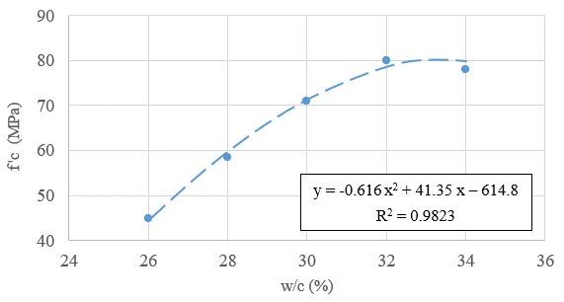
Figure 1: Compressive Strength versus Water-to-Cement

Batch group B was fit to a 2nd order polynomial equation as shown in Figure 2. The peak metakaolin-to-cement ratio was found to be 5% by tests and 5.8% from the polynomial equation. Silica fume improves particle packing in concrete and Metakaolin is a lower cost alternative to silica fume, that gives the same effects of improved particle packing in concrete mixes (Khatib 2007).

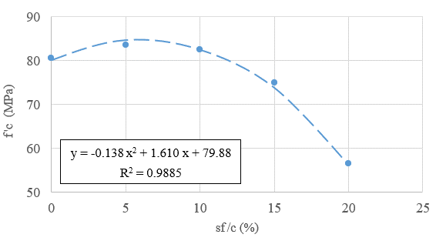
Figure 2: Compressive Strength versus Silica Fume-to-Cement

Batch group C was fit to a 2nd order polynomial equation as shown in Figure 3. The peak fiber-to-cement ratio was found to be 0% from tests and 0% from the polynomial equation. These findings are expected, as fibers are known to increase flexural strength and ductility and not compressive strength, however, the results quantify the reduction in compressive strength from their use.

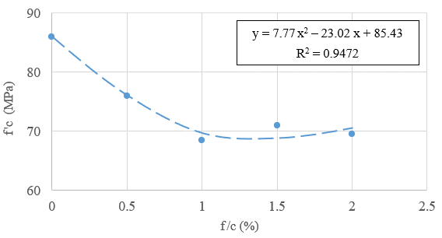
Figure 3: Compressive Strength versus Fibers-to-Cement

Batch group D was fit to a 2nd order polynomial equation, as shown in Figure 4. The peak cement-to-sand ratio was found to be 150% by tests and 126.6% from the polynomial equation. A standard conventional concrete mix would use between 25% and 50% cement-to-sand ratios in a 4:1 or 2:1 ratio for sand and cement. The higher the sand-to-cement ratio is the more brittle the concrete will be leading to lower compressive strength.

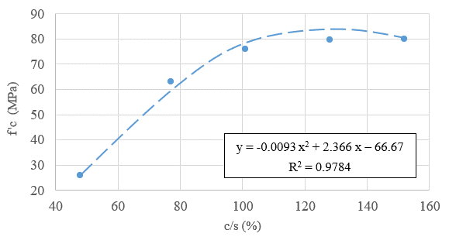
Figure 4: Compressive Strength versus Cement-to-Sand

Batch group E was fit to a 2nd order polynomial equation as shown in Figure 5. The peak fly ash-to-cement ratio was found to be 20% by tests and greater than 25% from the polynomial equation. The addition of fly ash in any type of concrete has been found to improve performance (Yerramala, 2012).

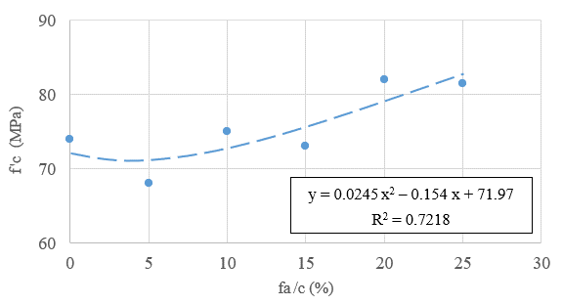
Figure 5: Compressive Strength versus Fly Ash-to-Cement

Once all batches were broken and analyzed within their groups, a combined equation using an expanded 2nd order polynomial equation was formed and iteratively optimized for maximum correlation. The resulting equation is shown below as Equation 2. Computed results for actual compressive strength values, f’c, in units of MPa are given by Equation 2. See Table 3. For units of PSI, the formula of Equation 2 is multiplied by 145.038. Weight was represented in grams by Wt in Equation 2, and R² was found to be 91.50% when compared to the four (4) compressive strength averages for all 26 concrete batches produced.

Equation 2
$${\text{f}}^{\text{ '}}\text{c =}-\text{32.41 + 0.153}\left(\frac{\text{w}}{\text{cm}}\right)\text{+ 0.0594}{\left(\frac{\text{w}}{\text{cm}}\right)}^{\text{2}}\text{+ 0.652}\left(\frac{\text{m}}{\text{c}}\right)-\text{ 0.0731}{\left(\frac{\text{m}}{\text{c}}\right)}^{\text{2}}-\text{26.13}\left(\frac{\text{f}}{\text{c}}\right)\text{+ 8.69}{\left(\frac{\text{f}}{\text{c}}\right)}^{\text{2}}$$
$$- \text{0.363}\left(\frac{\text{c}}{\text{s}}\right)\text{+ 0.00256}{\left(\frac{\text{c}}{\text{s}}\right)}^{\text{2}}-\text{ 0.940}\left(\frac{\text{fa}}{\text{c}}\right)\text{ + 0.0538}{\left(\frac{\text{fa}}{\text{c}}\right)}^{\text{2}}\text{+ 0.0277}\left(\text{wt}\right)\text{ + 0.0000178}{\left(\text{wt}\right)}^{\text{2}}$$

Summary & Conclusion

With all R² correlations being greater than or equal to 91.50% for all concrete batch mix ratios except for the fly ash-to-cement, with a correlation of 72.2%, a 2nd order polynomial can be safely considered an effective method for compressive strength prediction. As fly ash-to-cement was the only material ratio that had an upward progression continuing past the data samples taken, it is likely that a better fit could have been obtained by increasing the fly ash mixes used to include data points with 30% and 35%.

Figure 6: 2nd Order Polynomial Equation Line of Equality to Data Results

With the combined equation fitting to 91.5% correlation within the actual compressive strength test data and the majority of all predicted values less than 6.895 MPa (1,000 PSI) as shown in Table 3, this procedure is a more effective means to approximate the concrete mix design compressive strength than standard ratios and rules of thumb. The data fit to the equation is well within the 20% error from the line of equality shown on Figure 6. This process could be repeated with any combination of concrete trial batch mixes, to increase the achievable compressive strength of the material. Multiple equations could be generated to allow mixing plants to generate equation outputs for slump, air content, and other factors to allow for meeting mix design criteria without running large quantities of samples.
One limitation of this study was the absence of the use of aggregates in the mix samples, instead sand was used for the 26 concrete batches that the equation was fit too. Adding in another variable or more than one variable to represent aggregates would increase the applicability of the equation. However, the results of the individual curve fits in Appendix B, agree, in terms of deviation of recommended optimum ratios of less than 18%, with existing research that did use aggregates in the mixes (Khatib, 2007) (Malaiskiene, 2017).

References

Zhang, Hengchun, Zou, Kaibo, Ji, Xixian, Zhang, Changwen, Tang, Fangyu, Wu, Xiaoqiang (2015), Mixture Design Methods for High Performance Concrete: A Review. International Conference on Advanced Engineering Materials and Technology (AEMT).
ASTM C39M/C39 (2018), Standard Test Method for Compressive Strength of Cylindrical Concrete Specimens, ASTM International, West Conshohocken, PA, astm.org.
ASTM C136M/C136 (2019), Standard Test Method for Sieve Analysis of Fine and Coarse Aggregate, ASTM International, West Conshohocken, PA, astm.org.
ASTM C192M/C192 (2019), Standard Practice for Making and Curing Concrete Test Specimens in the Laboratory, ASTM International, West Conshohocken, PA, astm.org.
Khatib, J.M. (2007), Metakaolin Concrete at a Low Water to Binder Ratio. Construction and Building Materials, 22.8, pp. 1691-1700.
Yerramala, Amarnath (2012), Influence of Fly Ash Replacement on Strength Properties of Cement Mortar. International Journal of Engineering and Science Technology (IJEST), 4.8, pp. 3657-3665.
Malaiskiene, J., Skripkiunas, G., Vaiciene, M, and Karpova, E (2017), The Influence of Aggregates Type on W/C Ratio on the Strength and Other Properties of Concrete. IOPF Conf. Series: Materials Science and Engineering.
Nor, N. M., Ghazali, M., A. A., Ahmad, M., Z., Yusof, M. A., Vikneswaran, M., and Yahya, A (2017). Revisiting High Strength Concrete Using Common Admixtures. Journal of Fundamental and Applied Sciences, 9-3S, pp. 546-554.
Larrard, F. De, and T. Sedran (1994). Optimization of Ultra-High-Performance Concrete by the Use of a Packing Model. Cement and Concrete Research 24.6, pp. 997-1009.
Larrard,Francois De, and Thierry Sedran (2002). Mixture-Proportioning of High-Performance Concrete. Cement and Concrete Research, 32.11, pp. 1699-1704.
Langley, W. S., G. G. Carette, and V. M. Malhotra (1989). Structural Concrete Incorporating High Volumes of ASTM Class Fly. Materials Journal, 86.5.

Biographies

MICHAEL C. PICKETT is a structural and blast engineer at the US Army Corps of Engineers (USACE), Huntsville Center (HNC). He earned his BS from Western Kentucky University in 2013, and ME in structural engineering in 2015 from Vanderbilt University. Mr. Pickett’s research interests include material and structural optimization, structural health monitoring, and risk and reliability and may be reached at Michael.C.Pickett@usace.army.mil.

SHANE M. PALMQUIST is an associate professor at Western Kentucky University in Bowling Green, Kentucky. He earned his BS from the University of New Hampshire in 1995, MS from the University of Rhode Island in 1996, and a PhD from Tufts University in 2003. Dr. Palmquist’s research interests include high performance cementitious materials and engineering education. He may be reached at Shane.Palmquist@WKU.edu.
JASON WILSON is an instructor at Western Kentucky University in Bowling Green, KY. He earned his BS from Western Kentucky University in 2006, MS from the University of Wisconsin-Platteville in 2016. Mr. Wilson's research interests include material and structural optimization of lightweight concrete and engineering education and may be reached at Jason.Wilson@WKU.edu.

