# 238-M-20

Experimental Investigation and Theoretical Modeling of Ultrashort Pulse Picosecond Laser Ablation

Swapnil Patole
Mississippi State University
spatole@colled.msstate.edu

Xinyu Liu
Lamar University
xinyu.liu@lamar.edu

Raghabendra Rout
SUNY Binghamton
rrout1@binghamton.edu

Swagatika Patra
SUNY Binghamton
Spatra1@binghamton.edu

Abstract

Ultrashort pulse laser ablation has opened doors to many applications that require very high accuracy and precision. To fully harness the potential of these systems an optimized process and an adapted process strategy is required. For surface structuring, it can be shown that for metals and many other materials, the ablation process shows maximum efficiency at optimum fluence. The corresponding material removal rate depends on the threshold fluence and the energy penetration depth of that material. For achieving high efficiency and high machining quality it is necessary to maintain optimum working conditions consistently. Laser ablation depends on several parameters such as pulse width, frequency, scanning speed, overlap ratios etc. Precise control of these parameters is essential to obtain a superior quality cut.
A mechanistic surface generation model was developed based on the logarithmic ablation law. The model predicts the ablation depth with high accuracy using the material constants calibrated from the literature. If properly calibrated, the modeling accuracy can be further improved. This result can help many researchers in the field to predict the ablation depth based on the laser parameters like pulse width, frequency, scanning speed, overlap ratios, etc, with high accuracy. These results were verified by experimental investigation and analysis. The surface roughness cannot be accurately predicted due to significant stochastic components on the surface generation that were not accounted for in the mechanistic model. These simulation models are robust and can be used for any material just by using the appropriate ablation threshold and energy penetration depth values of that material.

Introduction

Ultrashort pulse laser ablation involves various laser parameters that play a vital role in achieving a good surface finish and laser ablation depth. Laser parameters like the laser power, pulse frequency, pulse width and scanning speed are together responsible for the amount of material ablated. It is challenging to predict the exact values of these laser parameters to achieve a laser ablation of specified depth. In this research, we propose a surface generation model that predicts the maximum groove depth that can be achieved for a specified set of laser process parameters. We introduce a method for predicting the ablation depth based on laser processing parameters and available properties like the ablation threshold fluence and the laser penetration depth.

During laser grooving, a laser beam is scanned over the workpiece surface, resulting in increasing its temperature above the material’s melting point, in a small region near the beam spot (Chryssolouris, 2006, p. 82). In cases where the heat flux, provided by the process parameters, is enough, vaporization of the material might also occur. The removal mechanisms include melting, vaporization and chemical degradation (Dubey & Yadava, 2008, p. 625). A gas jet may be applied coaxially or off-axially along with the laser beam to remove the molten material and produce the groove.

The laser grooving process has been investigated by many researchers. One of the first theoretical modeling approaches was presented by (Chryssolouris, 1991). He developed a theoretical model deriving from the relation between the groove depth and the process variables by using infinitesimal control surface on the erosion front surface. An analysis to derive groove depth as a function of process parameters, based on the assumption of complete removal of molten material, has also been reported. (Choi and Chryssolouris, 1995, p. 876)

The impact of laser intensity, repetition rate and scanning speed on the surface roughness and ablation depth of die-making steels was studied by (Kaldos et al., 2004, p. 1819). Their findings suggested that to obtain the desired accuracy in the laser milling of cold working steel by Nd: YAG laser, the thickness of single layers removed from the target material should be in the range of 2-5 µm. A good compromise can be found between high ablation depths and surface quality by careful laser choice and process optimization (Campanelli et al., 2013, p. 52-53).

Different analytical models describe the relationship between energy input and removed volume of material in laser ablation. These models relate to the ablation threshold and the energy penetration depth, both representing material dependent parameters (Häfner et al., 2016, p. 22608). Theoretical modeling of femtosecond pulsed laser ablation of silicon was carried out using a two-temperature model and the ablation threshold, and the depth of material removed per pulse was determined (Singh and Soni, 2009, p. 176).

More recent investigations into the ablation depth of a laser have indicated that laser incidence angle and laser power have a significant effect on the ablation depth with 48.02% and 39.67% contribution respectively. Also, laser incident angle, laser power, and scan speed have shown 40.88%, 24.66% and 30.16% contribution on surface roughness (Wang et al., 2017, p. 2971).
Nolte et al. (1997, p. 2716) for the first time formulated a relationship between the ablated depth per pulse and the energy penetration depth of the laser beam. The ablated depth per pulse is also dependent on the laser fluence and the ablation threshold fluence. These correlations are expressed in Beer-Lambert’s law and it forms the base for the interaction of the laser radiation with the workpiece.

Mechanistic Modeling of Ultrashort Pulse Laser Ablation: Formulation of a Simple Mathematical Model

Beer Lambert’s law states the absorption strength of the laser irradiation in the material. This law assumes that the interaction process and the subsequent ablation are dominated by the absorption of photons with energy above band gap, with little or no contribution from heat transport processes. Under these circumstances, the maximum ablated depth $Z_{abl}$ when one or more laser pulses hit the target surface can be expressed as (Liu, 1982, p. 196).

$Z_{abl}=δ.\ln\left(\frac{∅_{0}}{∅_{th}}\right)$………………………….(1)

Where, $∅_{0}$- is the peak laser fluence, δ - is the effective penetration depth of the incident light and $∅_{th}$ - is the material ablation fluence threshold.

The material may experience changes in the values of $δ$ and $∅_{th}$when pulses repeatedly hit the same area, a process known as incubation. This process is usually ascribed to a defect creation mechanism which generally causes $∅_{th}$to decrease. In the case of laser milling, where a laser beam is scanned across the target workpiece, the ablation depth cannot be predicted solely using the above equation. This happens because the laser spot hits the target material and depending on the scanning speed , there is an overlap of pulses and due to this each pulse that hits a particular point on the target material is going to do so with a different energy. Since only the pulses that have an energy above ablation threshold ($∅_{th})$ can contribute to the visible ablation of the material, it is possible to calculate the ablated depth of a train of pulses (Canteli et al., 2017, p. 113).

$Z_{abl}=δ.[ \ln\left(\frac{∅_{0}}{∅_{th}}\right)+2.\ln\left(\frac{∅_{0}.\exp^{{{-2d}^{2}}/{{w_{0}}^{2}}} }{∅_{th}}\right)+ 2.\ln\left(\frac{∅_{0}.\exp^{{{-2\left(2d\right)}^{2}}/{{w_{0}}^{2}}} }{∅_{th}}\right)+ 2.\ln{\begin{aligned}\left(\frac{∅_{0}.\exp^{{{-2\left(3d\right)}^{2}}/{{w_{0}}^{2}}} }{∅_{th}}\right)+…] \\ .\end{aligned}}$..............................(2)

Where, f - repetition frequency for the laser, v - Scanning speed, d = v/f, is the distance between two consecutive pulses, $w_{0}^{ }-$Spot radius, $∅_{0}$is the peak laser fluence,$δ$is the effective penetration depth of the incident light and $∅_{th}$ is the material ablation threshold fluence.

So, from the above equation, measuring $δ$ and $∅_{th}$is enough to predict the depth of the laser ablated scribe if information on the process parameters (v, f, $w_{0}^{ }$ and $∅_{0}$) is given. One important consideration in using the above equation for predicting the depth of the laser ablated scribe is that the geometry of the ablated region should not change considerably i.e. grooves with high aspect ratios. That’s because in that case the fluence might decrease considerably due to the increase in the effective area.

Simulation of the Ultrashort Pulse Laser Ablation using MATLAB software

Algorithm

Simulation of a laser ablation process can be challenging. Several process parameters need to be optimized to achieve a clean cut with minimal thermal damage to the surrounding region. For simulation of the Ultrashort pulse laser ablation process, a laser pulse having a spot radii $w_{0}^{ }$ is focused on the XY plane. For simplicity, it is assumed that the XY plane is perfectly flat. Now, as shown in Figure 1, for a Gaussian beam with peak fluence $∅_{0}$ and threshold fluence$∅_{th}$, the effective diameter D of the laser pulse that results in the ablated area is the diameter at the threshold fluence. The surrounding area is the irradiated area when the laser intensity is less than 10% of the intensity at the beam center. A mesh is generated for the x, y and z coordinates. As the laser pulse hits the xy plane with a peak fluence $∅_{0}$ and threshold fluence $∅_{th}$. These values of peak fluence and threshold fluence, along with the energy penetration depth are fed into the logarithmic equation for the laser ablated depth per pulse. The logarithmic equation gives the ablated depth z. This process is iterated repeatedly and the respective z values are updated to give the total ablated depth.

But in laser cutting a large number of pulses hit the target material and also the laser moves in the X and Y direction. So by using scanning speed in mm/s and pulse frequency in KHz a model is created that generates the laser tool path by taking into consideration the laser spot size. Later, this model is synced with the laser ablated depth to give the 3d profile of laser ablated area with x,y and z coordinates (z being the ablated depth) as shown in Figure 1.

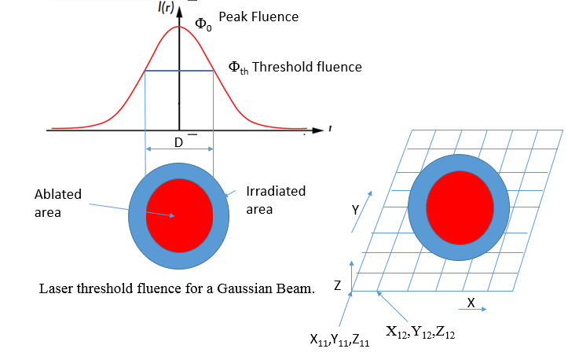
Figure 1. Figure showing the x, y and z coordinates of the target where the laser beam is focused.

Generation of the Laser Tool Path and Simulating for the Ablated Depth and Surface Roughness.

The simulation starts with the generation of the laser tool path. For this a function is created that allows the user to input the maximum values for the working space. The input values are as :
xs: the x coordinate of the starting point (in um),
xe: the x coordinate of the ending point (in um),
ys: the y coordinate of the starting point (in um),
ye: the y coordinate of the ending point (in um).

Then the scanning parameters like scanning speed, pulse frequency and the overlap ratio Ox are defined. The outputs are the vectors xt and yt with the x and y coordinates of the surface points where the laser beam ablated the surface. Figure 2 below shows the laser ablated tool path.

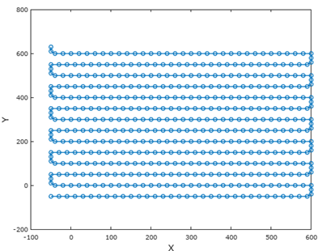
Figure 2. Laser tool path generation considering the pulse frequency, scanning speed and overlap ratios.

By changing the scanning speed, the overlap ratios change as shown in Figure 3 below. It can be seen that the overlap increases as the scanning speed decreases. At higher scanning speeds such as 400 mm/s as seen in the Figure 3 below, there is no overlap. When the laser beam hits the target material with no overlapping pulses, the result is a series of dimples of the size of the laser spot.
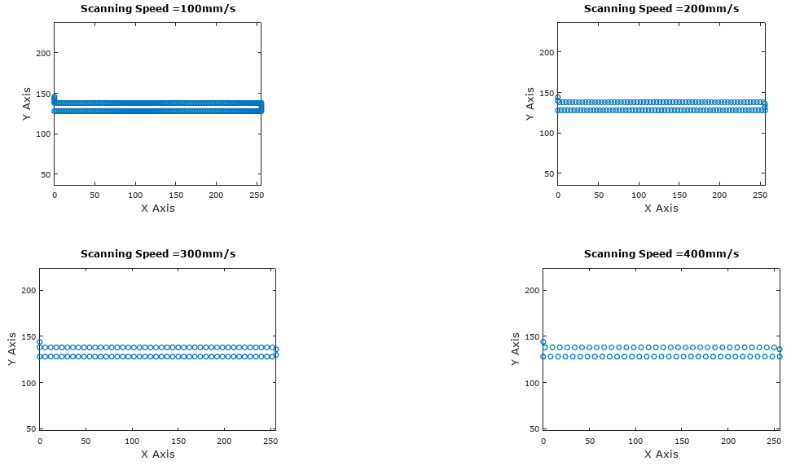
Figure 3. Simulation showing varying Scanning Speeds

Then a function is created to determine the laser ablation per pulse. This function can be used to simulate the laser ablation in surface modification. The surface height of the region where the laser ablated will be updated. The inputs for this function are:
(1) Surface Topography Data: A 2D array (z) of the surface height before the ablation. It contains the entire surface to be processed. Only the portion inside the laser beam will be modified to reflect the material removal process,
x: the x coordinates of the surface array (1D vector), used to generate 2D XY grid points
y: the y coordinates of the surface array (1D vector), used to generate 2D XY grid points
x0: the x coordinate of the laser beam center,
y0: the y coordinate of the laser beam center,
(2) Material properties: $δ$: Energy penetration depth, $∅_{th}$: the threshold fluence to process the specific material.
(3) Laser Beam optical parameters: Ep: Pulse energy of a Gaussian beam, $w_{0}^{ }$: the spot radius

The output of this laser ablation per pulse function is (z) a 2D array of the surface height after the ablation. It contains the entire surface to be processed. Only the portion inside the laser beam were modified to reflect the material removal process. Both functions, the laser tool path generation and the laser ablation per pulse are used together to output the values of the ablated depth as the laser ablates the material. Figure 4 below shows the output.
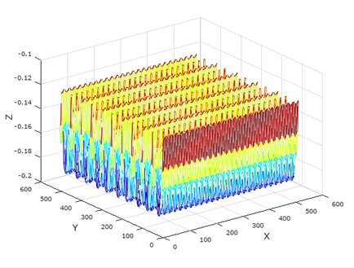
Figure 4. The simulated surface topography.

The ablations profiles for different Energy per pulse are plotted in Figure 5. These profiles are for a laser spot radius $w_{0}^{ }$ = 30 µm. The laser spot size is adjustable and can be changed using the expander on the laser setup. The laser spot size $w_{0}^{ }$ is related to the unfocused beam diameter D and the unfocused beam diameter can be changed using the beam expander.

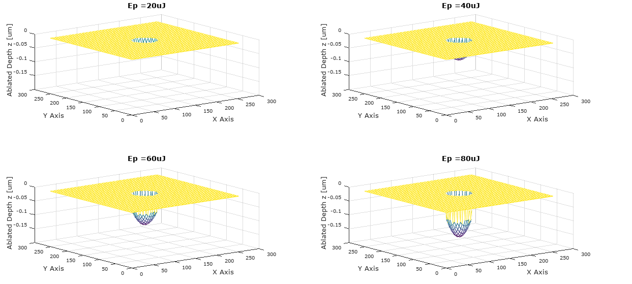
Figure 5. Ablation Profile for Different Energy per Pulse.
Ablation depth is plotted against Energy per pulse (Ep) and ablation ratio ($\frac{ϕ_{0}}{ϕ_{th}}$) in Figure 6. It can be seen that the ablation depth is zero for Energy per pulse less than 5µJ. Also, the simulation results show that at Energy per pulse of about Ep = 13µJ, the corresponding ablation ratio ($\frac{ϕ_{0}}{ϕ_{th}}$) is 18 and at Ep = 5 µJ it is$(\frac{ϕ_{0}}{ϕ_{th}}$) = 8. These results suggest that the nominal range for$(\frac{ϕ_{0}}{ϕ_{th}}$) ratio is$(\frac{ϕ_{0}}{ϕ_{th}}$) = [8, 18]. But, according to Neuenschwander et al. (2014, p. 1053), keeping the$(\frac{ϕ_{0}}{ϕ_{th}}$) ratio in between [5, 15] results in the optimal material removal rate and higher surface quality. Working at higher or lower peak fluences leads to a reduced efficiency in terms of material removal rate and a reduced quality for too low fluences. For most metals this leads to quite low fluences and therefore high repetition rates or spot sizes are needed when working at high average power.

The Energy per pulse that we are using for our experiments is Ep = 60µJ, so, from Figure 6 it can be seen that the$(\frac{ϕ_{0}}{ϕ_{th}}$) ratio for Ep = 60µJ is about$(\frac{ϕ_{0}}{ϕ_{th}}$) = 50. So, the range of$(\frac{ϕ_{0}}{ϕ_{th}}$) for our experiments is between [40, 90]. These results contradict the results of Neuenschwander et al. (2014, p. 1057) and may indicate that the system is not being utilized optimally.
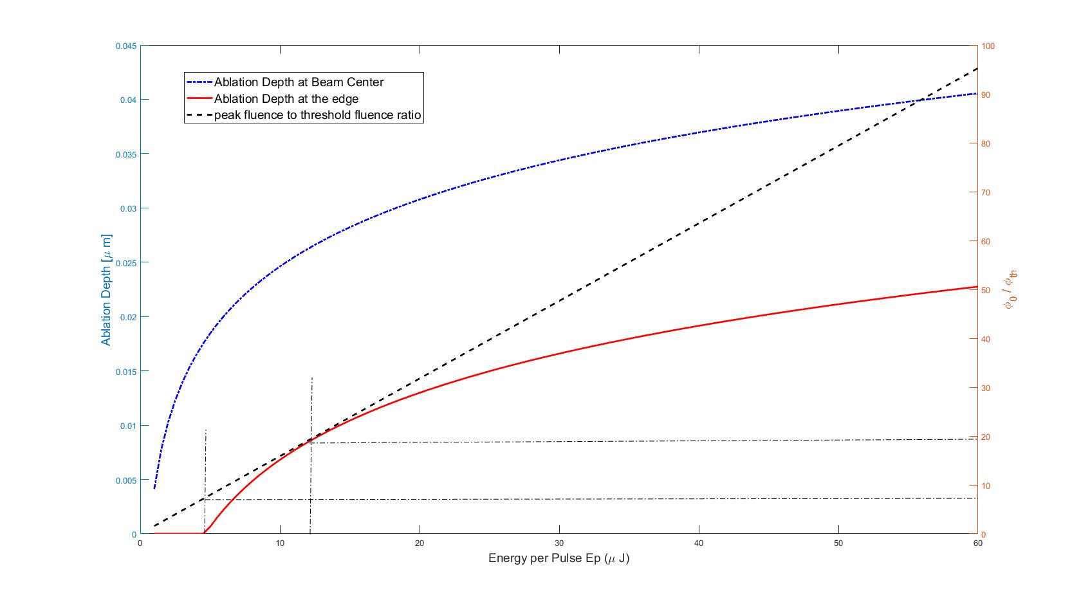
Figure 6. Ablation Depth vs Energy per Pulse Ep.

The influence of both overlap ratios (overlap ratio Ox and overlap ratio Oy) on the generated surfaces with pulse frequency kept constant are shown below. The overlap ratio Ox depends primarily on the scanning speed and the overlap ratio Oy depends on the distance between the adjacent trajectories, or the size of step-over between adjacent passes.
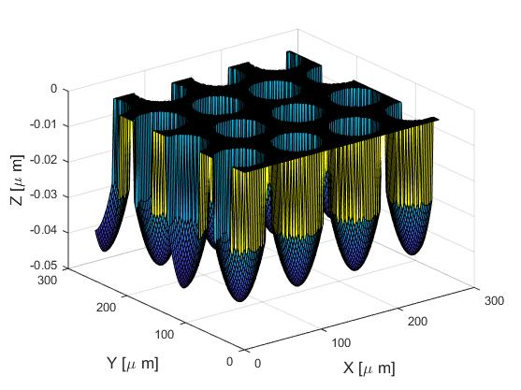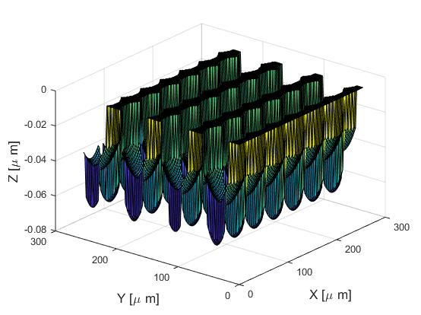
- (b)
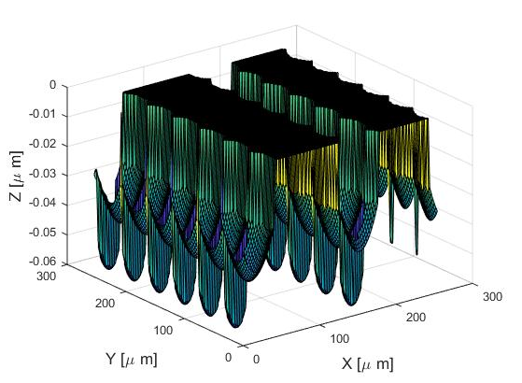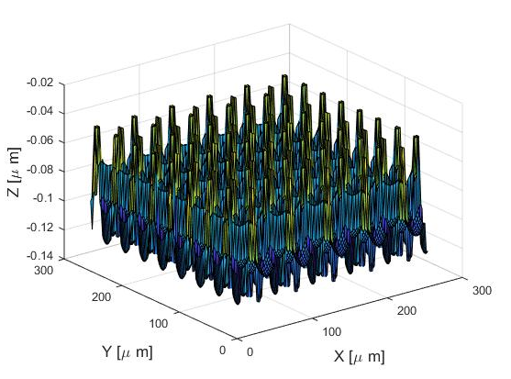
(c) (d)
Figure 7. (a)Surface topography generated with no overlap in both directions, (b) significant overlap ratio Ox in the X direction, (c) significant overlap ratio Oy in the Y direction, (d) Surface topography generated with significant overlap in both directions.

Figure 7(a) above shows the ablated region with no overlap of pulses in both directions. For this condition the scanning speed is kept high so that the overlap ratio Ox is low and also the overlap ratio Oy is kept low. Figure 7(b), above shows significant overlap in the X direction. For this condition a lower scanning speed is used so that there is significant overlap of pulses in the X direction, but the overlap ratio Oy is kept lower so that there is no overlap in the Y direction. This tends to generate deep grooves parallel to the Y axis. Figure 7(c), shows the surface topography when there is significant overlap in the Y direction. A higher scanning speed is used so that the overlap of pulses in the X direction is not significant, but the overlap ratio Oy is kept higher. The ablated surface under these conditions are deep grooves parallel to the X direction. Figure 7(d), shows the surface topography significant overlap in both direction. For this condition a lower scanning speed is used to keep the overlap ratio Ox higher and the overlap ratio Oy is also kept higher. Also, it can be noted that the ablated depth is higher when both the overlap ratios are higher, this is simply because more laser pulses hit the target material at the same spot.

Several simulations were performed with scanning speeds varying from 100 mm/s to 500 mm/s, pulse frequency from 20 KHz to 50 KHz, focal spot size from 20 µm to 60 µm and overlap ratios varying from 20% to 100%. Only two plots for spot size 20 µm and 30 µm are shown in Figure 8. The focal spot size $w_{0}^{ }$ for the experimental investigation is about 30 µm. It can be seen from Figure 8 that for spot size 30 µm, the overlap ratios Ox and Oy that give the least surface roughness are around 40% overlap. For lower overlap ratio Oy the surface roughness is seen to increase whereas, as the overlap ratio Ox increases above 40% the surface roughness increases initially and then decreases at around 80%.

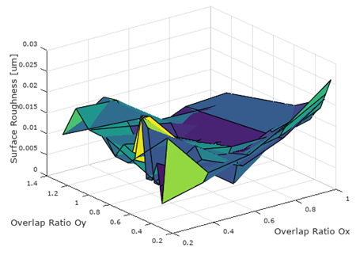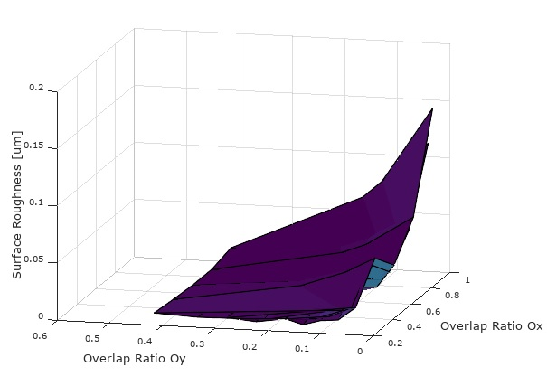
Spot size = 20 µm Spot size = 30 µm

Figure 8. Surface roughness values for different overlap ratios Ox and Oy with varying laser spot radius.

Apparatus and Experimental Design

The laser head used in our experimental process is a Coherent Helios 532-3-50 Q-switched DPSS (Diode pumped solid state) pulsed laser. It is a 3W laser with a wavelength of 532 nm and setpoint frequency of 50 KHz. The scan head is an IntelliSCAN 14 from Scanlab. The laser head and the scan head are connected through an attenuator and a beam expander that enables us to change the focal spot size. The beam expander ratio ranges from 1 to 5. For the experiments, the expander ratio was set at 1.

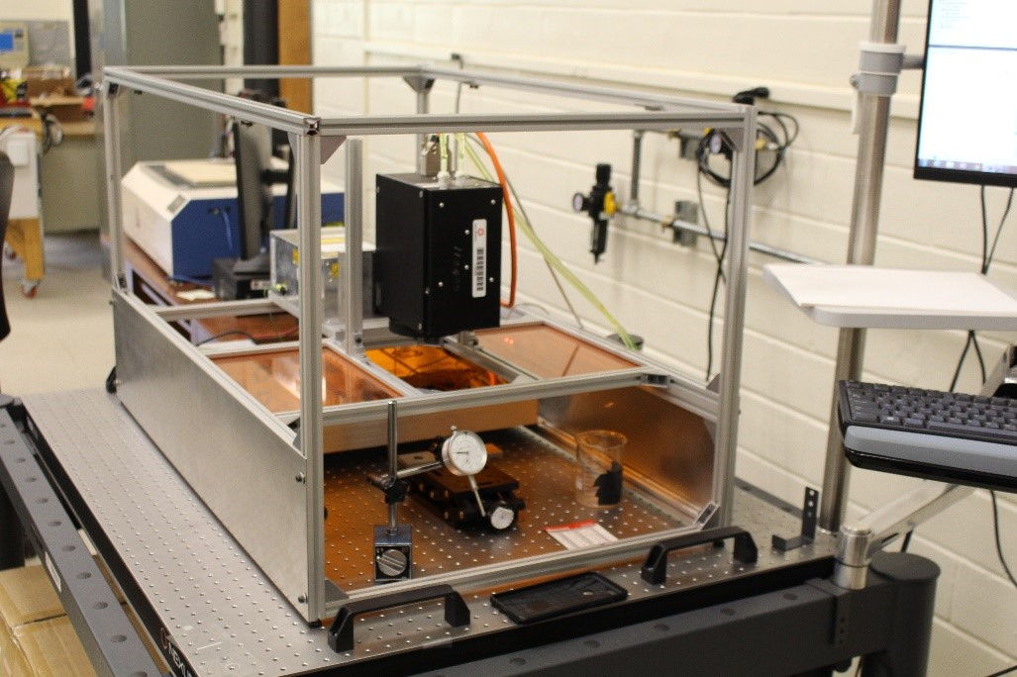
Figure 9. Image showing Coherent Helios 532 nm Picosecond Laser System (Micro-
Manufacturing Lab)

The most commonly used experimental model to analyze the relationship between the input parameters and the output response is the factorial design. The model developed from the factorial design shows the interrelationship between the response variables and control variables, which help us to control those control variables to obtain the optimal responses. The mathematical model generated can also be used as the prediction model. The different variable factors and factor levels chosen for parametric analysis are as shown.

Table 1. Variable factors and factor levels
Variable factors | Factor Levels
 | 1 | 2 | 3 | 4 | 5 | 6 | 7 | 8 | 9
Scanning Speed (mm/s) | 100 | 150 | 200 | 250 | 300 | 350 | 400 | 450 | 500
Pulse width (µs) | 10 | 15 | 20
Pulse Frequency (KHz) | 20 | 30 | 40 | 50

The values of the pulse width are set from 10 to 20µs, as the laser system is limited to a pulse width of 20 µs. Also, the pulse frequency is set from 20 to 50 KHz because the pulse energy decreases above 50 KHz as discussed earlier.

Experimental Results and Analysis

From the above variable factors and factor levels, a total of 108 number of tests were conducted. After laser machining grooves on grey cast iron, each of these 108 grooves are examined under the 3D-profilometer from Filmetrics to determine the surface roughness values. These values of surface roughness are plotted against scanning speed for different pulse widths and pulse frequencies as shown in Figure 11.

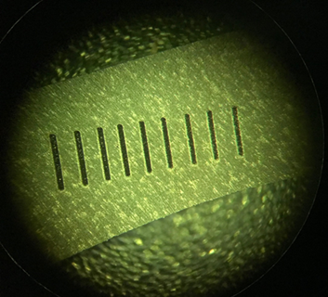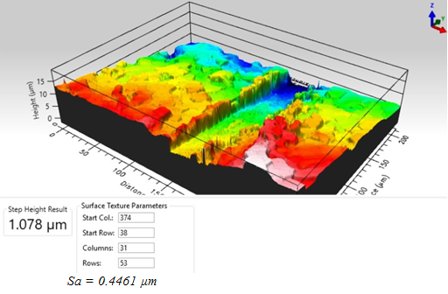
Figure 10. A zoomed view of one set of grooves with image captured under profilometer showing surface roughness for one of the grooves.

Figure 11. Scanning speed vs surface roughness for pulse widths 10µs, 15µs and 20µs with varying pulse frequencies. (Series 1–20 KHz, series 2–30 KHz, series 3–40 KHz, series 4–50 KHz)
After a careful examination of these plots in Figure 11, it is evident that the laser parameters that yield the least surface finish are with the pulse frequency of 20 KHz, pulse width 15 µs, overlap ratio Ox of 41.6% and scanning speed of 300 mm/s. Also, at these optimal parameters, 50 passes were taken to make these cuts and the value of surface roughness obtained is $Sa≈0.2$ µm and the ablated depth per pulse is 0.12 µm.

Table 2. Comparison between the Model prediction and the Experimental Results

 | Model Prediction | Experimental Results
Ablation Depth per Pulse | 0.14 µm | 6 µm/ 50pulse = 0.12 µm
Surface Roughness | 0.018 µm | 0.2 µm

Conclusion

From the comparison of the model prediction and the experimental results it can be seen that the model predicts the ablation depth within 15% error using the material constants calibrated from the literature. But, the surface roughness values cannot be predicted accurately due to the significant stochastic components on the surface generation that were not accounted for in the mechanistic model. If properly calibrated, the modeling accuracy can be further improved and this may help many researchers in the field to predict the ablation depth based on the laser parameters with high accuracy. These simulation models are robust and can be used for any material just by using the appropriate ablation threshold and energy penetration depth values of that material.

Future Research

The authors intend to continue their work in ultrashort pulse laser applications, specifically biofouling. The effect of modified engineering surface by laser texturing on biofouling and the study of biofouling using laser induced breakdown spectroscopy.

References

[1] Campanelli, S. L., Casalino, G., & Contuzzi, N. (2013). Multi-objective optimization of laser milling of 5754 aluminum alloy. Optics & Laser Technology, 52, 48–56.
[2] Canteli, D., García-Ballesteros, J. J., Molpeceres, C., Gandía, J. J., & Torres, I. (2017). Depth-prediction method for direct laser-scribing processes. Applied Surface Science, 422, 111–115.
[3] Choi, W. C., & Chryssolouris, G. (1995). Analysis of the laser grooving and cutting processes. Journal of Physics D: Applied Physics, 28(5), 873–878.
[4] Chryssolouris, G. (1991). Laser Machining: Theory and Practice. New York: Springer-Verlag.
[5] Chryssolouris, G. (2006). Manufacturing Systems: Theory and Practice. Springer Publishing.
[6] Dubey, A. K., & Yadava, V. (2008). Laser beam machining—A review. International Journal of Machine Tools and Manufacture, 48(6), 609–628.
[7] Häfner, T., Heberle, J., Dobler, M., & Schmidt, M. (2016). Influences on incubation in ps laser micromachining of steel alloys. Journal of Laser Applications, 28(2), 022605.
[8] Kaldos, A., Pieper, H. J., Wolf, E., & Krause, M. (2004). Laser machining in die making—a modern rapid tooling process. Journal of Materials Processing Technology, 155–156, 1815–1820.
[9] Liu, J. M. (1982). Simple technique for measurements of pulsed Gaussian-beam spot sizes. Optics Letters, 7(5), 196.
[10] Neuenschwander, B., Jaeggi, B., Schmid, M., & Hennig, G. (2014). Surface Structuring with Ultra-short Laser Pulses: Basics, Limitations and Needs for High Throughput. Physics Procedia, 56, 1047–1058.
[11] Nolte, S., Momma, C., Jacobs, H., Tünnermann, A., Chichkov, B. N., Wellegehausen, B., & Welling, H. (1997). Ablation of metals by ultrashort laser pulses. Journal of the Optical Society of America B, 14(10), 2716.
[12] Singh, A. Kumar, and R. K. Soni. (2009). Theoretical Modeling of Femtosecond Pulsed Laser Ablation of Silicon. American Institute of Physics, 1147 (1): 172.
[13] Wang, X., Duan, J., Jiang, M., Zhang, F., Ke, S., Wu, B., & Zeng, X. (2017). Investigation of processing parameters for three-dimensional laser ablation based on Taguchi method. The International Journal of Advanced Manufacturing Technology, 93(5–8), 2963–2974.

Biographies

SWAPNIL PATOLE is an assistant professor for Industrial Technology at Mississippi State University. He earned his B.S. degree in Mechanical Engineering from India; an M.S. in Mechanical Engineering, 2011, from Lamar University, Texas; and, a Ph.D. in Industrial and Systems Engineering, 2018, from Lamar University, Texas. He has worked for several years in the industry as a Mechanical Engineer. Dr. Patole may be reached at spatole@colled.msstate.edu

XINYU LIU is a professor in Industrial and systems Engineering Department at Lamar University, Beaumont, TX. Prior to joining Lamar in Fall 2007, Dr. Liu worked as a research engineer in Microlution Inc., a startup company dedicated in micro-manufacturing machine design and manufacturing. He received his Ph.D. in Mechanical Engineering from University of Illinois at Urbana-Champaign in 2006. He got both his MS and BS degrees in Mechanical Engineering from Tsinghua University, Beijing, China in 1999 and 1997, respectively. Dr. Liu may be reached at xinyu.liu@lamar.edu

RAGHABENDRA ROUT is currently pursuing PhD in Industrial and systems Engineering at State University of New York at Binghamton. He has a B.S. in Manufacturing Engineering from India and a M.S. in Industrial and Systems Engineering from Lamar University.

SWAGATIKA PATRA is currently pursuing PhD in Industrial and systems Engineering at State University of New York at Binghamton. She has a B.S. in Manufacturing Engineering from India and a M.S. in Industrial and Systems Engineering from Lamar University.

